AJAC Soccer Registration
- Go to: http://www.sportsmanager.us/ajac.htm (opens 6/15/2015)
- Click the “Registration” link on the left-hand side
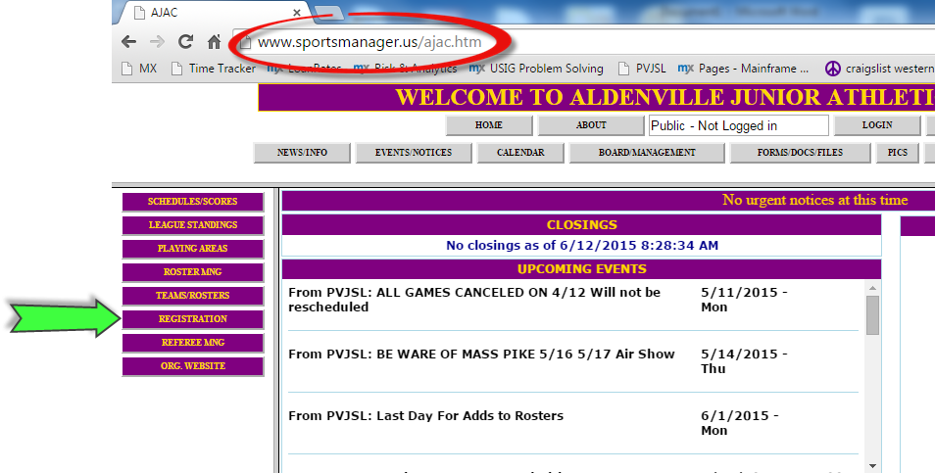
- Click the blue “Fall Soccer 2015” link
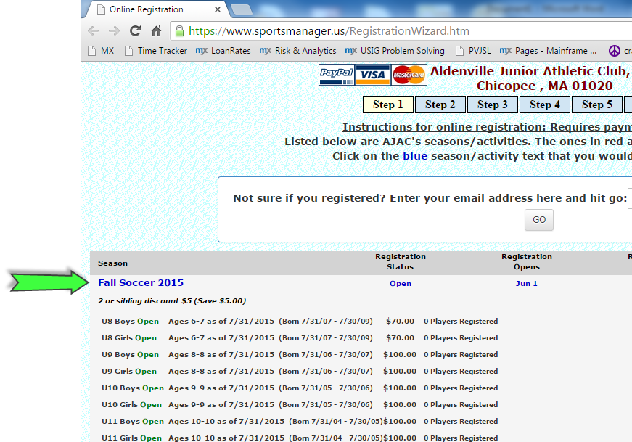

- Follow the sequence of prompts
- Enter your last name

In Person Signups – Academy Only

AJAC Clubhouse at Ray Ash Park

Saturday 8/1, Sunday 8/2

Saturday 8/8, Sunday 8/9

9:00 AM – 1:00 PM

There will be a late fee of $10 for registrations after August 9th

In Person Signups – Academy Only

AJAC Clubhouse at Ray Ash Park

Saturday 8/1, Sunday 8/2

Saturday 8/8, Sunday 8/9

9:00 AM – 1:00 PM

There will be a late fee of $10 for registrations after August 9th

In Person Signups – Academy Only

AJAC Clubhouse at Ray Ash Park

Saturday 8/1, Sunday 8/2

Saturday 8/8, Sunday 8/9

9:00 AM – 1:00 PM

There will be a late fee of $10 for registrations after August 9th

In Person Signups – Academy Only

AJAC Clubhouse at Ray Ash Park

Saturday 8/1, Sunday 8/2

Saturday 8/8, Sunday 8/9

9:00 AM – 1:00 PM

There will be a late fee of $10 for registrations after August 9th

