2016 Fall Registration
The website for Fall soccer registration, https://www.sportsmanager.us/AJAC.htm, is up and running. Below you find some valuable information about changes to the leagues age groupings and steps to ensure you register your child correctly.
As many of you are aware, Mass Youth Soccer has required players to be registered on a calendar year basis starting with the Fall 2016 season. A modification was made to that mandate to also include school grade in determining the age group a player will be placed in. As a result, there is really no difference to the prior age group set up and only a few players will need to be assigned to a new team.
You will notice that the registration site now requires you to add the grade your child will be entering in the Fall of 2016. Depending on birth date, a player may have to choose between multiple age groups. See the detailed instructions below.
Once you navigate to the registration screen, choose the age/grade for your child.
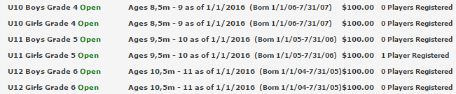
After entering parent info, you will be prompted to verify your child’s grade in the Fall.
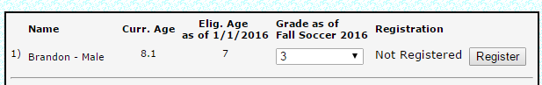
Next you will be prompted to select a team. Choose the grade appropriate team for your child.
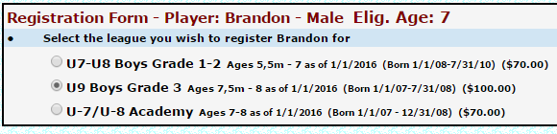
If at this point you are not presented with a team that you believe your child should be playing on or have questions, please send an email to ajacsocceracademy@gmail.com or reach out to one of the following individuals for assistance:
Tony Kibler | 413-885-3096
Hugo Destapado | 413-636-5602
Paul Langevin | 413-427-0951
Paul Marques | 413-250-9413
Miguel Ribeiro | 413-478-3618

