Roots Coach Certifcation
Please be advised, this is a lengthy process and MUST be completed by ALL coaches ASAP.
Go to Rootssoccerleague.com and click “Links” on the banner. From there, choose “Coach Requirements”

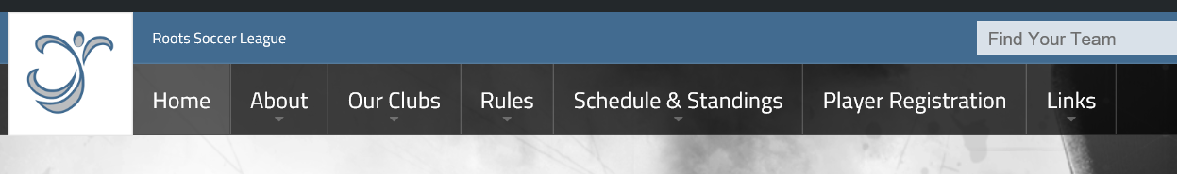

- Compelete the Sideline Sports Doc (SSD) online course. This will take about an hour to complete.

- Click the “Step 1…” blue banner
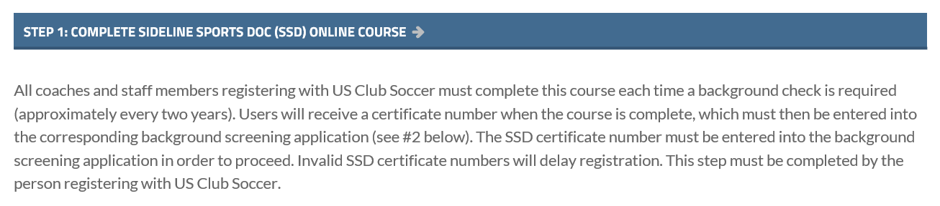
- Once on the SSD page, click the “Take the Course Today” button at the bottom
- Click “Register Now”
- On the following page, enter all your information
  - In the “Payment” section, enter the coupon code CHICOPEEFC. AJAC has covered the fee for this certification

- Complete the Background Screening

- Click the “step 2…” blue banner from the Roots page

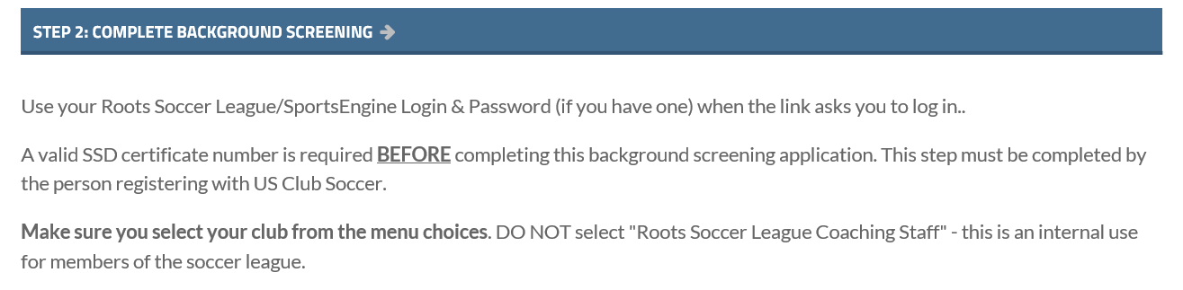
- You must complete the SSD course (see above) and the SafeSport Trained course before the background check can be requested.
  - The SafeSport course, new for 2018, covers training on multiple types of abuse. This course will take roughly an hour to complete.
    - Once on the site, click “(request information)” in #1. This will prompt you to send an email to US Soccer. Once you send that you will receive an email back with the instructions. This email contains all the information you will need to complete the certification, including the access code.
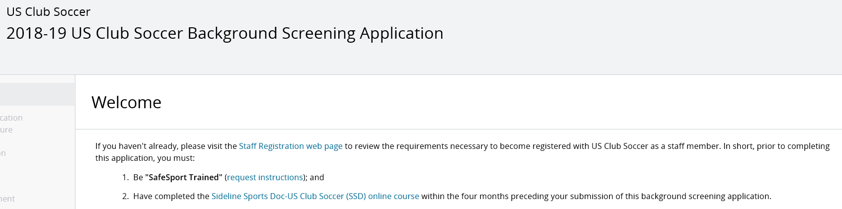

    - You will be prompted to create an account
    - Once account is created (including validation of email), you can log in to your account and begin the training modules. Click on each to start the module

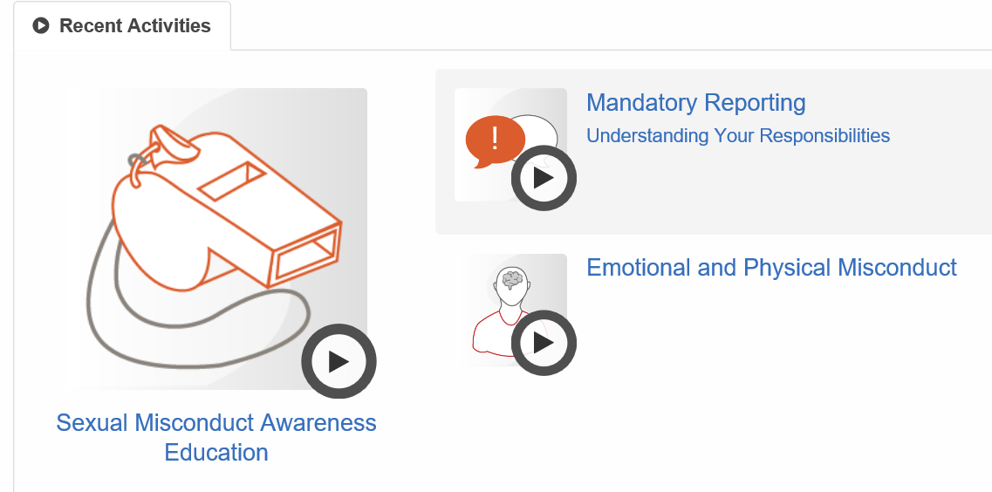
    - After each section is completed, you will be able to download the module certificate. Please do so and keep on file
    - Once all 3 modules are complete, return to the SafeSport Dashboard and download a copy of the SafeSport trained certificate. You will need this later.

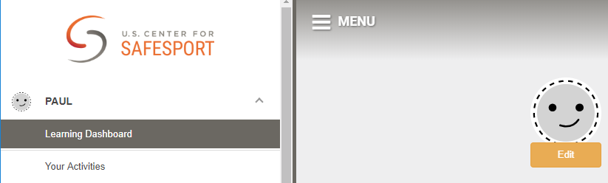

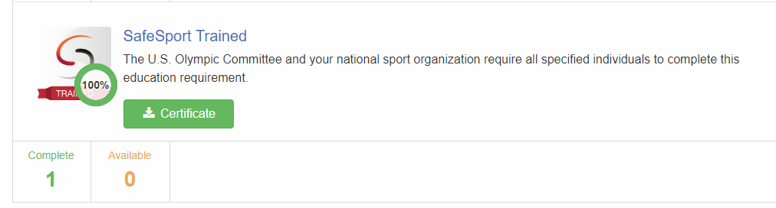

  - Return to the Roots site and to “Step 2…” of the Coach Requirements page;
    - On the page that follows, scroll to the bottom and click Continue

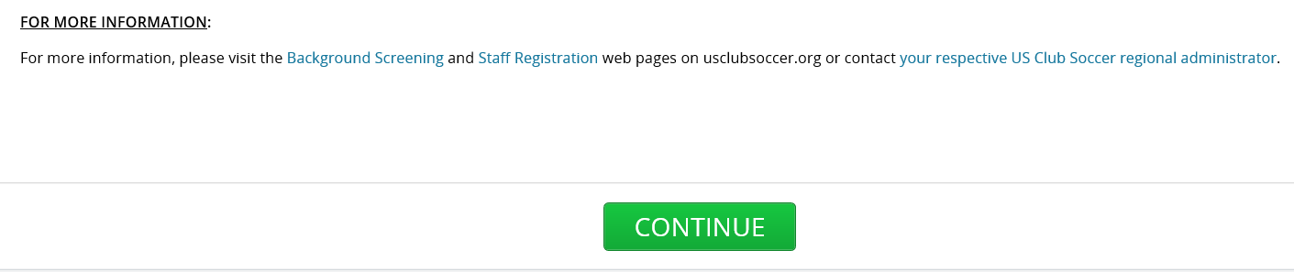

    - Follow the prompts through the first two pages. You will eventually be asked to upload your SSD and SafeSport certificates

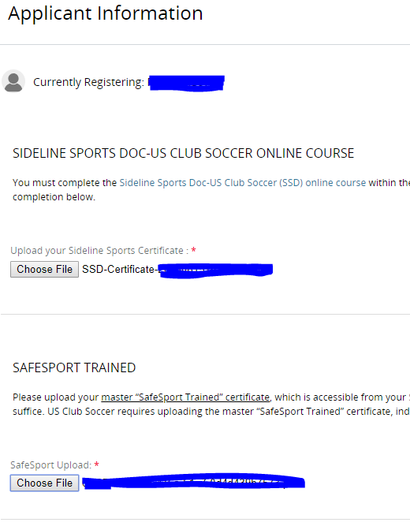

    - Continue on this page and fill in the appropriate information
    - On the following page, Select your state (MA) and the AJAC from the list of clubs
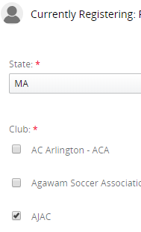
    - Scroll to the bottom and click Continue; AJAC has pre-paid for this screening

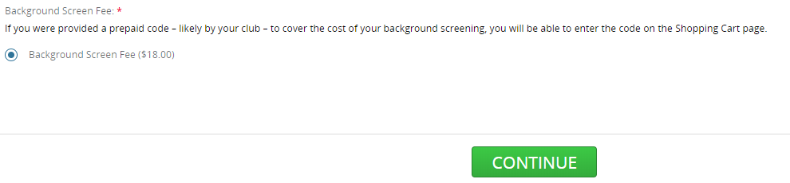

    - Scroll the bottom of the next two pages, check the box and click Continue
    - On the following page, enter your information and click Review
    - Review the information on the following page and click “Proceed to Shopping Cart”
    - AJAC has pre-paid for this background check. Please contact your team liaison for you specific Discount Code
    - Enter your code and click Apply, then click Checkoout

