Bring your appetite to the AJAC fundraising night!
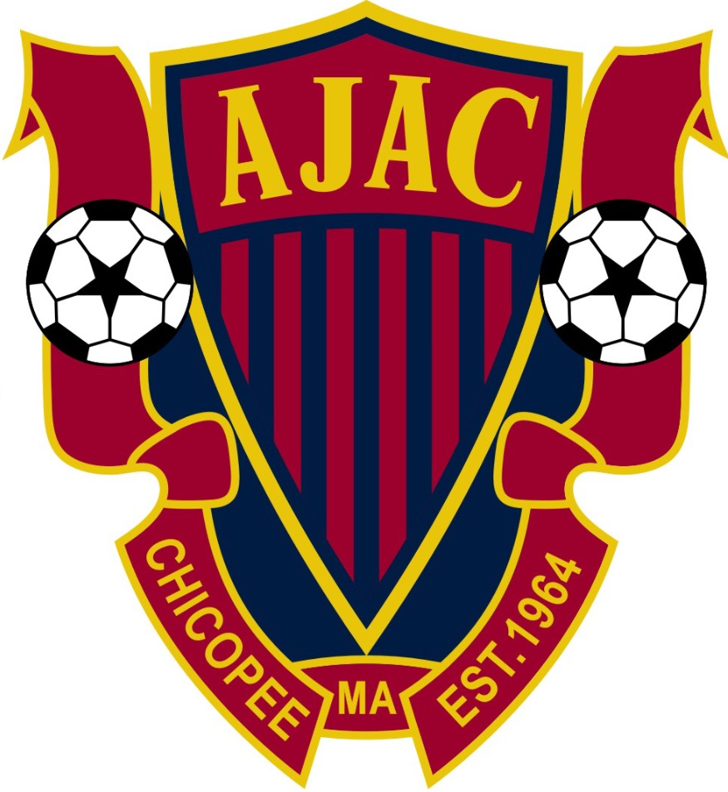
Show this coupon and 20% of your DINE-IN or TAKE-OUT order will be donated to AJAC.
When: Wednesday, Mar 24th Time: 11 a.m. to 8 p.m.
Where: Pizza Chop 486 Springfield St Chicopee
413-331-3636

