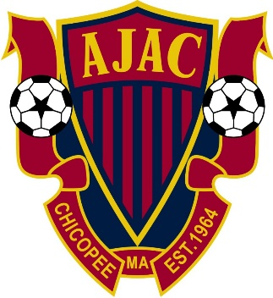

Youth Academy Program
Under-5 through U-8: The primary objective of the U-5, U-6 and U-8 Instructional Program is to help our young players get to know and love the game of soccer and to teach them the skill of dribbling. We want players to be comfortable with the ball at their feet and want to help build their confidence.

By encouraging them to dribble, we hope to encourage creativity. Only a very few players at the U-8 level will begin to develop passing skills. However, we will begin to introduce basic passing technique for the oldest and most mature players.

We do not list “kicking” as an objective and do not encourage players to aimlessly “kick” the ball as it is not helpful to their development. Players at this level need to “touch” the ball as often as possible and to develop skills.

We will encourage players to learn to dribble as opposed to just kicking the ball. Players at this level find dribbling much more fun!

Players will be placed on teams based on age group. Typically, U-5 teams will have 8 players, U-6 teams will have 10 players and U-8 teams will have 12-13 players. The object of the game at this level is not winning! It is to instill a love of the game. There will be no score keeping at this level

