Resizing a picture using Windows
- Open Windows Explorer from taskbar
- Locate the photo you want to resize and right click
- Select “Open With” and then choose “Photos”
- Click the three dots “…” in the upper right
- Choose “Resize”
- Select the size option “S” for small
- Save the resized file as a new name in order to preserve the original

These steps are illustrated below

Steps

Previous Next
Step 1: (‎4/‎8/‎2021 1:14:29 PM) User left click on "File Explorer (button)"
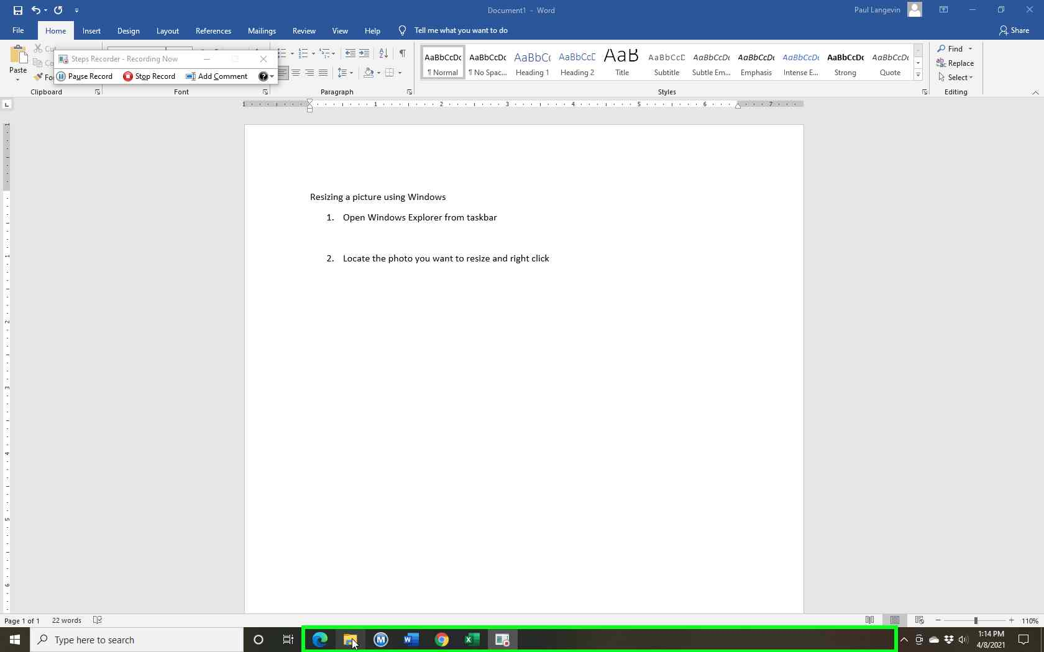Step 1 screenshot.

Previous Next

Step 2: (‎4/‎8/‎2021 1:14:32 PM) User left click on "Pictures (pinned) (tree item)" in "File Explorer"

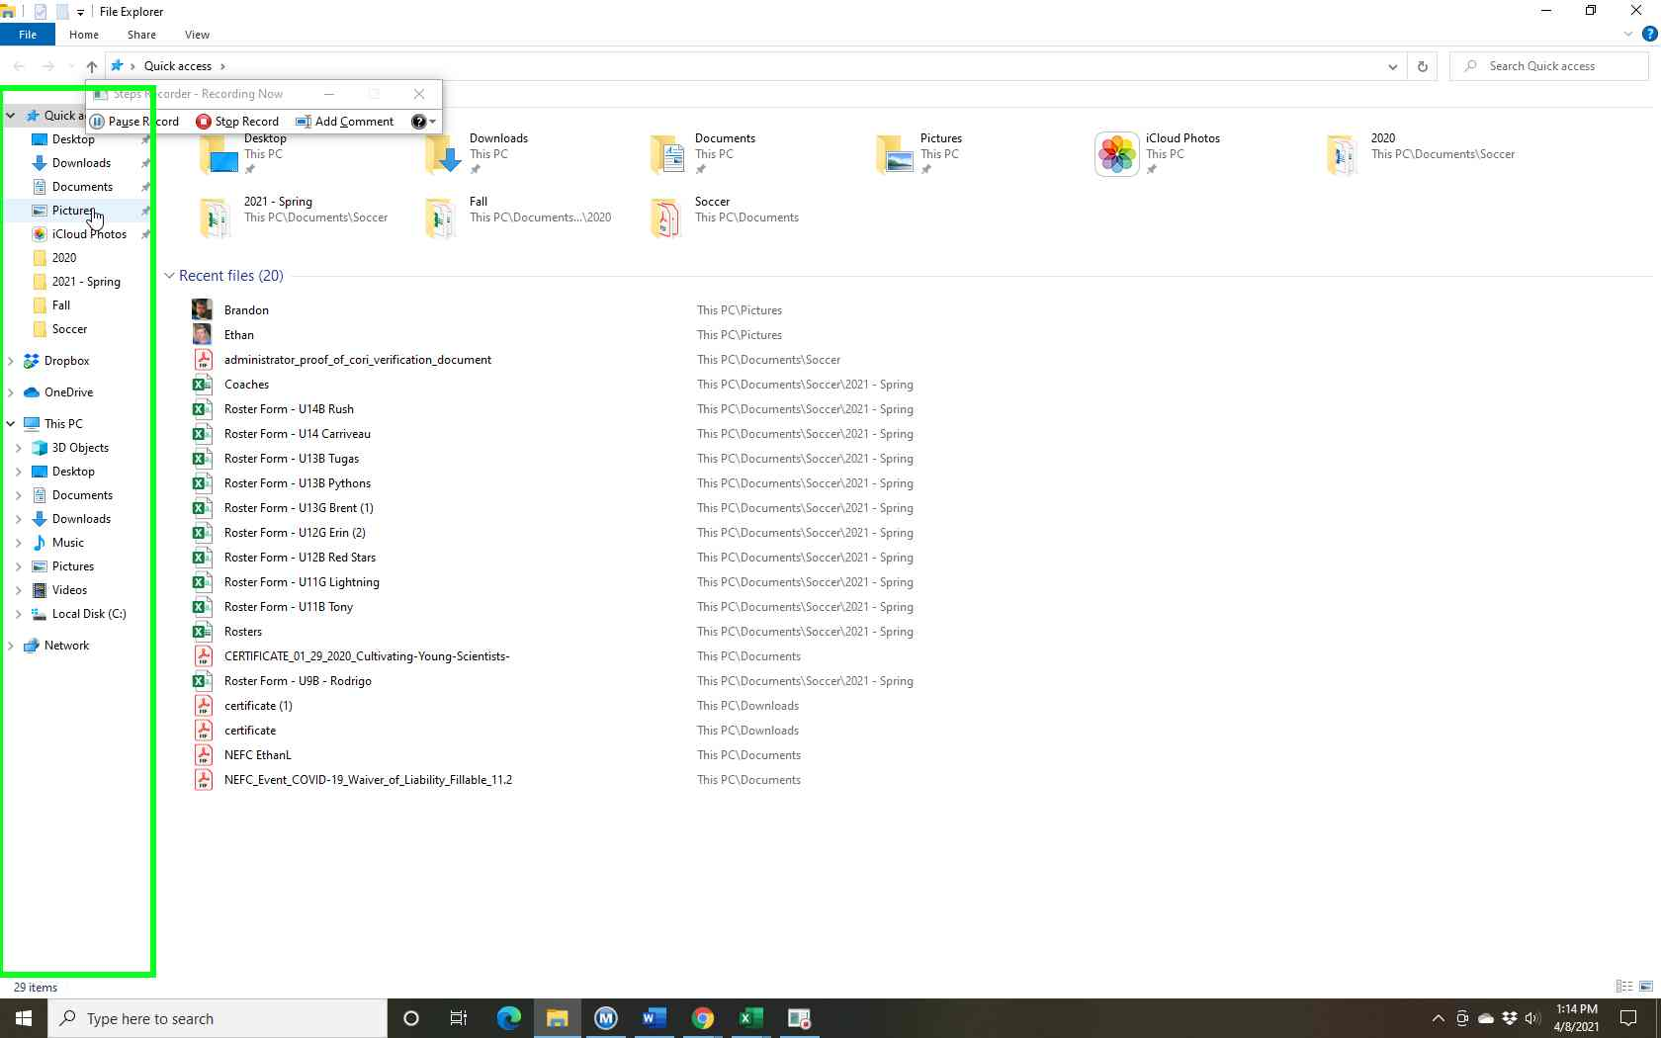Step 2 screenshot.

Previous Next
Step 3: (‎4/‎8/‎2021 1:14:33 PM) User right click on "Brandon (list item)" in "Pictures"

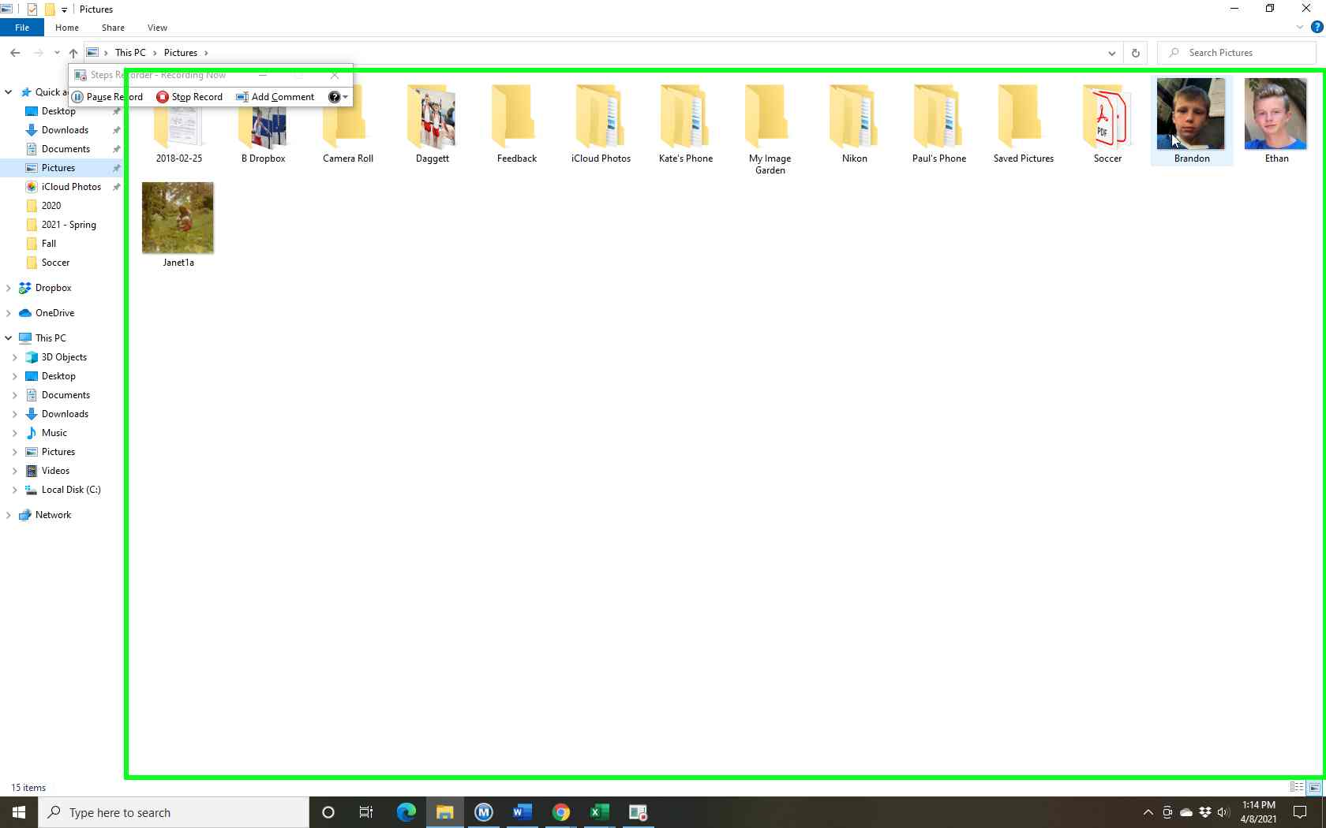Step 3 screenshot.

Previous Next
Step 4: (‎4/‎8/‎2021 1:14:35 PM) User left click on "Open with (menu item)"

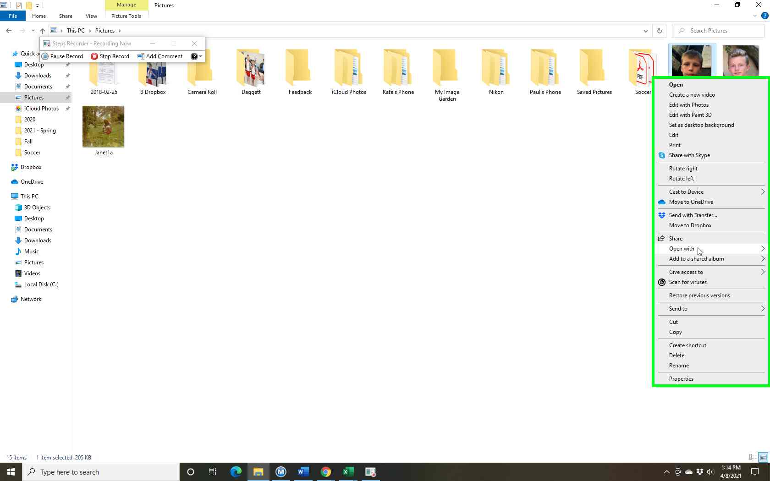Step 4 screenshot.

Previous Next

Step 5: (‎4/‎8/‎2021 1:14:37 PM) User left click on "Photos (menu item)"

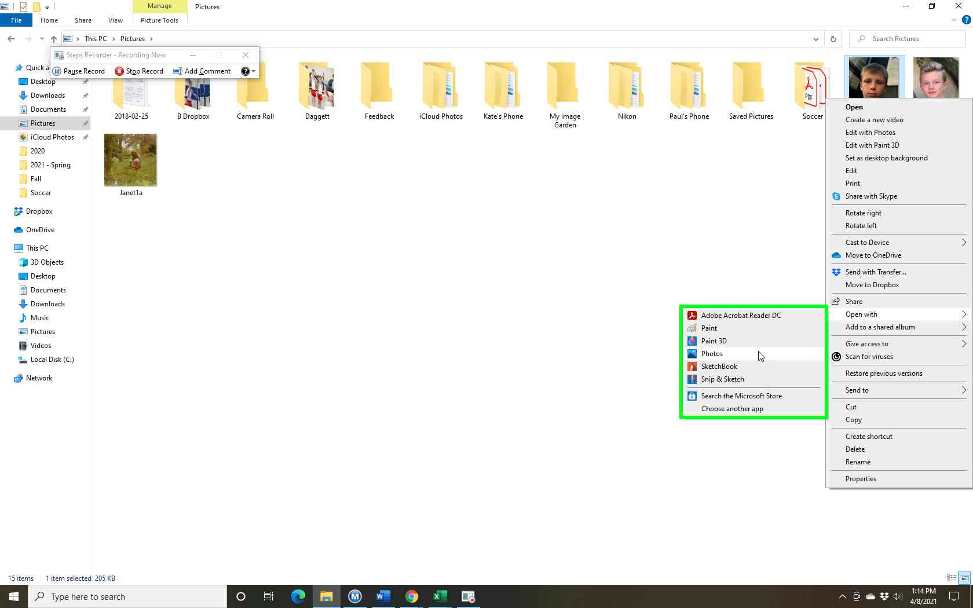Step 5 screenshot.

Previous Next
Step 6: (‎4/‎8/‎2021 1:14:40 PM) User left click on "More app bar (button)" in "Photos"

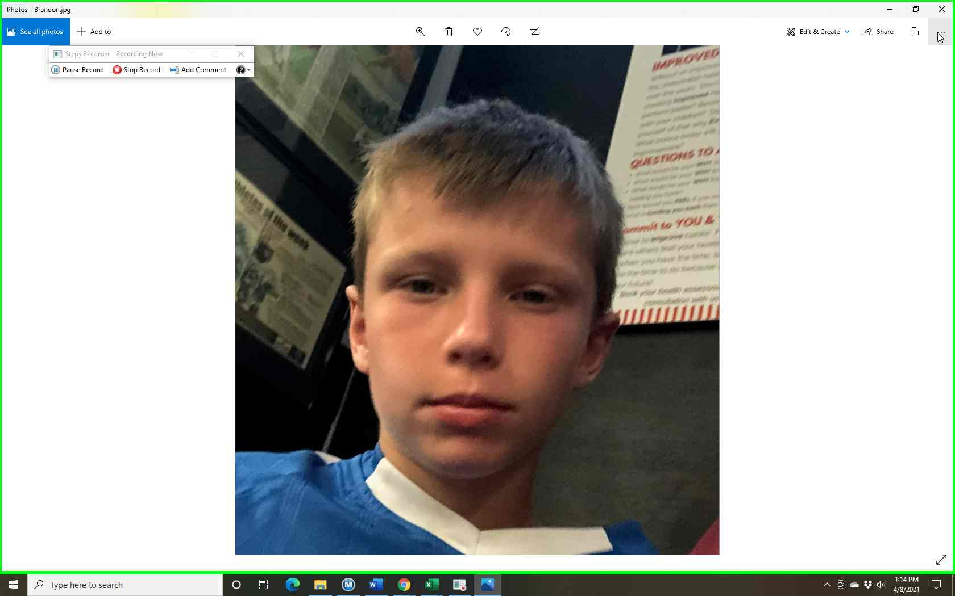Step 6 screenshot.

Previous Next
Step 7: (‎4/‎8/‎2021 1:14:44 PM) User left click on "Resize (app bar button)" in "PopupHost"
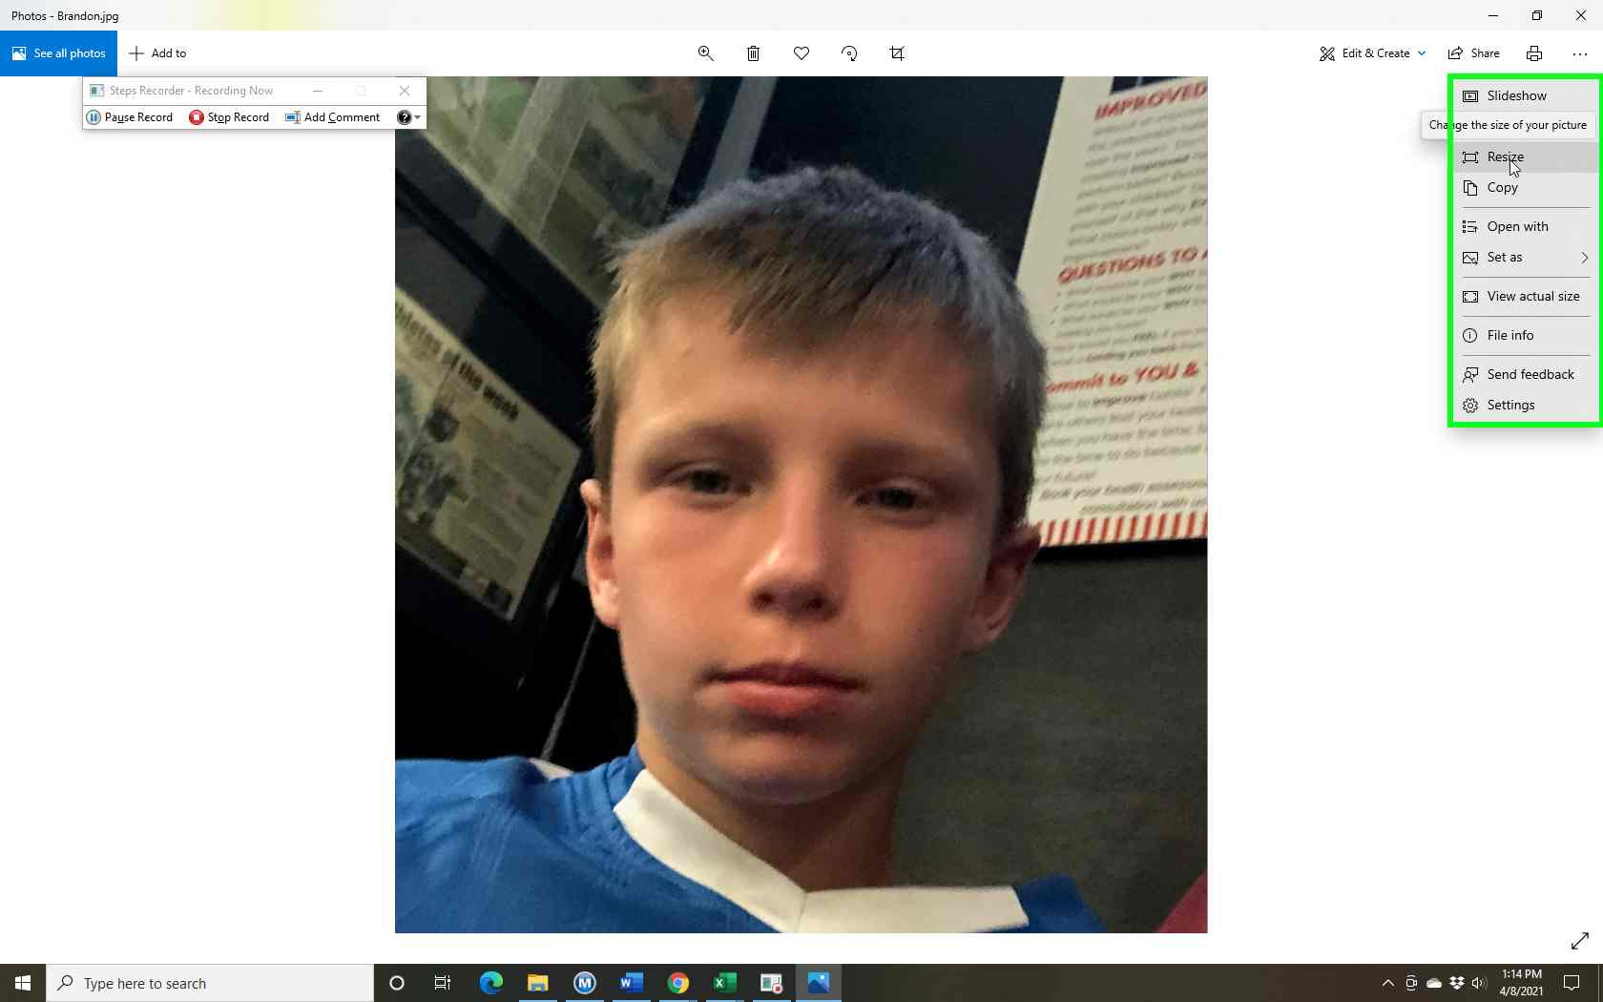Step 7 screenshot.

Previous Next

Step 8: (‎4/‎8/‎2021 1:14:47 PM) User left click on "Small file size. Best for profile pictures and thumbnails. 0.25 megapixels (button)" in "Photos"

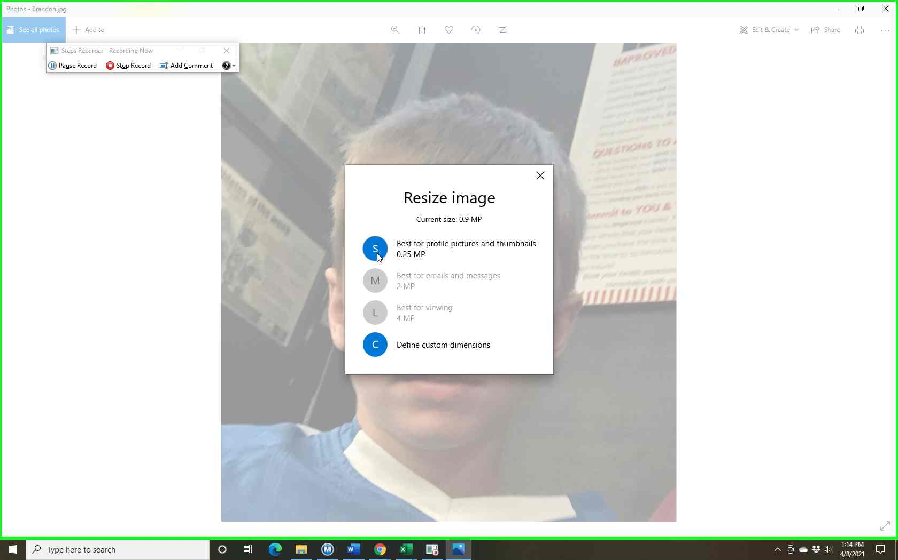Step 8 screenshot.

Previous Next
Step 9: (‎4/‎8/‎2021 1:14:51 PM) User left click on "File name: (edit)" in "Save As"

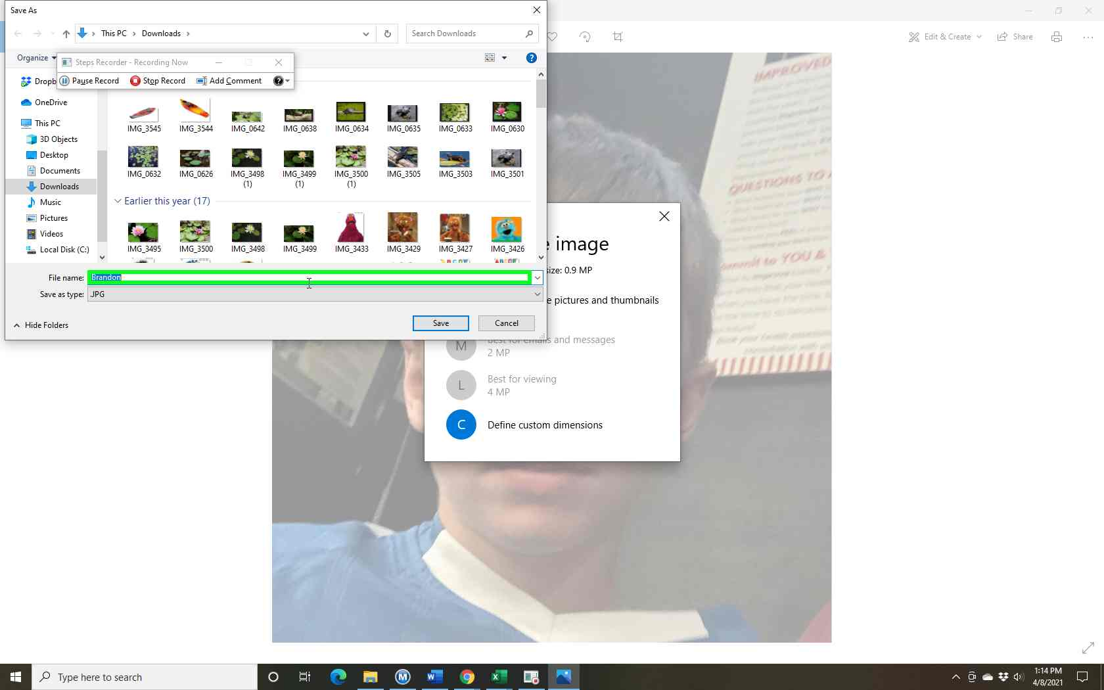Step 9 screenshot.

Previous Next
Step 10: (‎4/‎8/‎2021 1:14:52 PM) User keyboard input on "File name: (edit)" in "Save As" [...]

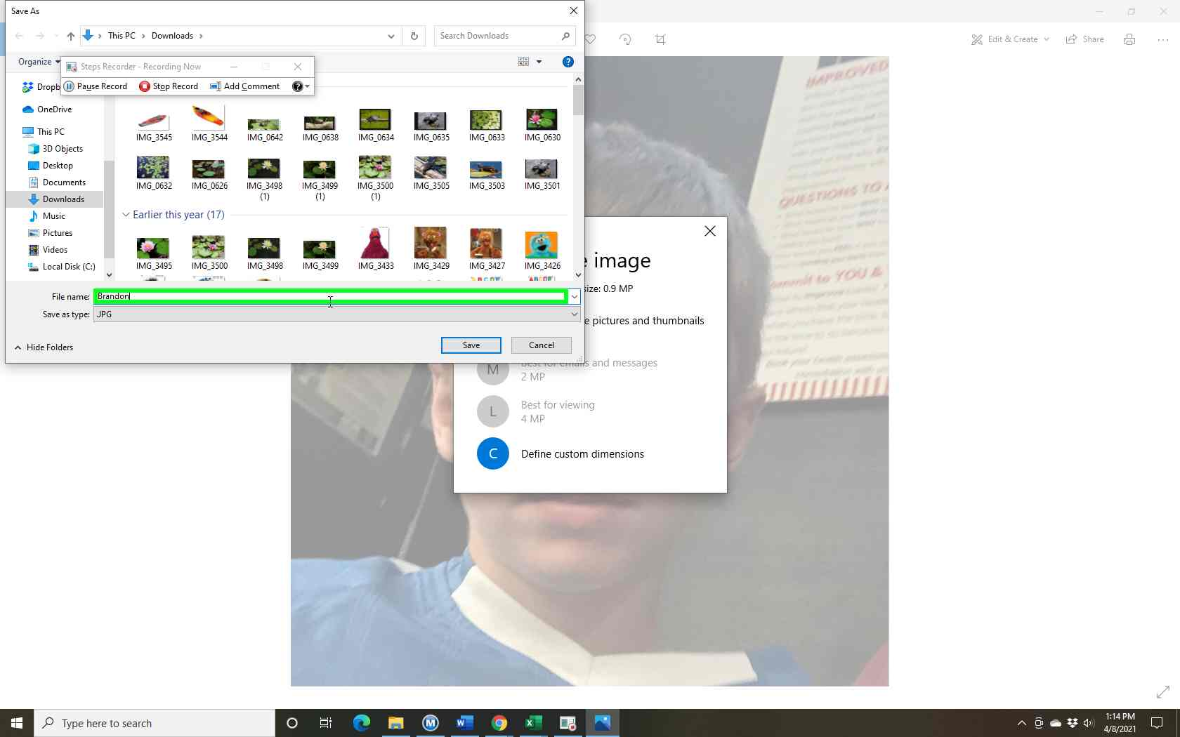Step 10 screenshot.

Previous Next

Step 11: (‎4/‎8/‎2021 1:14:56 PM) User left click on "Pictures (tree item)" in "Save As"
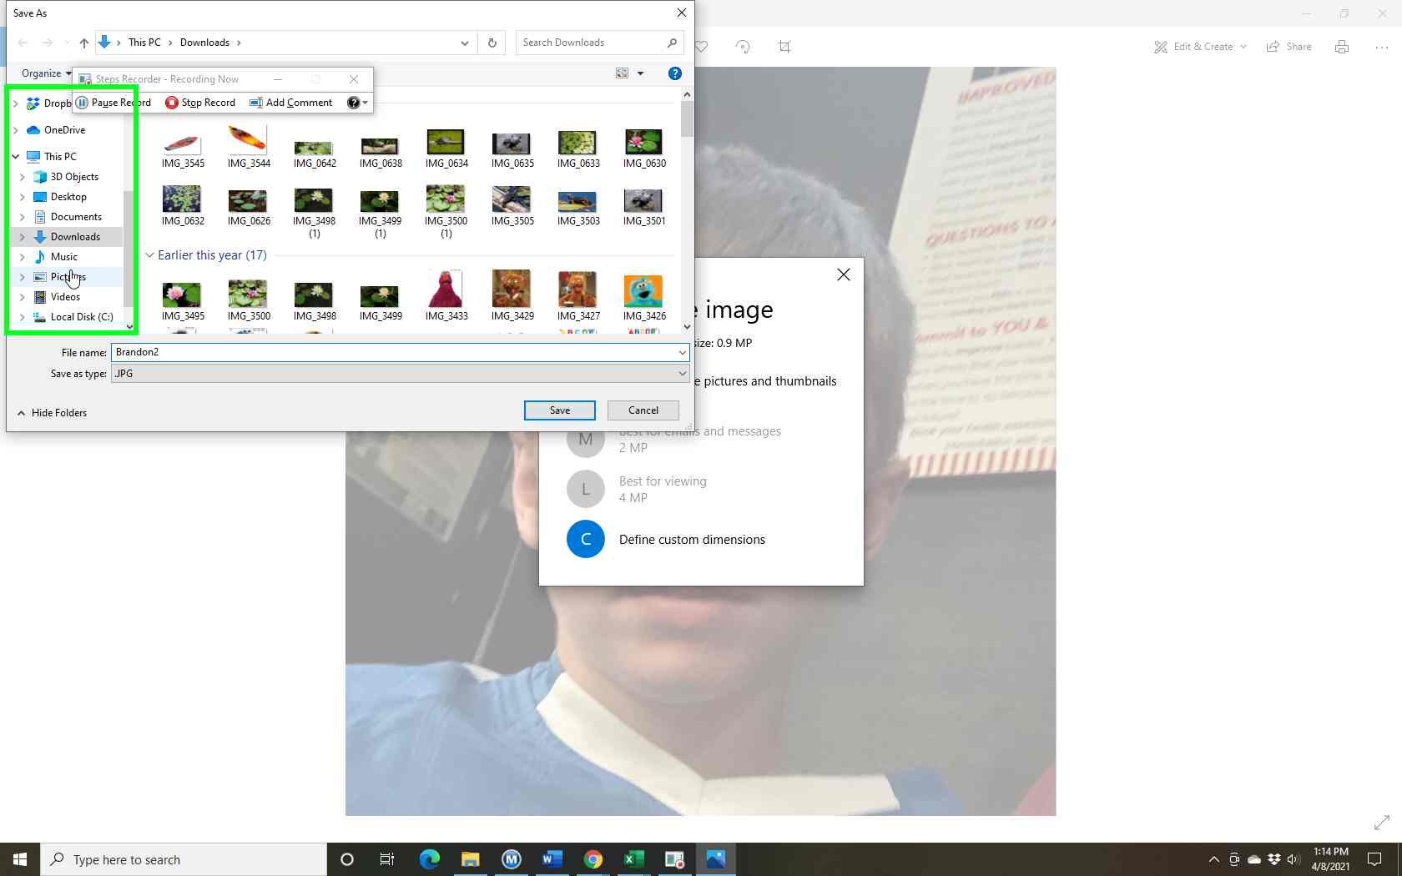Step 11 screenshot.

Previous Next
Step 12: (‎4/‎8/‎2021 1:14:59 PM) User left click on "Save (button)" in "Save As"
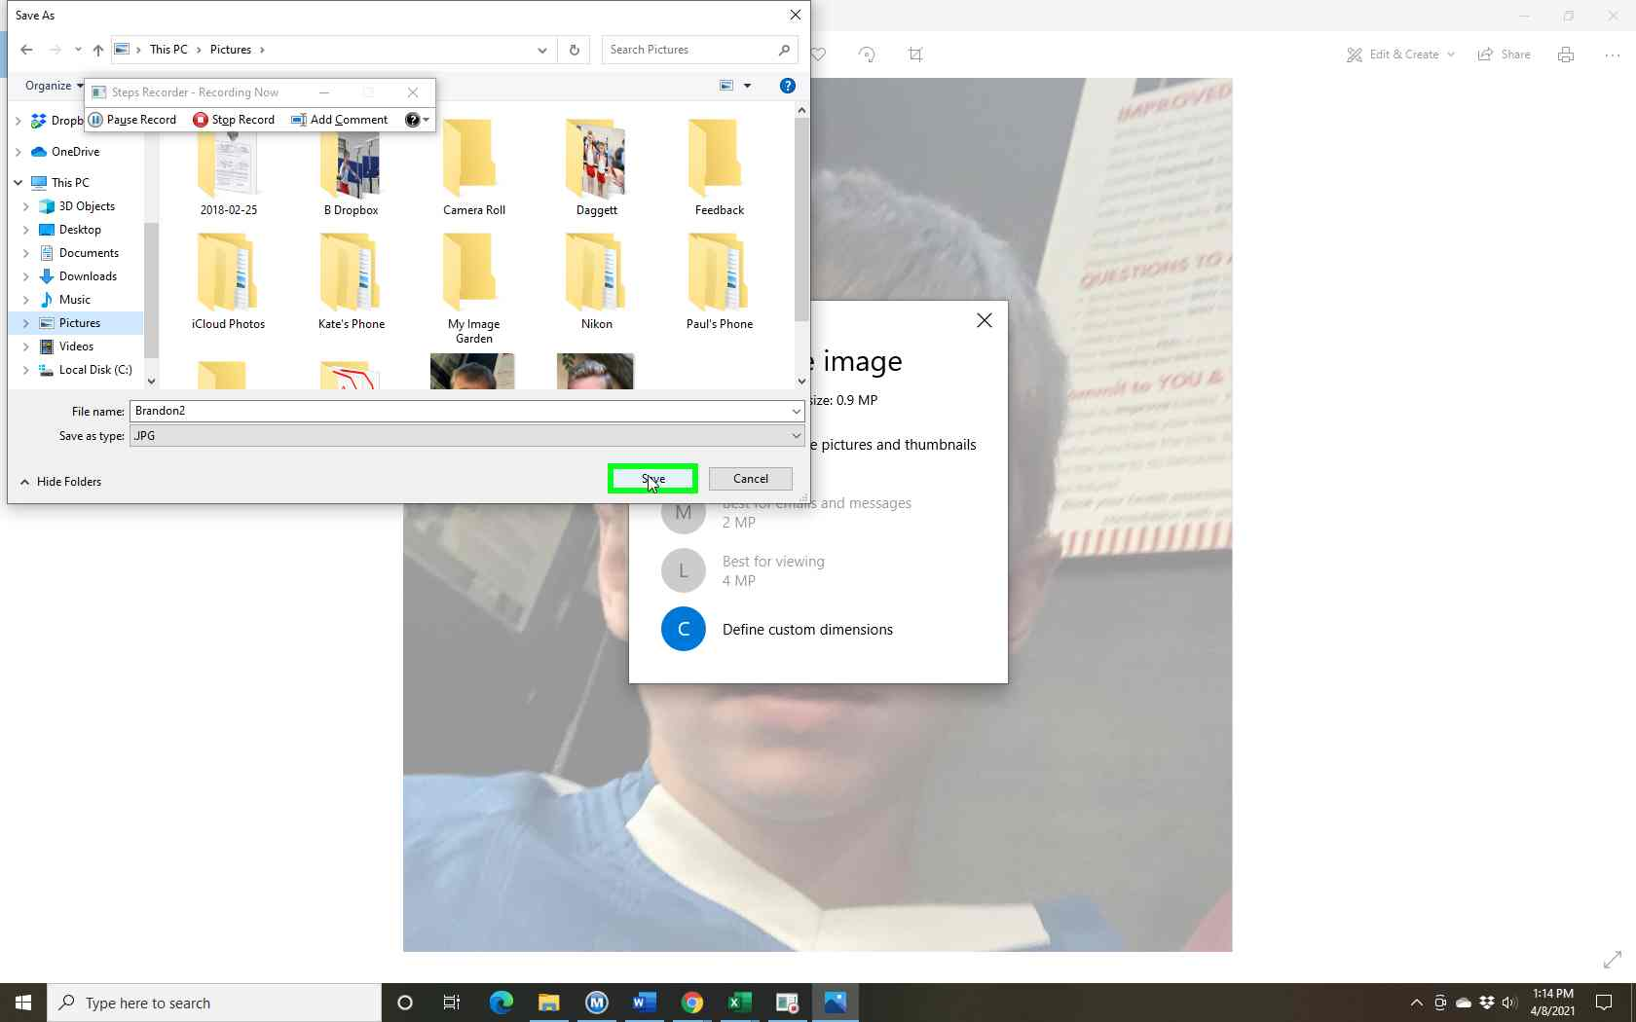Step 12 screenshot.

Previous Next
Step 13: (‎4/‎8/‎2021 1:15:03 PM) User left click on "Close Photos (button)" in "Photos"
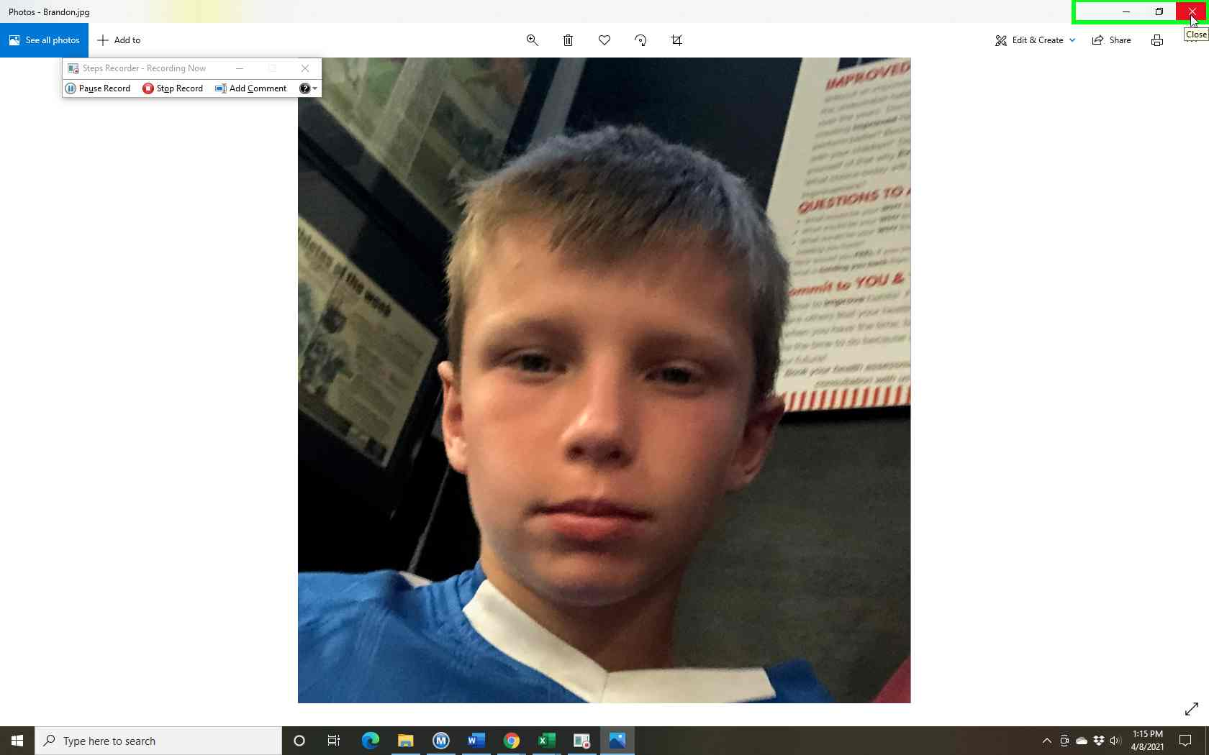Step 13 screenshot.

Previous Next
Step 14: (‎4/‎8/‎2021 1:15:09 PM) User left double click on "Brandon2 (list item)" in "Pictures"
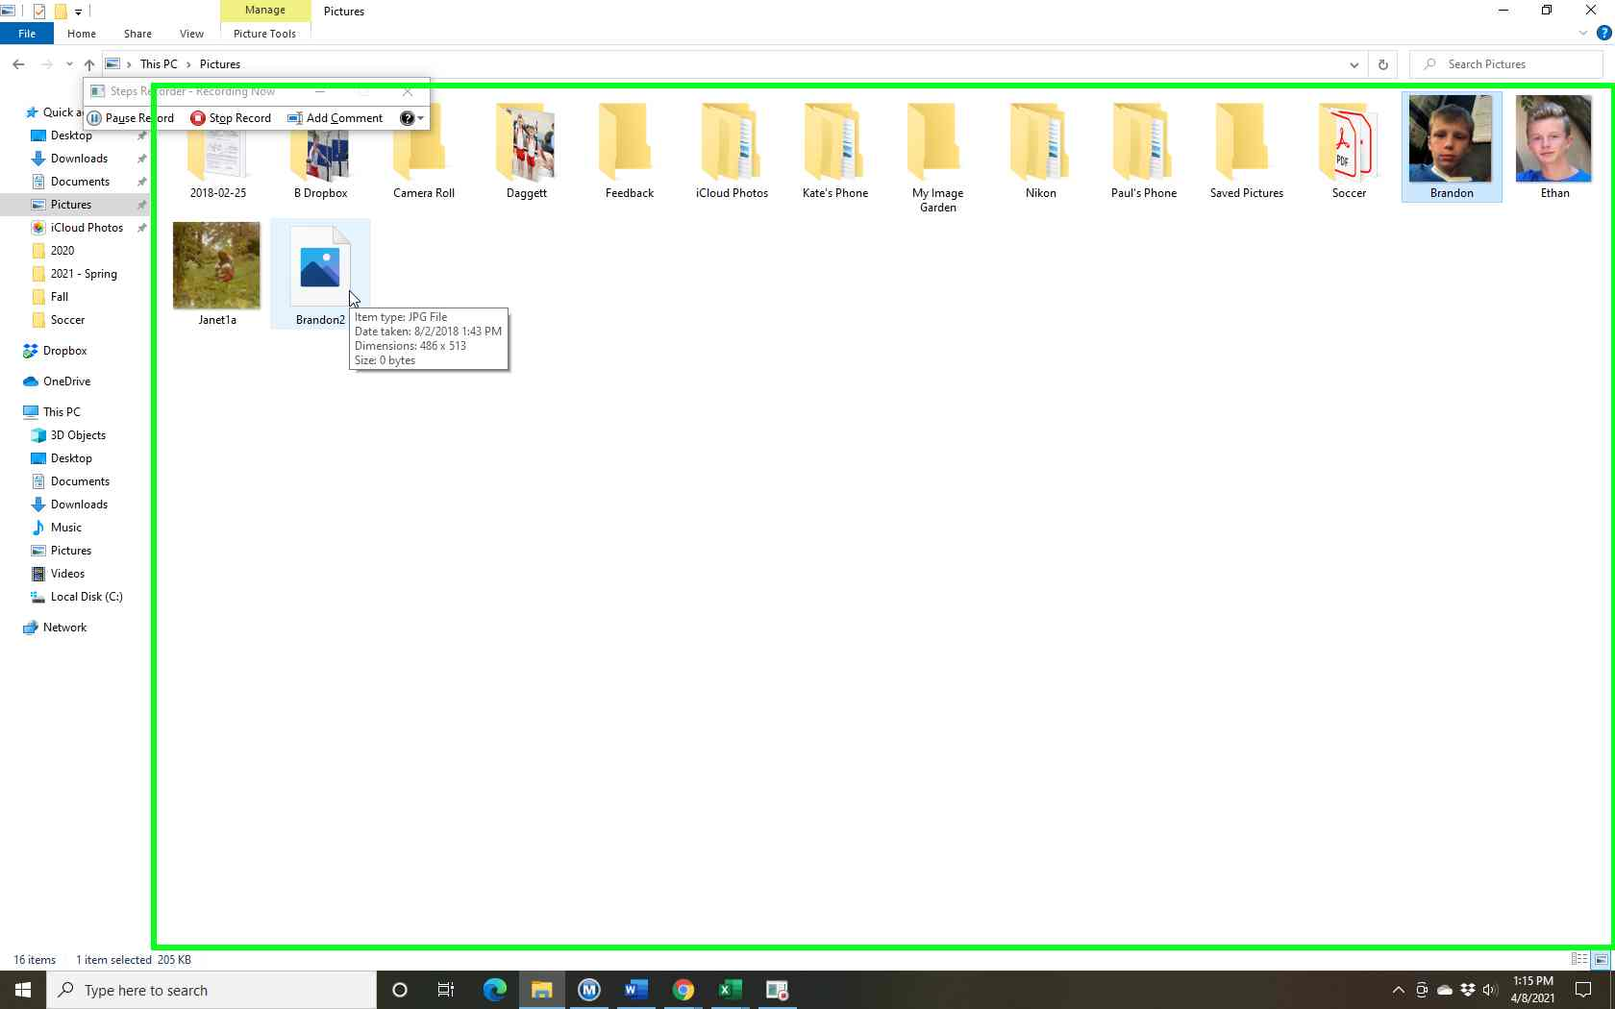Step 14 screenshot.

Previous Next
Step 15: (‎4/‎8/‎2021 1:15:12 PM) User left click on "Close Photos (button)" in "Photos"
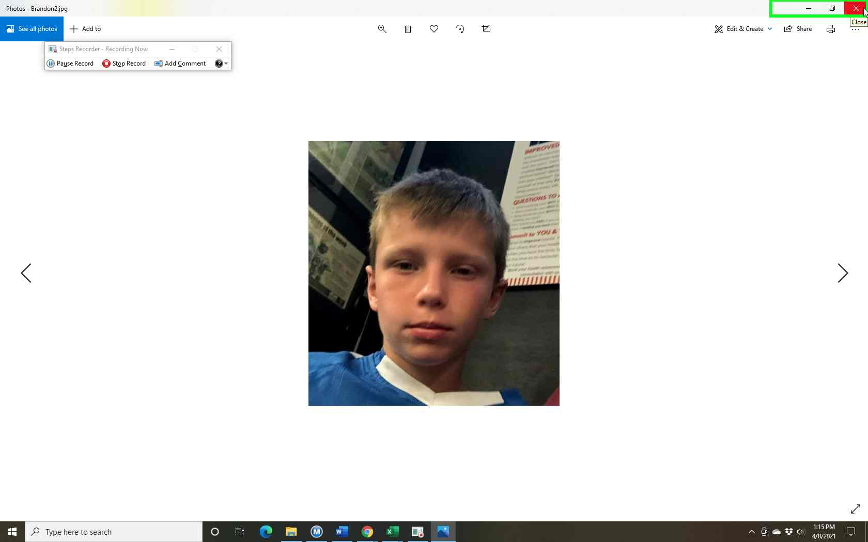Step 15 screenshot.

Return to top of page...

