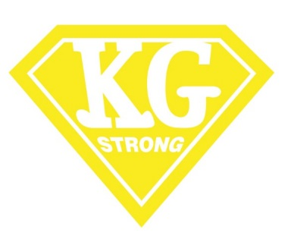
Dear Andover Girls Softball Community:

Our friend and Doherty Middle School eighth grader Kelly Graber has been a regular AGSL player since the 4th grade in 10U. During that time, Kelly has consistently been a fun-loving, supportive teammate and an excellent softball player. Kelly’s softball experience epitomizes all that the AGSL strives for… fundamental play, sportsmanship, team-spirit!!
Over the course of the past year or more, Kelly has been combatting what was once an undiagnosed and unexplainable life-threatening auto-immune illness that has significantly impacted her physically. Throughout this time, Kelly continues to fight and persevere. In most recent months, Kelly has received some optimistic news about her condition and treatment, and is making significant positive strides toward recovery.
As you can imagine, many ancillary efforts undertaken in Kelly’s ongoing battle have impacted the Graber family in many ways. Thankfully, the Phillips Academy, Town of Andover, Andover Soccer Association (ASA), Andover Travel Basketball and Andover Girls Softball League (AGSL) communities have all done their best to try to support the Graber family during this sensitive time.
This spring AGSL will do the following:
- Dedicate the 2016 AGSL Season to Kelly, in recognition of her strength and ongoing perseverance
- All AGSL uniforms will adorn a “KG Strong” patch for the upcoming spring and summer Middle Essex seasons
- The AGSL Board of Directors will contribute $1,000 to the Graber Family fund to assist the Graber’s with basic support in Kelly’s recovery
And, we encourage all of the AGSL community to join our efforts in support of the Graber’s through a request for a modest support for one of our own through the:

Graber Family Fund
c/o Kevin Graber
Philips Academy Andover
180 Main Street
Andover, MA 01810

Thank you all very much for your attention and support on behalf of the Graber’s and in sharing absolute best wishes to see Kelly back on the softball diamond just as soon as possible!!

Stay KG Strong!!

