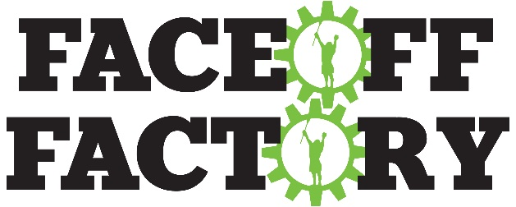

Summer Tour Training & Competition

It’s that time of year again. Our coaches are returning home from college and we are having our big events. This summer we have some awesome additions to our coaching staff. The three primary coaches are all Division I face-off specialists. Two of whom are ranked in the top 10 nationally. We are also adding additional coaches; specializing in wing play, face-off defense and shooting on the run. We look forward to having you join us for our Face-Off Factory Summer Tour. For those of you traveling this summer, we have also listed the additional events that we are holding across the country.

Tuesday, June 24th, 2014 – FO 60
9am-4pm
Youth/MS, rising 4th - 8th grade
(Players will have a one-hour lunch break from 12pm-1pm. Players are responsible to bring their own lunch.)
LOCATION:
Sport Center 481
6841 Collamer Road
East Syracuse, NY 13057

Register at: http://www.adrln.com/events/face-off-factory-summer-tour-syracuse-ny/

Wednesday, June 25th, 2014 - FO 101
9am-4pm
Rising 8th - 12th Grade
(Players will have a one-hour lunch break from 12pm-1pm. Players are responsible to bring their own lunch.)
LOCATION:
Sport Center 481
6841 Collamer Road
East Syracuse, NY 13057

These events are very different from the previous training/combines. We are increasing the number of coaches so we can focus on greater detail on all aspects of the face-off position. We will be placing players in small groups by age and ability. The groups will run through multiple stations focusing on different aspects of the face-off position. The days will end with a one on one knock out style competition to declare a FOF winner. Top performers will be awarded prizes.

Register at: http://www.adrln.com/events/face-off-factory-summer-tour-syracuse-ny/

Thursday, June 26th, 2014 - FO 201 (Prerequisite: FO 101 or coaches’ recommendation)
9am-4pm
Rising 7th through 12th grade
(Players will have a one-hour lunch break from 12pm-1pm. Players are responsible to bring their own lunch.)
LOCATION:
Sport Center 481
6841 Collamer Road
East Syracuse, NY 13057

*Limited to a specific number of players. Players need to have a strong knowledge of the basics and previously completed FO 101 or submit a coach’s recommendation for approval. Players will be filmed and evaluated at the beginning of the day and put into groups based on skill level. These groups will work together through stations to ensure the right level of instruction and supervision. The day will focus on building the complete quarterback at the “X” – shooting, fast breaks, early offense, defense, and substitutions. The event will end with a one on one knock out style competition to declare a FOF winner. Top performers will be awarded prizes.

Register at: http://www.adrln.com/events/face-off-factory-summer-tour-syracuse-ny/

This summer we have partnered up with some of the top Lacrosse recruiting tournaments in the country.

- Father’s Day Wounded Warrior in FL
- MVP3 in Delaware
- Philly Invitational Showcase in PA
- Champ Camp in Baltimore, MD

These tournament partners have agreed to allow us to post the results of our nationwide events into all of the attending College recruiters’ packets.

All top performers at all of the Face-Off Factory challenges nationwide will have the opportunity to be inserted into the College recruiters’ packets, regardless of whether they attend that specific tournament or not.

If you have any questions, please email or contact me at (310)704-8467.

Bryan Burkhart
FACE-OFF FACTORY
Email: info@face-offfactory.com
Website: www.face-offfactory.com
Like us on Facebook: https://www.facebook.com/TheFaceOffFactory
Follow us on twitter: @FaceoffFactory

Other Face-Off Factory Summer Events:

May 31 – June 1 Orange County, CA
June 5-6 Wellington, FL
June 12 – 13 Palm Coast, FL
June 16 Dallas, TX
June 18 Austin, TX
June 20 Houston, TX
June 24 – 26 Syracuse, NY
June 27 Delaware at University of Delaware
July 8 Park Ridge, NJ
July 10 – 11 Philadelphia, PA
July 14 – 16 Baltimore, MD at Loyola and Towson Universities
July 17 – 18 Chicago, IL
July 25 Bend, OR
July 31 – Aug 1 San Jose, CA

