Billerica Youth Soccer Association
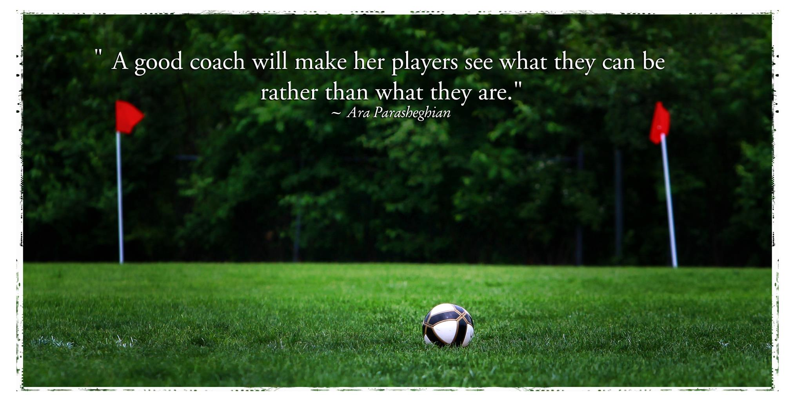
Coaching Handbook

Intramural Programs U6, U8, U11, and U14
Spring 2019

Table of Contents

Section 1 - Introduction

Introduction and Mission Statement
Zero Tolerance Policy
Copy of the Coaches Code of Conduct
Important Contacts

Section 2 – BYSA Intramural Rules

U8 Rules
U11 Rules
U14 Rules

Section 3 - MYSA Curricula

Player Characteristics
Player Fundamentals and Skills

Section 4 - General all ages information

Risk and Injury: Management and Prevention
Systems of Play
Guided Discovery
Online References
Section 1: Introduction

Welcome to Billerica Youth Soccer! This Coaching Handbook has been developed to provide some basic information for new and experienced coaches, outline the expectations for conduct that coaches are responsible for, and provide age appropriate rules, development goals, and practice plans to use when planning for a practice or game.

A lot of the content in this Handbook has come from the work of previous BYSA board members, and from the online resources provided by the Massachusetts Youth Soccer Association (MYSA). We are very grateful to those people and organizations for their support.

Billerica Youth Soccer Association Mission Statement

BYSA's purpose is to develop and deliver superior soccer programs, for the youth of Billerica that help to develop sportsmanship, fitness, confidence, and team spirit amongst our young athletes. BYSA seeks to provide soccer training that is fun, supportive of all skill levels, and is inclusive in its orientation.

Zero Tolerance Policy
Conduct of the Game
Players, coaches, and spectators are expected to conduct themselves within the letter and the SPIRIT of the law. We expect all players, coaches, and spectators to uphold the spirit of ZERO TOLERANCE policies. Displays of TEMPER or DISSENT by word or action against opponents or referees are cause for ejection from the match and/or premises and/or further disciplinary action by the BYSA board of directors.
The Head Coach of each team is responsible for his or her own conduct and behavior and for the conduct and behavior of his or her players and team spectators. Coaches should inform their spectators of the rules (i.e.: behavior, spectator areas, etc.). Each coach is expected to monitor his or her spectators and take corrective action if necessary. Each coach is expected to support the referee and other coaches if action against a spectator is required.
Protests
No protests will be heard on any judgment calls by the referee. If a coach has an issue with the referee, they must address it with him/her calmly and patiently after the game. Yelling at the referee will not be tolerated at any time. The referee is correct 100% of the time.
If a coach has a major complaint or if he/she thinks the referee was unfair, biased, unfit, or incompetent, the coach must report it in writing to the BYSA Intramural Director. Concerns will be taken seriously if they are presented objectively and formally.

BYSA Coaches Code of Conduct

I as a coach hereby agree to follow the BYSA and the MYSA guidelines for a Code of Conduct.

- Referees are to be treated with respect.

- I will display good sportsmanship and fair play at all times. I will teach my players to win graciously and lose graciously.

- The emotional and physical well-being of my players will be placed ahead of my personal desire to win.

- I will remember that this game is for the children and not the adults.

- I will make myself knowledgeable in the game of soccer for the level that I coach.

- Practices will be run so that they are enjoyable and challenging.

- It is imperative to explain to parents and players acceptable behavior, at practices and games, in a preseason meeting.

- I will check the playing field before practices and games for reasons of safety.

- I will make a reasonable attempt to play each player 50% of the time during a game.

- I will bring any suggestions or comments to my coordinator.

Coaches who do not follow the expectations described above will be disciplined or removed.

Important Contacts

Ricci DeRosa, President
Kevin Williams, Registrar and Webmaster
Cathy Giordano, Instructional Director (U4, U5, U6)
Tristan Brawn, Intramural Director (U8, U11, U14)
Bob Kinsella, Coaching Director
Renato Camelio, Player Development Director
Shelly Brawn, Intramural Fields Coordinator
Felix Trinidad, Referee Assignor

Please visit the BYSA website for up to date contact information at:
https://www.billericasoccer.org/board-members

Section 2: BYSA Intramural Rules

These rules have been set forth as a guide to help coaches understand how the rules are modified for each age group, specifically for Intramural BYSA Soccer. They are not a complete list of the Rules of the Game. Refer to the US Youth Soccer website for more complete rules, at: https://www.usyouthsoccer.org/referees/rules-of-the-game/

Common Rules for All Age Groups
- No jewelry (earrings, necklaces, bracelets…), metal or plastic hair clips are allowed on the playing field.
- Common color jerseys or a similar shirt must be worn by players of each team
- The goalie must wear a shirt or pinnie which is clearly distinct from the colors of each team.

U8
- Format is 6v6 (5 field players and a goalie on each side). If limited players are available, this can be adjusted by agreement between coaches before the game starts.
- Size #3 ball.
- Games are two 25 minutes halves. Teams change ends at halftime.
- Score is not kept. Players at this age will keep track on their own, so remind them to focus on the progress of the team working together. Winning the game is not the priority.
- Coaches or assistants must serve as referees. Switch with the opposing team at halftime, if both teams have an assistant.
- No direct free kicks, including penalty kicks. All penalties result in a free indirect kick (ball must touch another player before going into the goal). If an infraction occurred within the penalty area, the ball should be placed on the penalty line and an indirect free kick awarded.
- Slide Tackling is not allowed. No sliding at all. Remind players to stay on their feet.
- Heading the ball is not allowed. Aerial balls should be rare at this age, but players should begin to learn controlling the ball with the chest and knees.
- Throw-ins: both feet must remain on the ground while the ball is thrown with both hands over their head. U8 players are always allowed a second attempt if they violate the first one.
- Goal kicks: the ball is placed halfway between the penalty line and goal line, and a free indirect kick is taken by the goalie or a defender. The opposing team must back up to their half until the ball is received by a defender.
- After the Goalie collects the ball with his/her hands, upon return the ball to the field, it may not cross the center line in the air.
- Corner kicks follow standard rules, an indirect free kick from the arc in the corner.

U11
- Format is 7v7 (6 field players and a goalie on each side).
- Size #4 ball.
- Games are two 25 minutes halves. Teams change ends at halftime.
- Score shall be kept by the referee. Winning the game is still not the priority.
- Referees will be assigned to each game.
- No direct free kicks, including penalty kicks. All penalties result in a free indirect kick (ball must touch another player before going into the goal). If an infraction occurred within the penalty area, the ball should be placed on the penalty line and an indirect free kick awarded.
- Slide Tackling is not allowed. No sliding at all. Remind players to stay on their feet.
- Heading the ball is not allowed. Players should practice controlling aerial balls. Juggling practice is fun way to get comfortable with the ball in the air.
- Throw-ins: both feet must remain on the ground while the ball is thrown with both hands over their head. U8 players are always allowed a second attempt if they violate the first one.
- Goal kicks: the ball is placed halfway between the penalty line and goal line, and a free indirect kick is taken by the goalie or a defender. The opposing team must back up to their half until the ball is received by a defender.
- After the Goalie collects the ball with his/her hands, upon return the ball to the field, it may not cross the center line in the air.
- Corner kicks follow standard rules, an indirect free kick from the arc in the corner.

U14

Due to low registration in U14 this season, we are experimenting with a Round Robin style tournament on game days. Rules are provided for the Round Robin format and for a standard U14 game.

U14 Round Robin

- Format is based on number of players available for the day. Players should be divided randomly or by the coach into 4 equal groups. Try to structure teams so that no substitutions are needed, even if number of players is imbalanced. This can be intentional to create an additional challenge for stronger players, or support the younger players. 4v4 or 5v5 is a good fit for the players and the field.
- Games are 20 minutes. 3 consecutive games are played so that every team plays each of the other 3. At least one brief water break should be taken by both teams during a stop in play.
- Allow players to work together to communicate and manage their team, as much as possible.
- 1-2 coaches should serve as referees for each match.
- No direct free kicks, including penalty kicks. All penalties result in a free indirect kick (ball must touch another player before going into the goal). If an infraction occurred within the penalty area, the ball should be placed on the penalty line and an indirect free kick awarded.

U14 Standard

- Format is 11v11 (10 field players and a goalie on each side).
- Size #5 ball.
- Games are two 35 minutes halves. Teams change ends at halftime.
- Score shall be kept by the referee. If the score is tied at the end of regulation, there will be two 10 minute overtime periods.
- Referees will be assigned to each game.
- Direct free kicks, indirect free kicks, slide tackling, and heading are all allowed. Heading the ball should still be discouraged at this age. It is typically not well controlled off the head, and the risk of injury is too great.
Section 3: MYSA Curricula

Player Characteristics (MYSA)

In order to make practices run smoothly and be fun, it is important for us to have a basic understanding of the intellectual, emotional and physical developmental stage of the players we are coaching. Here are some typical characteristics of players at each age group:

U6

Focused on themselves – reality to them is based on what they see and feel
Unable to see the world from another’s perspective
Everything is in the here and now
Cooling systems are less efficient - need frequent water breaks
Enjoy playing, not watching. Every player should have a ball in practice
Limited attention span - keep directions concise and to the point
Effort is performance – if they try hard, they are doing well
Active imaginations – utilize their imagination in activities, and they will love practice!
Look for adult approval – be encouraging when they say “Coach, look what I can do!”
Unable to think abstractly – spatial relationships are a mystery
Typically have 2 speeds -- extremely fast and stopped
Usually unaware of game scores – keep it that way

U8

Enjoy playing in pairs – help the players find new and appropriate partners
Are now able to take another’s perspective.
Still unable to think abstractly – be patient.
Cooling system still less efficient than adults – still make sure to give frequent water breaks.
Still prefer playing to watching – keep everyone active during practice.
Limited attention span
Have an understanding of time and sequence – “if I do this, then that happens”.
Some now have a third or fourth speed in addition to stopped and as fast as possible.
Very aware of adult reactions – be very aware of your reactions.
Seek out adult approval and need reassurance – be supportive.
Begin to become aware of peer perception – a social order is beginning to develop.
Wide range of abilities between children at this age
Beginning to develop motor memories
Some become more competitive
Less active imaginations than U6 players

U10

Attention span lengthens and they start to show the ability to sequence thoughts and actions.
Players start to think ahead and think “If this, then that”
Players are more inclined towards wanting to play soccer rather than being told to play
Demonstrate increased self-responsibility
Players start to recognize fundamental tactical concepts
Begin to become aware of peer pressure.
Players affiliate with their team or their coach
There is a wide continuum of maturity evident on most teams.
U10 is still a crucial age for technical skill development.

U12

All children are maturing at different rates and are sensitive to that fact.
Need to warm-up and stretch as muscle pulls and other nagging injuries tend to become more common.
Typically understand elemental abstract concepts and hypothetical situations.
They like to solve problems.
Peer evaluation is a constant.
Egos are sensitive.
Coordination may depend on whether or not they are in a growth spurt.
Technique still needs to be reinforced constantly.
Playing too much can lead to overuse injuries.
Playing too much and not feeling like they have a choice in the matter can lead to burnout and drop-out.
This is the dawn of tactics!
Keep asking the players to be creative and to take risks.
Ask for feedback from them. They will tell you how things are going.
Try to hand over leadership and ownership of the team to them. They will enjoy leading and it will add to the learning environment.

U14

Players are developing a broad understanding of the game.
Proper physical conditioning and preparation are even more critical, during the off season and around sessions.
Physical size of the players begins to become a limiting factor for speed, endurance, and risk of injury.
Practice sessions should move further into tactical and technical elements of the game.
Players should be given more opportunities to take on leadership roles and responsibilities within the team, and learn to follow the guidance of a more experienced captain as well as a coach.

Player Fundamentals and Skills (MYSA)

These basic skills should be the focus of player development at each age group. Although they may come at different times for different players, these fundamentals will be critical to the player effectively competing at their level.

U8

Dribble with all sides of both feet
Dribble out of trouble
Dribble past someone
Shielding
Soft first touch
Introduce proper shooting technique
Introduce passing

U10

Skill Priorities
Continue with dribbling focus from U8
Passing with inside and outside of both feet
Shooting with both feet---using laces
Receiving the ball with all parts of body

Tactical Priorities
Basic Attacking Ideas
Basic Defending Ideas
Comprehend 1 vs 1 concepts
Comprehend 2 vs 1 concepts
Introduction to 2 vs 2 concepts
Comprehend roles of 1st and 2nd defenders
Comprehend roles of 1st and 2nd attackers

U12

Skill Priorities
Continue with all U-10 skills
Speed Dribbling in Traffic
Ability to chip the ball
Accurately play long passes
Power/Accuracy Shooting

Tactical Priorities
Communication
Basic Support Positions
Receiving the Ball Away from Pressure
Combination Play
How and when to switch the point of attack
Pressure vs Containing
Proper 2 vs 2 roles
Introduction to all roles in 3 vs 3

U14

Adult standards and formal rules become applicable. The pace of development quickens at this time due to the acceleration of physical and mental maturation. The demands of skill training as well as training loads should increase thus provoking improvement in mental toughness, concentration and diligence. Awareness of tactics within the game becomes an important facet of the learning process. Players tend to be self-critical, rebellious but have a strong commitment to the team.

Skill Priorities
Build on the base
Development of individual skills under the pressure of time, space, and an opponent
Increase technical speed
Dribbling: Encourage to take players on 1v1; Feints/moves; Keep possession with shielding/spin turns
Receiving: Quality first touch; take balls out of the air/turning = All surfaces, on the run
Shooting: On the run; On the turn; From all angles/crosses, volleys
Passing: Short, long, bent, crosses, driven, chipped = All surfaces, ALL on the run
Heading: To goal (shoot/glance), to pass, to clear
Tackling: Proper technique, slide

Tactical Priorities
Increase Tactical Speed (Decision making)
Individual = 1v1
Attacking: Keep possession; Encourage risk taking = taking players on in the proper areas of the field
Defending: Proper pressure (in front and behind); Channel player; immediate chase, angles of pressure
Small Group = 2v1, 2v2, 3v2, 3v3, 4v2, 4v4
Attacking: Keep possession= Support; Combination play= wall pass, take-over, overlap, double pass
Width, depth, penetration; Crossing with proper runs in the box; Simple set plays

Physical Priorities
All fitness work with the ball
Flexibility: Static Stretching and Dynamic Flexibility
Agility: Coordination on the ball
Speed
Strength: Especially core strength and stability
Endurance
Balance/Proprioception

Psychological Priorities
The game should remain fun and enjoyable. Players should have a passion for the game.
Imagination/creativity
Increase demands.
Establish training targets
Maintain discipline.
Encourage to watch high level soccer.

Section 4: General Information

Risk and Injury: Management and Prevention

An integral component of all coaching and playing activity throughout the season must be the prevention and management of injury to players (and coaches). There are numerous simple tasks a coach can and should do in order to secure the health of his
or her players. Before the season begins, the coach should make sure all parents know the emergency procedures for all situations (injuries, accidents, weather problems). This procedure should be clear and simple. If it includes cell phone use, the coach should make sure he/she gets reception at all playing sites.

Field Safety/Weather Conditions

Before starting practice or a game, it is important to check the field for dangerous objects. Often glass and other sharp objects can be found on fields, as well as holes and other hazards. Goals need to be inspected and anchored properly, or moved away from the playing area if not being used. When moving goals, it is important to utilize adults and to supervise them, as often it is the first time they are moving goals. They may not know how to move them or realize how heavy they are.

At every field, look to see where you could go in case of lightning or heavy rain. Is there a building or public bathroom nearby where you could fit all the children? If not, do enough parents stay to watch practices and games in order that all the children could fit in their cars in case of severe weather? At the first sign of lightning, get the players into a safe environment. This is where your written emergency plan comes into use.
Lightning detectors are already in use at many of the parks in which you play. Make sure you know the meaning of all signals coming from this system. If you do not have a lightning detection system, seek out ways to get one installed.

Seeing all the Children

Players cannot be let out of your sight. Often times, young players need to go to the bathroom. Make sure they are supervised when they go (preferably by their parent). Never allow a child out of your sight without adult supervision.

Second Adult Present

Always have a minimum of two adults at every practice. This allows one person to care for injuries or bathroom breaks as the other tends to the rest of the team. It also
provides for another witness in the case of injury or accident. Make sure that both of you are present until the parents of the last child arrive. You should stress to parents they should arrive on time to pick up their children.

Injury Prevention for Common Injuries

Heat Stroke - If a player shows signs of heat stroke their sweating will stop, the player may be confused or dizzy, have pale skin, an extremely dry mouth or be unconscious. It is important to call an ambulance immediately. This can be life threatening. While
waiting for the ambulance, similar steps to that which are taken for heat exhaustion should be followed. Making sure your players are properly hydrated will help prevent heat injuries.

Fractures & Dislocations - If a body part does not have a normal appearance or function, then suspect a fracture. Do not move the player, keep warm and make comfortable, call 911. With a possible dislocation, the joint will have a marked deformity with intense pain. If a player can walk, immobilize the joint and immediately transport to hospital. If the player is unable to walk, call 911.

Abrasions - Abrasions are very common sports injuries that are usually caused by a fall on a hard surface. As the athlete falls or slides on the ground, friction causes layers of skin to rub off. General treatment of abrasions includes treating the area by cleaning the wound with mild soap and water or a mild antiseptic wash like hydrogen peroxide, and then covering the area with an antibiotic ointment and a dry dressing. Be sure to wear latex gloves before you treat the player!

Sprains, Strains and Contusions - R.l.C.E. Principle (Rest, Ice, Compression, and Elevation) is the best method of dealing with these injuries. Using these four immediate first aid measures can relieve pain, limit swelling and protect the injured tissues.

The RICE Method of Acute Injury Treatment:

o Rest: Resting is important as it will allow the injured area the time to heal itself as · well as help prevent further injury.

- Ice: Use ice bags & cold packs to limit swelling by reducing blood flow to the injured area. Do not leave ice on an injury for more than 20 minutes at a time. Compress or wrap the area with an ACE bandage around the swollen part of your body. If throbbing occurs, remove the bandage and re-wrap the area so the bandage is a little looser.

- Compression: Compress or wrap the area with an ACE bandage around the swollen part of your body. If throbbing occurs, remove the bandage and re-wrap the area so the bandage is a little looser.

- Elevation: Elevating an injury reduces swelling. It's most effective when the injured area is raised above the level of the heart. For example, if you injure an ankle, try lying on your bed or sofa with your foot propped on a couple of pillows.

Two important factors with dealing with field injuries of this nature:

        - If you see clear visual evidence of abnormal deformity to the injured area, call emergency professional care immediately.

        - If symptoms persist (pain, swelling, severe bruising) after 24-48 hours of using the R.l.C.E. method, consult your doctor.

Concussions

Concussions are a traumatic brain injury caused by a bump, blow, or jolt to the head, or by a hit to the body that causes the head and brain to move rapidly back and forth. Sometimes immediate symptoms are not present, but can show up days or weeks later. A repeat concussion before complete recovery from the first incident can cause severe brain damage or death.

MYSA strongly recommends that all soccer coaches complete a free online concussion training course created by the Centers for Disease Control and Prevention (CDC). The course is called HEADS UP, and can be found online at www.cdc.gov/headsup.

Systems of Play

Although we would love to be able to recommend a perfect system of play to you and save hours and hours of consternation, we cannot. There simply is not one system of play that has been proven most effective at any level.

A system of play is simply a way to organize the players in hopes your organization will allow your team to apply the principles of play better than the other team. Through a specific arrangement of players on the field, the coach tries to close dangerous spaces when defending and take advantage of open spaces when attacking. This requires a great deal of understanding of the role of each position and capabilities of each of your players. Soccer is all about the players, their skills and personalities. A system must fit the abilities and characteristics of your players. Too often a system is seen as a solution to all problems and is forced on unwilling players. When a coach at any level imposes a particular system on players in disregard of their abilities, success is highly unlikely.

The importance of systems of play is exaggerated. It should be understood there is no system which will overcome inaccurate shooting or inaccurate passing; there is no system which caters to players who will not support each other and there is no system which caters to players who will not or cannot run. No system can improve ball control; no system can improve decision-making; no system will accommodate a lack of aggression or composure or confidence. However, a coach should be able to teach their team how to employ different systems when the game dictates the need for a change.

When discussing organization within a system of play we talk of lines of players from back (defense) to front (offense) and these lines are generally arranged into three groups (defense, midfield, offense). For example, a 4-4-2 is comprised of 4 back players, 4 midfield players and 2 forwards. The GK is a constant and need not be mentioned.

The following factors can be taken under consideration when selecting a system:

- Technical ability of the players
- Tactical understanding by the players of their roles in the game
- The fitness required for particular systems
- The system, style of play or the strengths and weaknesses by the opposing team
- Game situations

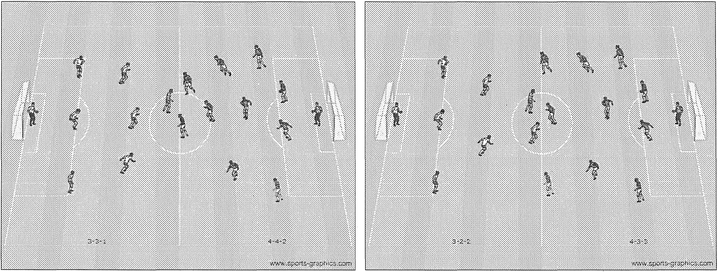

3-3-1 to 4-4-2 3-3-2 to 4-3-3

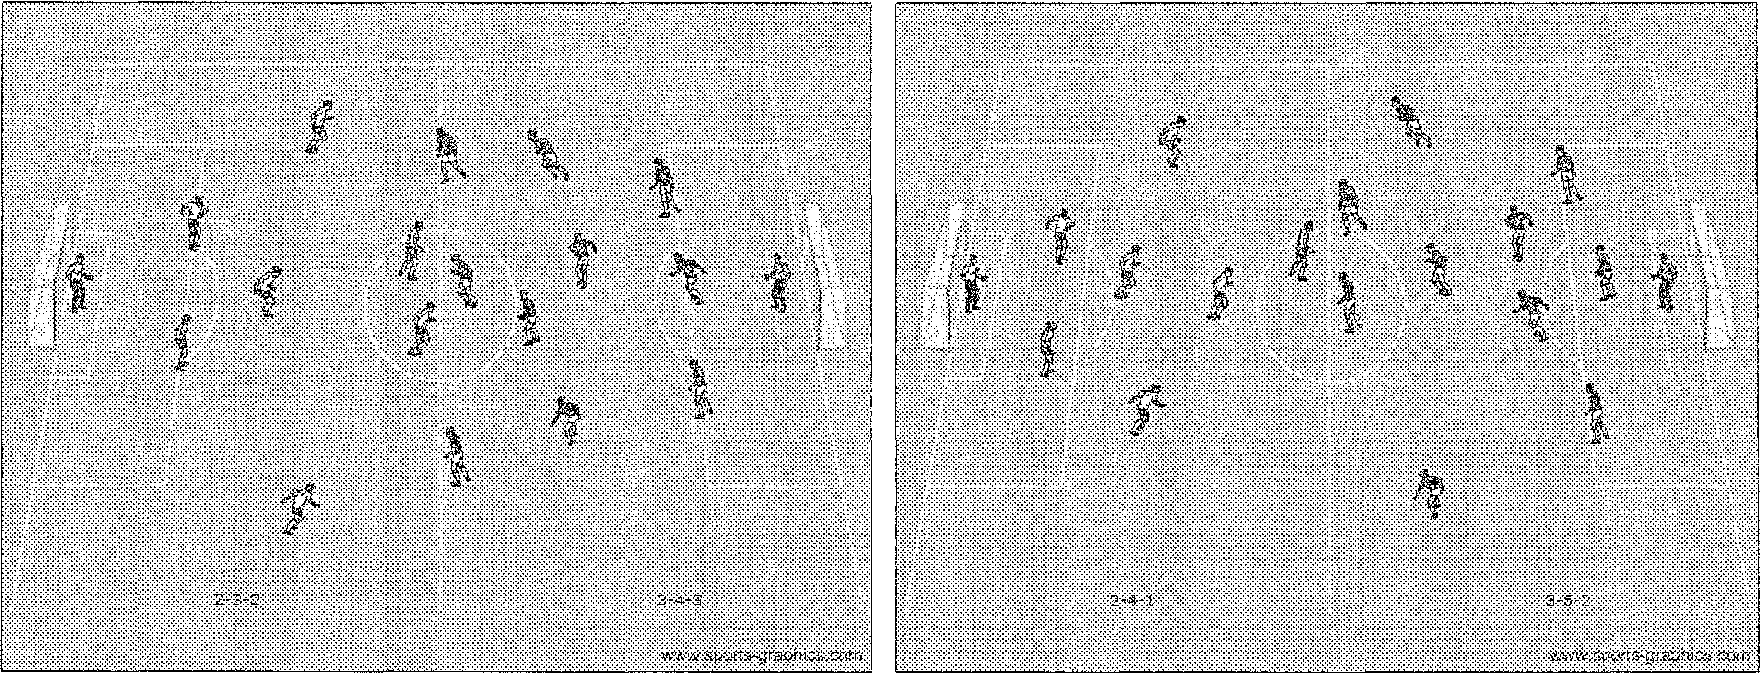
2-3-2 to 3-4-3 · 2-4-1 to 3-5-2

Guided Discovery (MYSA)

If you ever attended a youth soccer game, you were likely to hear many specific directions from coaches and spectators alike. We then expect this young player to sort through the information and then make a quality decision. All the contradicting information interferes with the player's ability to solve the problem. As a result, the
player now tries to kick the ball as far as possible or lower their head and run with it. It's simple and sometimes gets results; however, that doesn't make for better soccer players.

If we asked these players to explain their decisions to us at the end of the game, or
even immediately after their actions, it is unlikely they would be able to provide us with a rational explanation. If these players are placed in the same situation at a later time, they will not have experience from which to draw upon when faced with a similar situation. Many times the player will continue to make the same mistake or randomly try something else in order to please the adults.

So what can we do as coaches to prevent players from making the same mistakes and feeling a sense of frustration? We could continue to yell louder and hope they are listening to us. Of course, that will continue to make the game less enjoyable for the player. A better choice is to provide the players with the tools to make these decisions for themselves. If our players understand when it is best to kick the ball forward or to run forward with the ball and why they are making all the decisions they are making during a game, then they will be able to improve their own play and be rewarded with success. Further, if they become thoughtful, strategic players, they will have more fun, gain confidence, and your team's performance is more likely to improve continually.

By asking our players questions to which they must come up with answers, we can insure that our players are thinking, as opposed to mindlessly following our directions. By asking guided questions, we can help maintain focus and direction for our team and help provide learning experiences for our players.

When referring to guided questions, we mean that our questions should place our players on the right track (guide) in order to be able to solve the questions we pose. Some such questions may be quite direct and simplistic, such as:

  - What part of the foot do you use to make a short pass?
  - Where should you aim when shooting on goal?

Questions such as these are called - low order questions as they demand factual, memorized answers. In contrast, we could ask -high order questions that challenge our players a bit differently by asking them to weigh options within the framework of a larger process. High order questions beg interpretation and comprehension over memorization or recall. Examples of -high order questions include:

  - How can we get the ball down the field quickly?
  - Why should we play high-pressure defense?
  - In a 3v3 situation, what's the best way to get the ball to your teammate? Try it!
  - What happens when you pass the ball behind your teammate? Let's try it!
  - Why didn't that pass work? So, how should we do it next time?
  - How can we get the ball to the other side of the field?
  - Why is it important for you to lift your head up when you have the ball?

Utilizing questions such as these will help our players learn and retain information that will aid them in making optimal choices as they play.

Through the use of guided questions, players develop confidence and learn to trust their own decisions. Of course, we must temper the difficulty of our questions to insure they achieve the success necessary to help build their confidence. Players may be a bit uneasy at first when asked these types of questions (especially high order) at first. For this reason, it is a good idea to provide a few positive words before asking a question.
For example:

  - Great. ...so how could we do it faster?
  - I like that answer ...what other skill can we use to get the ball to our teammates?
  - Now you're getting the idea! Where could you position yourself so that you could see both the player you are defending as well as the ball?

Now armed with the confidence and skill to evaluate situations and make decisions on their own, these players will look within themselves (not toward the sideline) in order to determine what choice to make on the field.

Online References

Billerica Youth Soccer Association
www.billericasoccer.org
BYSA Sports Manager
www.sportsmanager.us/billericasoccer.htm
Middlesex Youth Soccer League
www.sportsmanager.us/orgmanager/mysl.htm
Massachusetts Youth Soccer Association
http://www.mayouthsoccer.org/default.aspx
United States Youth Soccer
http://www.usyouthsoccer.org

Coaching Websites
http://www.cdc.gov/concussion/sports/index.html
http://www.stack.com/soccer-drills/
http://www.worldclasscoaching.com/
www.Soccerexpert.com
www.freeyouthsoccerdrills.com

