How to get to your Team Roster information in Sportsmanager

- Go to the following link:
  - https://www.sportsmanager.us/BillericaYouthBasketball.htm
  - Click on the Coach/Director Login

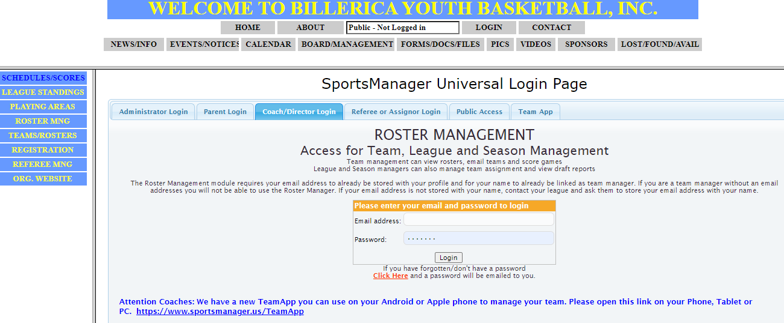
- Enter your email address and password. If you don’t know it, Click here and a password will be sent to you
- On the left side, click on Roster MNG
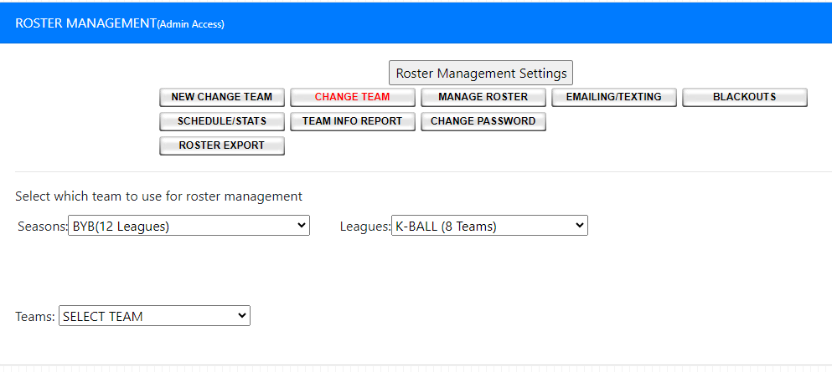
- Use the Leagues: Dropdown to select your league
- Then select your Teams: Dropdown to select your team
- Click on Team Info Report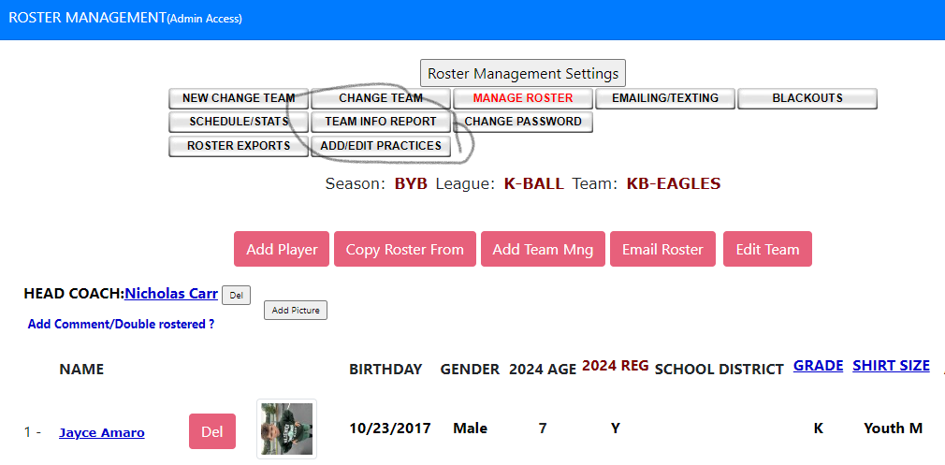
- This will give you a list of contact information for your team.

