BYSA is holding Evaluations June 5-7 for all kids playing in Travel Soccer for Fall 2017/Spring 2018.
YOU MUST REGISTER BY JUNE 3RD IN ORDER TO ATTEND EVALUATIONS.
REGISTRATION FEE IS $10 per CHILD (with a family cap of $25 if you have multiple kids)
INSTRUCTIONS ON HOW TO REGISTER YOUR CHILD FOR EVALUATIONS: (example is for a U10)
- Go to the Burlington Youth Soccer webpage- On the left side click the REGISTRATION BUTTON
- Brings you to this page (see screenshot below)
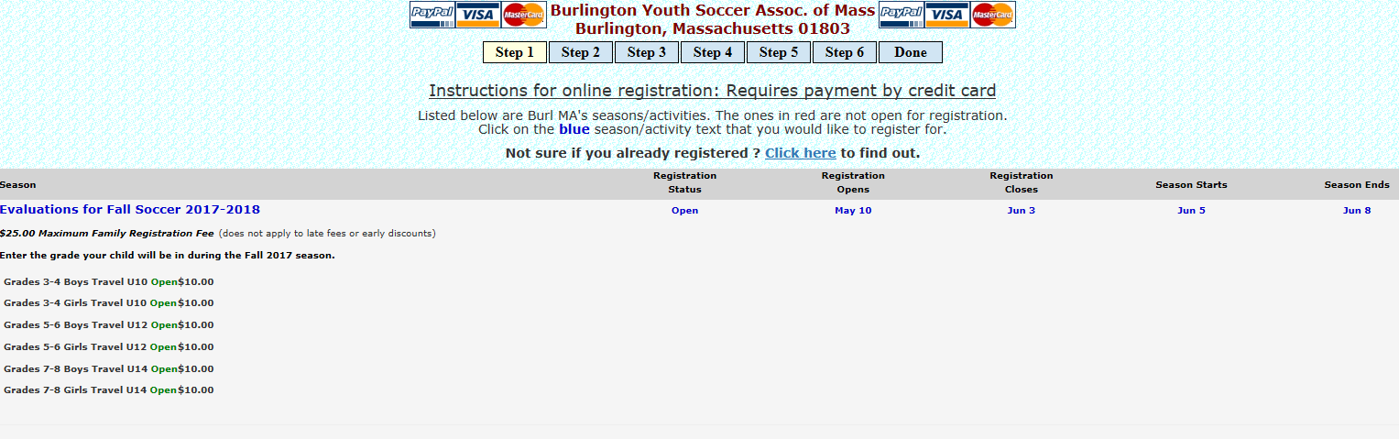
Click the OPEN for GRADES 3-4 Travel U10 (either girls for your daughter/boys for your son)
- Prompts you to next screen asks for Adult Last Name. Please type in your last name. Click Submit.
- Find your name (street) click “This Is Me” button.
- Next screen you check the box saying you are over 18 yrs old registering. Then type your name. Click Proceed
- Next screen is list of your children. Choose your child (your 2nd grader). Click Register button. (If you do not see that child you can click the “Add Child” button and add them to list.) There is a drop down box for GRADE as of EVALUATIONS FOR.. That should be their current grade TODAY and should be correct should not have to change it.
- A box will POP up saying …”This Site says…. Is this correct grade for Evaluations for Fall Soccer 2017-2018? XXXXX – Female/Male Grade 2 Yes/No. Click OK
- Next screen is a box says Registration Form – Player: XXXXX Curr. Age. SELECT THE GARDE YOUR CHILD WILL BE IN THIS UPCOMING SEPTEMBER. So you WILL CLICK THE GRADES 3-4 Girls/Boys TRAVEL U10 ($10.00) button.
- You MUST also CLICK the Button that says “Yes, I have entered the correct grade my child will be in this upcoming September and have selected the age/grade group that corresponds to that grade.”
- THEN CLICK THE REGISTER BUTTON!
- Brings you back to the first box where your list of children (child) is and will show under Registration “REGISTERED for Evaluations for Fall Soccer – Grades 3-4 Travel U10. If you have an older child can also register them for Evaluations. If not CLICK “ I am done registering my children..Proceed” Button
- Next screen just disregard, is comments box..just CLICK PROCEED button.
- Brings you to Registration Summary page with your name on it. And Total Price due $10 per CHILD. CLICK THE “PROCEED TO CHECKOUT WITH VISA/MASTERCARD/PAYPAL” button. And Pay.

