BURLINGTON YOUTH SOCCER ASSOCIATION

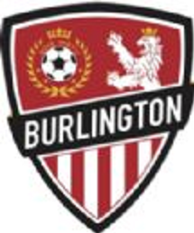

U6 PLAYERS AND COACHES DEVELOPMENT CURRICULUM

Reviewed: August, 2018.

Hello Coaches -

Thank you for volunteering to help with Burlington Youth Soccer Association (BYSA) for this season! As the Director of Coaching (DOC), I would like to say, on behalf of the program, that we are really thankful for your participation. The contribution of your time and energy will help to develop our kids into better soccer players and to encourage them to have fun (and who doesn’t like that?!).
In this guidebook you will learn a little bit more about how to coach U6 players by creating the right environment for development, recognizing the common characteristics of this age group and learning techniques for how to teach this sport. Additionally, this guidebook will provide the weekly session plans for your teams.
We strive to support your development and inspire your passion as a coach as we all work together to encourage the love of the game for the players. During your time coaching you will learn how great and rewarding this experience can be (hopefully, you already know and feel this, if you are a “returner” coach).
I wish you both a fun and successful season coaching the kids. I want to encourage you to come to me for help. Please reach out with any questions or problems relating to this document or during any of your training sessions.
I look forward to working with each of you. Good luck this season!

Matheus Campos – Director of Coaching

U6 General Guidelines
- Have Fun!
  - Be Positive
  - Be Patient

- Focus on player development vs winning games
  - Encourage learning - mistakes are not bad, it’s how we learn!
  - Reinforce correct technique vs speed.
  - Notice and acknowledge individual progress of players.
  - Coach the team, not the player. At this age group, there's no point shouting information to them all the time. Use the water breaks or time during substitutions to coach the team or pull individual players aside.
  - The main focus of the U6 program is to have these kids associate soccer with something fun. Avoid excessive competition or instruction and focus on the players having fun.

- Teach Sportsmanship and Teamwork
  - After games line up for high fives with the other team and then form a circle with your team to point out positive things they did (end on a high note).
  - When children are watching on the sidelines, have them cheer on their teammates.

  - Keep an eye on the parents’ behavior. Please feel encouraged to promote a supportive/positive environment as a discussion with your team’s parents. If you notice parents continuously making inappropriate/negative comments, please reach out to me, another challenger coach or your age coordinator and we can assist.

- Coaching Points
  - Keep kids moving (explain activities quickly, their attention span is short) and maximize the number of touches they have with the ball during activities.
  - Go down to their level to talk to them, take a knee or bend over to stay in their natural visual/height range while talking.
  - Take lots of water breaks.
  - Ensure equal playing time.
  - Kids can be shy at first in this age group, so jump in! Start as the tagger, play with them to help them to break the ice and get confidence playing.
  - You can progress all the tag games from tagging to having to take the ball from other players.
  - Give attention to players doing things right instead of calling the attention to players that are being distracting or disruptive. This will reinforce the idea of getting attention/recognition by following the coach’s instructions.
  - If you already went through the activities for your session, and you still have time, then we encourage you to use the extra drills at the end of the curriculum! (Please don't let the players kick around anticipating the start of the scrimmage) If you need help with any of the sessions, please reach out to me or to any of the Challenger coaches.

- Session Format
  - All the U6 sessions will be an hour long and will be divided in:
  - 10 minutes warm up with challenger coaches.
  - 30 minutes for drills (including water breaks).
  - 20 minutes scrimmages.
  - When the balls goes out, players will use kick-ins vs new ball.
  - 3v3 or 4v4 with NO goalies

WEEK 1 FALL
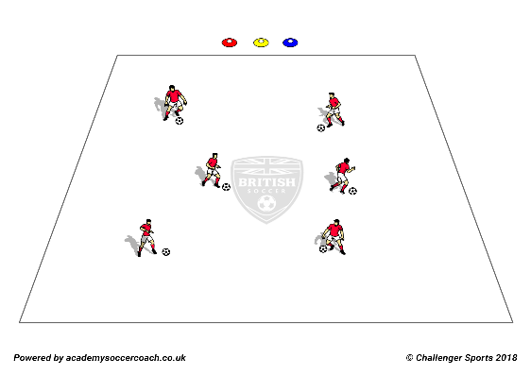
TRAFFIC LIGHTS: Players dribble inside the grid, their soccer balls are their cars. Coach yells traffic colors and players have to dribble the car according to the color called: Red Light- Stop the soccer ball with one foot on top of it. Yellow Light – Dribble slowly with the soccer ball. Green light – Dribble as fast as the player can with the inside of the feet. Players tend to rush on green light and will kick the ball with their toes or kick the ball too far away from them. Make sure that each player is going as fast as they can but in a speed where they manage to keep the ball close and under control. Coaches can progress the activity by adding a Gas Station – Toe Taps and Car Wash – Inside Taps, Little Penguins, Pendulums…
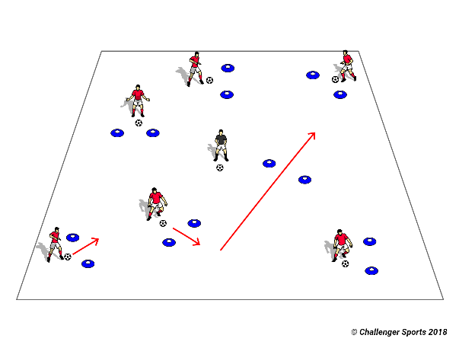
MARIO KART: Players have to dribble their soccer ball around the track and through checkpoint “gates” that should be positioned inside the grid. Players have to see how many gates they can get through in one minute. Don’t put the gates side by side, spread them around to make the players work on changing directions. Coaching progression: continue the drill but the coaches can kick extra balls (turtle shells) onto the “track”. If the coaches hit the ball with the turtle shells, the players have to do sole rolls (rolling the ball with the sole of their foot –3 times with right foot then 3 times with left foot) on the ball before continuing.
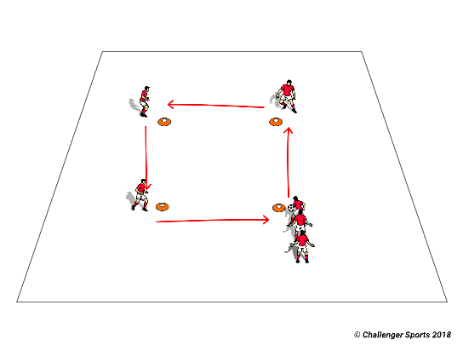
HOT POTATO: Set up a large square and place players at each corner. Players have to dribble the ball around the square and give to the next player in line. If the coach yells “switch”, players have to do a pull back and start to go in the opposite direction.
GAMES: 20 min. 3v3 or 4v4. No goalies.

WEEK 2 FALL
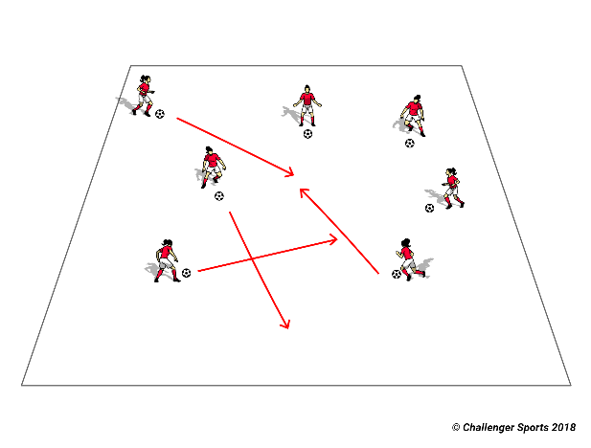
MATH DRIBBLING: Players dribble the soccer ball around the grid. Coaches call a number and the players have to get together in that number. Coaching progression: Occasionally call odd numbers, where players that “are left” have to do toe taps before going back.
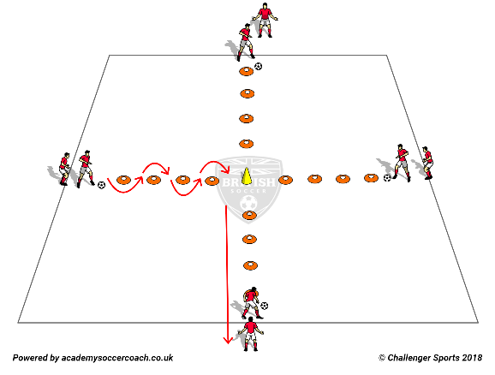
CROSS DRIBBLING: Set up cones in a cross format with 3-4 yards in between each cone and a large (or different color) center cone. Players line up behind the cones and dribble the ball around the cones to the center cone, then they turn to the right and dribble the ball to the next player in the next line. Coaches can change directions during the drill or add passing.
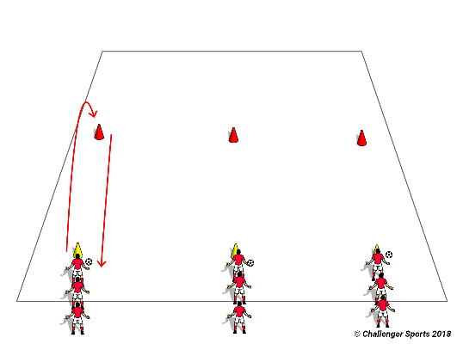
RELAY RACE: Make lines for an even number of players (if possible) and make the players dribble to a cone, turn around the cone and dribble back to their lines. Coaches progression: add cones in the path to the “final point” to make the route harder for the players.

GAMES: 20 min. 3v3 or 4v4. No goalies.

WEEK 3 FALL
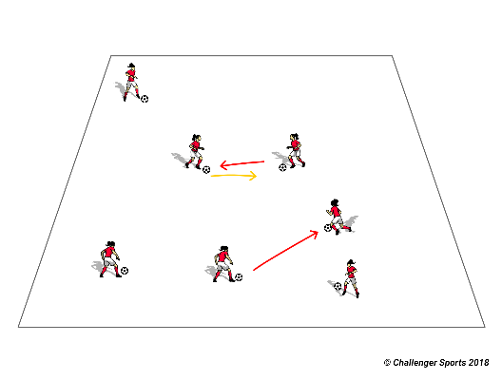
KING OF THE RING: Set up a grid/ring that make sense for how many players you have. All players have a soccer ball inside the grid/ring. Players have to try to knock the others balls out of the “ring” while keeping their balls. If their ball gets knock out or players dribble out they have to do 10 toe taps before getting back in.
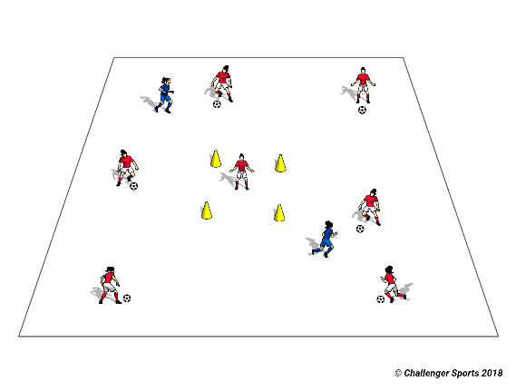
COPS AND ROBBERS: Coaches set up a large grid and a small grid/ “jail” in the middle of the large grid and assign 1 to 2 taggers/ cops (1 cop to 4 robbers approximately). The remaining players / robbers have to dribble their soccer ball around the grid. If one of the cops touch the robbers’ soccer ball they have to go inside the jail and wait for another robber to come and high-five them. Coaches can be the cops/taggers to begin with if players are shy. Make sure to rotate the taggers every minute because they tend to get tired and lose focus.
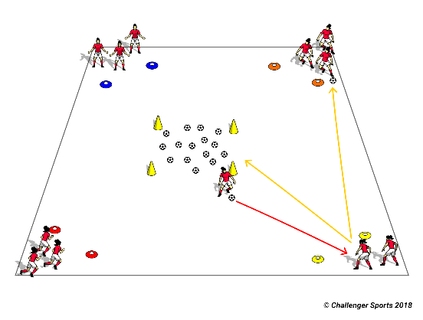
HUNGRY HIPPOS: Coaches set up teams based on each corner of the grid. Coaches place all the soccer balls in the middle of the grid; players have to take turns going into the middle of the grid and dribbling a ball back to their base. When there’s no more balls in the middle of the grid the team with more balls in their base wins. Coaches can let kids do the first round with hands for easier understanding of the game. If the game is going well coaches can let players steal balls from other bases instead of taking balls from the middle. Players CANNOT block players coming for their team balls.
GAMES: 20 min. 3v3 or 4v4. No goalies.

WEEK 4 FALL
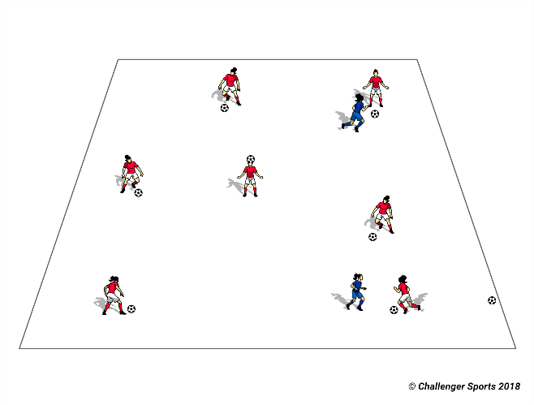
STUCK IN THE MUD: Players have to dribble their soccer balls around the grid. Coaches set up taggers. If a player gets tagged they get “stuck in the mud”. They have to place the soccer ball on the top of their head open their legs and shout for help. Another player has to dribble the soccer ball through the player stuck and then this player can go back to the game.
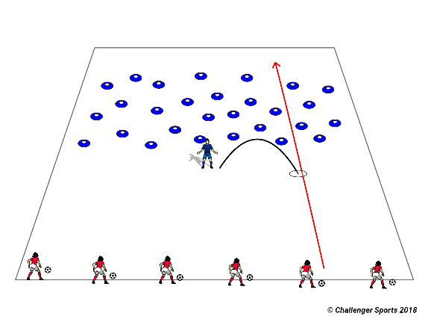
LANDMINES/STINKY BOMBS: Coaches spread cones (landmines) on the grid (image above). Players have to dribble their soccer balls around the cones, without hitting them, to cross the minefield. If a player hits a mine they have to do 10 toe taps before going back to the game. Coaches progress to throwing stinky bombs (pinnies) at the players when they are crossing the minefield. If a player get hit by a pinnie they have to do 3 sole rolls (rolling the ball with the sole of their foot -3 times with the left then 3 times with the right) to “clean” their ball before going back to dribbling.
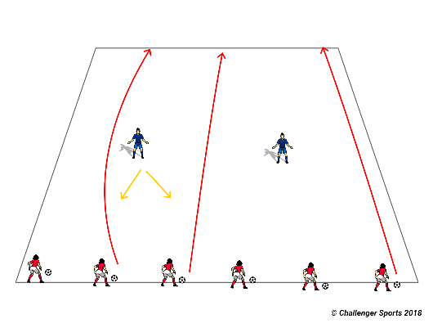
SHARKS AND MINNOWS: Players are the minnows and have to cross the ocean without getting tagged by the sharks. If they get tagged they become sharks in the ocean as well.
GAMES: 20 min. 3v3 or 4v4. No goalies.

WEEK 5 FALL
MATH DRIBBLING: Players dribble the soccer ball around the grid. Coaches call a number and the players have to get together in that number. Coaches progress to occasionally calling odd numbers; players that “are left” have to do toe taps before going back.
CROSS DRIBBLING: Set up cones in a cross format with 3-4 yards in between each cone and a large (or different color) center cone. Players line up behind the cones and dribble the ball around the cones to the center cone, then they turn to the right and dribble the ball to the next player in the next line. Coaches can change directions during the drill or add passing.
RELAY RACE: Make lines for an even number of players (if possible) and make the players dribble to a cone, turn around the cone and dribble back to their lines. Coaches progression: add cones in the path to the “final point” to make the route harder for the players.

GAMES: 20 min. 3v3 or 4v4. No goalies.

WEEK 6 FALL
KING OF THE RING: Set up a grid/ring that make sense for how many players you have. All players have a soccer ball inside the grid/ring. Players have to try to knock the others balls out of the “ring” while keeping their balls. If their balls get knock out or players dribble out they have to do 10 toe taps before getting back in.
COPS AND ROBBERS: Coaches set up a large grid and a small grid/ “jail” in the middle of the large grid and assign 1 to 2 taggers/ cops (1 cop to 4 robbers approximately). The remaining players / robbers have to dribble their soccer ball around the grid. If one of the cops touch the robbers’ soccer ball they have to go inside the jail and wait for another robber to come and high-five them. Coaches can be the cops/taggers to begin with if players are shy. Make sure to rotate the taggers every minute because they tend to get tired and lose focus.
HUNGRY HIPPOS: Coaches set up team bases on each corner of the grid. Coaches place all the soccer balls in the middle of the grid, players have to take turns going into the middle of the grid and dribbling a ball back to their base. When there’s no more balls in the middle of the grid the team with more balls in their base win. Coaches can let kids do the first round with hands for easier understand of the game. If the game is going well coaches can let players steal balls from other bases instead of taking balls from the middle. Players CANNOT block players coming for their team balls.
GAMES: 20 min. 3v3 or 4v4. No goalies.

WEEK 7 FALL
STUCK IN THE MUD: Players have to dribble their soccer balls around the grid. Coaches set up taggers. If a player gets tagged they get “stuck in the mud”. They have to place the soccer ball on the top of their head open their legs and shout for help. Another player has to dribble the soccer ball through the player stuck and then this player can go back to the game.
LANDMINES/STINKY BOMBS: Coaches spread cones (landmines) on the grid (image above). Players have to dribble their soccer balls around the cones without hitting them to cross the minefield. If a player hits a mine they have to do 10 toe taps before going back to the game. Coaches progress to throwing stinky bombs (pinnies) at the players when they are crossing the minefield. If a player get hit by a pinnie it has to do 3 sole rolls (rolling the ball with the sole of their foot -3 times with the left then 3 times with the right) to “clean” their ball before going back to dribbling.
SHARKS AND MINNOWS: Players are the minnows and have to cross the ocean without getting tagged by the sharks. If they get tagged they become sharks in the ocean as well.

GAMES: 20 min. 3v3 or 4v4. No goalies.

WEEK 8 FALL:
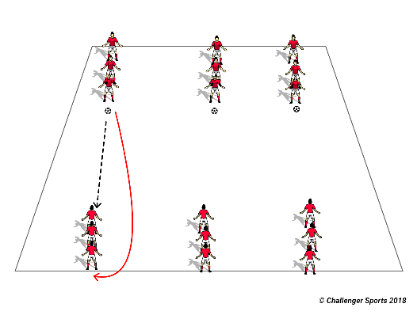
PINBALL: Players form lines 5 yards apart. Player make a pass to the player that he/she is facing and runs to the end of that line. Keep lines to a maximum of 3 players to keep the kids moving at all times. It’s very important to correct the part of the foot that they are using to pass, always inside, NO TOES.
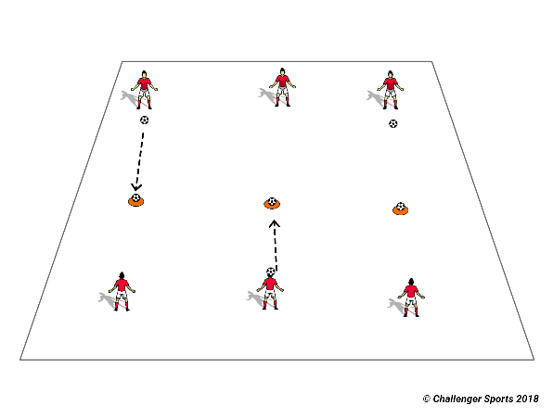
BULLSEYE: Make the players’ line up 10 yards apart. Place a ball on the top of a cone between them and make them try to hit the ball in turns. Every time a player knocks down the ball they get one point. If the players are finding it too hard, decrease the distance between them and the ball. Coaches can also make this a 2v2 game in a case of too many players or a small number of balls.
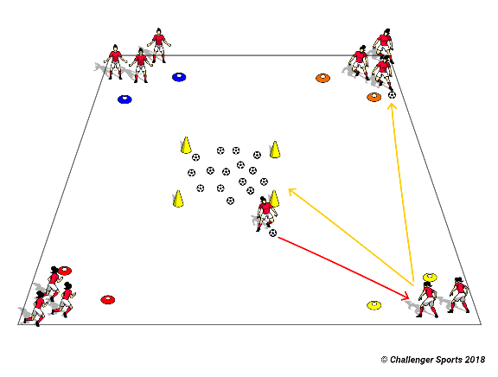
PASSING HUNGRY HIPPOS: Same idea of the hungry hippos game (check weeks 3 and 6) but instead of dribbling the ball back the players pass the ball back to their base.
GAMES: 20 min. 3v3 or 4v4. No goalies.

EXTRA DRILLS:
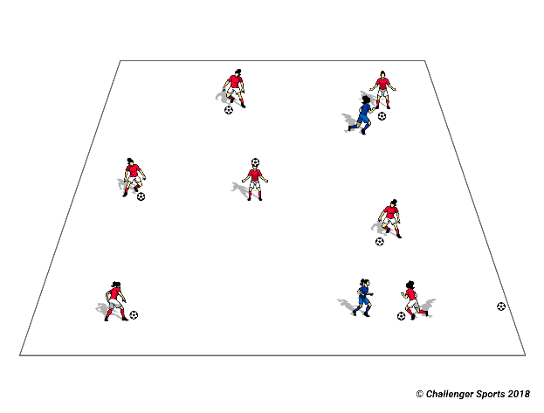
FREEZE TAG: Coaches set up grid. Players have to dribble their soccer ball and if they get tagged they “freeze” on the spot where they got tagged. Once a teammate high fives them, they can start to dribble their ball again.
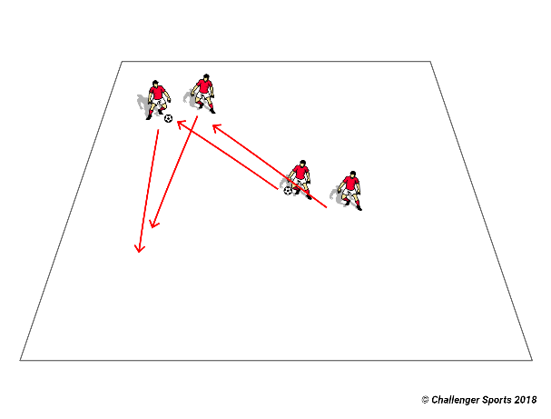
SHADOW: Players work with partners. Each player has a number (1 and 2), one of them starts with the soccer ball and dribbles it on the grid and the other player has to follow him around, paying attention to the change of direction. After a minute, change the player that has the soccer ball. A progression that coaches can make, if the game is going well, is to make the player without the ball trying to take the ball away from the player with the ball and count how many times he/she manages to do it in a minute. Then switch.
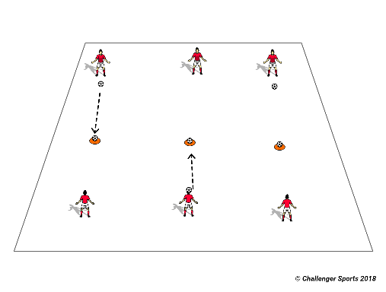
KING CONES: Same idea of the bullseye but it’s a team game. Coaches set up tall cones, or cones with balls on top, 5 yards from each team. The team that knocks more cones/balls down wins.

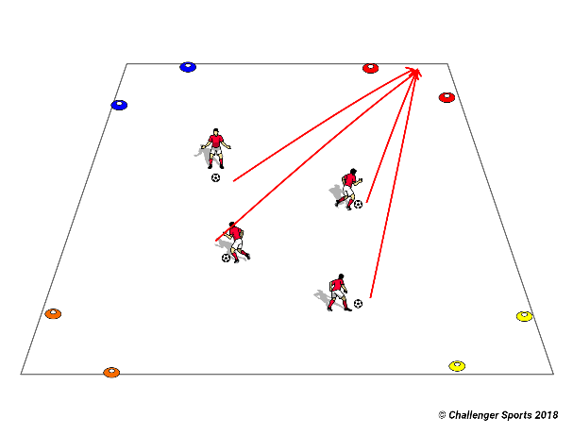
COLORS CORNERS: Coaches set up bases on each corner of the field and name it after a color. When the coach shouts that color, all players have to dribble their soccer ball as fast as they can to that corner. Switch colors of the corners during the game.
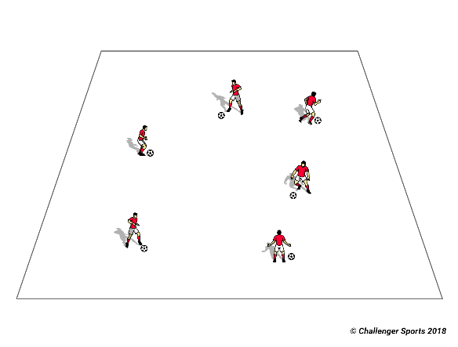
BODY PARTS: Players dribble soccer balls around the grid. Coaches call a body part and they have to touch that body part on the soccer ball.
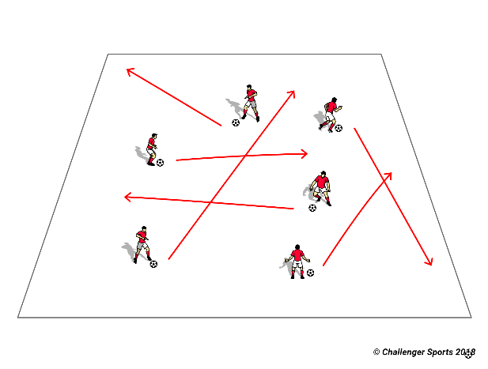
PAINT THE FIELD: Coach gives a color to each player. Every time that they dribble the ball on the field they are “painting” that area with their color. Players have to try to paint as much as they can of the grid.

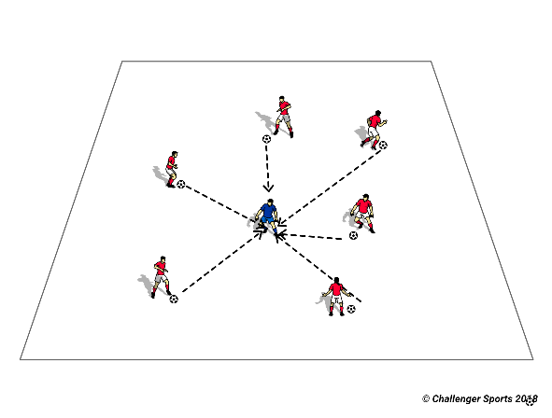
SHOOT AT THE COACH: Kids love this game by the simple reason that they get to hit their coach with soccer balls. The Coach has to move around the grid and the kids have to try to hit him/her by kicking their soccer balls.
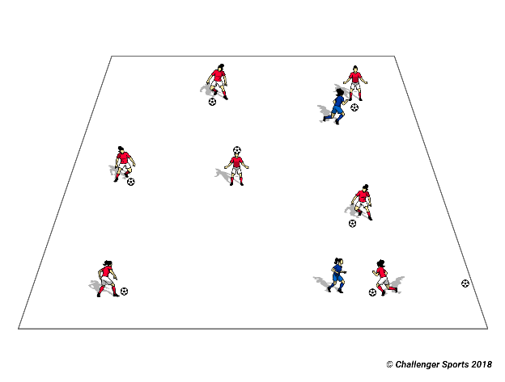
KANGAROO JACK: Taggers have to hop as kangaroos and try to tag players dribbling their soccer balls around the grid. Once a player is tagged, put their soccer ball aside and become a kangaroo!
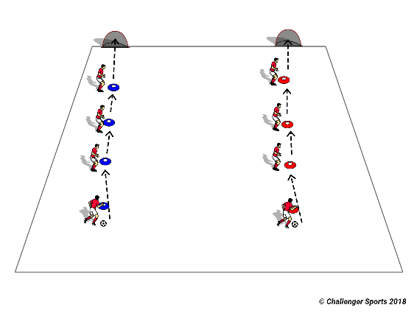
CONNECT 4: This game is a passing relay race. Players have to pass the ball to the players at the cone ahead of them and make the ball get to the last player. The first team that manages to do that, without making a bad pass, wins. Coaches progress to making the ball have to go all the way up and then back down the line. The Second progression can be adding a shot in a goal after the ball gets to the last cone (if you do that, rotate the players after each round to give them all a chance to shoot).

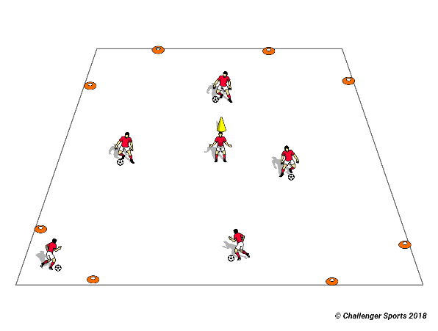
SHARK ATTACK: Coaches make safe zones on the corners of the field. Two taggers stay on the middle of the grid as sharks. When coach yells “shark attack” players have to dribble the ball to the other safe zone without getting tagged. If they get tagged they become sharks. Sharks can hold cones on the top of their heads as a shark fin.
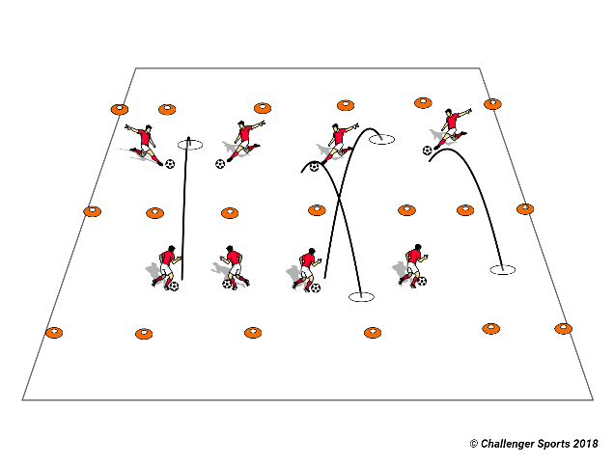
MESSY YARD: Coaches set up a line in the middle of the grid that split both “yards”. Coaches also set up a line at the end of each yard to make the boundaries. Players are divided in two teams and have to try to kick balls into the other yard. If the balls are in the yard they are live. If they go out of the boundaries they are out. At the end of the round, the coach counts how many balls on each side. The team with more balls, inside their yard, loses the round.
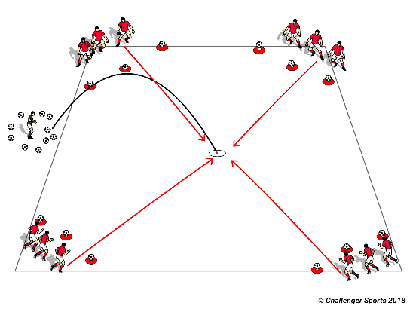
BATTLESHIPS: Players are divided into teams. Each player has a number and each team has its battleships (tall cones or balls on the top of cones). Coach calls a number and plays a ball in. Players have to try to knock down other battle ships and try to protect theirs. Numbers not called cannot block balls coming to their ships. Once a team is out of the battleships they keep playing to try to knock down other team ships.

