Coaching Sportsmanager Log-In

You can log onto the Sportsmanager System one of two ways to view your roster and communicate with your team.

- Access the Login page through Burlington’s soccer website with this link. https://www.sportsmanager.us/BurlingtonSoccer.htm
- Make sure you are on the coach/director login tab.
- Enter your email address and password, this is the same id and password that you used to registered your child.

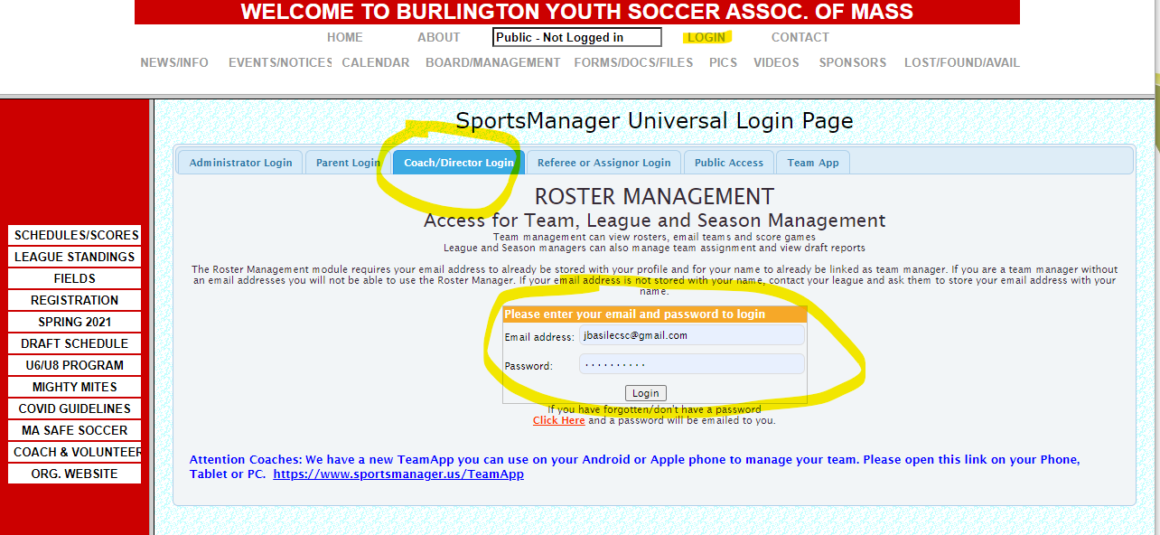

- Once you have signed in you will see the below screen.
- If you are a coach listed on multiple teams, you will see them all listed here. Make sure you select the current team you want to see.
- On the top of the screen are all of the pages that you will have access to, for U6 you only need to use Team Info Report and Emailing/Texting, everything else is for our travel program.

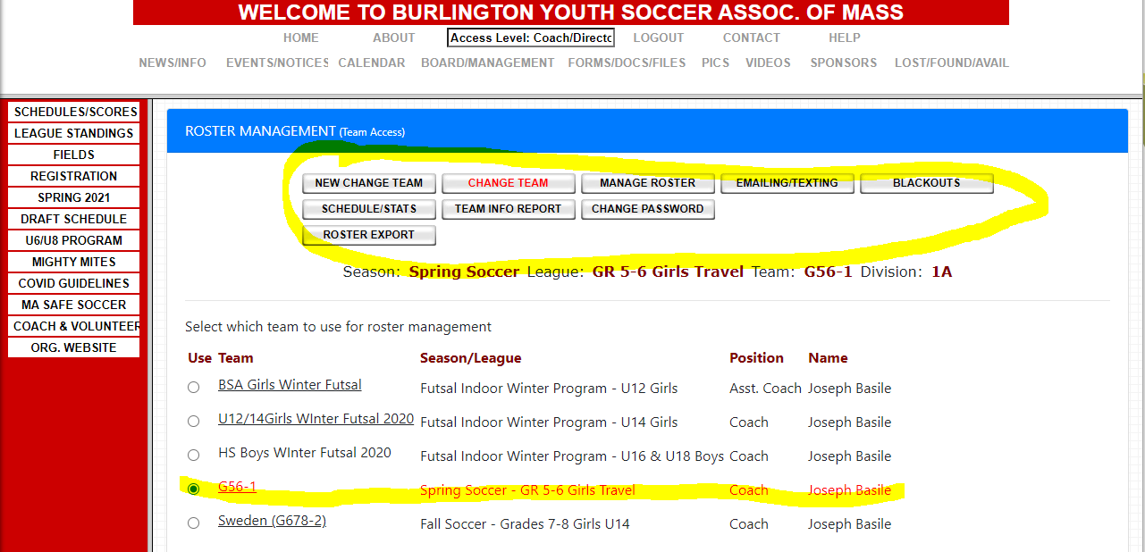

- The Team Info report is a report of all of the contact information for players on your team, it is good to print a copy and have it with you during the sessions.
- Email Team option will look like below.
  - This will email your entire team, you can click on the “Select Recipients/Edit Info” tab if you want to email selected players.
  - We will also have an application called TeamSnap which can be used to communicate to parents.

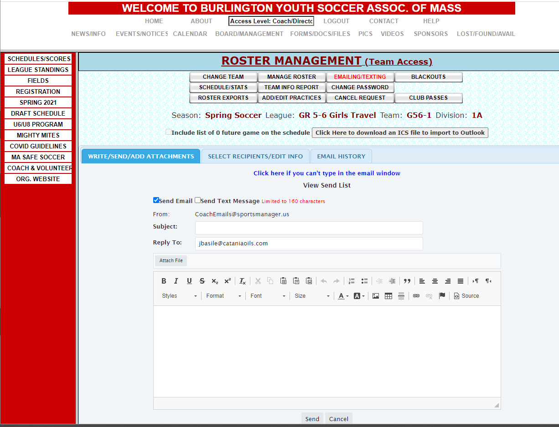

This is the other way which is preferred if using from an Android or Apple phone, same functionally as above just a different look.

- To access this Login page through Burlington’s soccer you can follow the same steps above (it will redirect you here) or use the direct link below
https://www.sportsmanager.us/teamapp/
- Enter your email address and password, this is the same id and password that you used to registered your child.
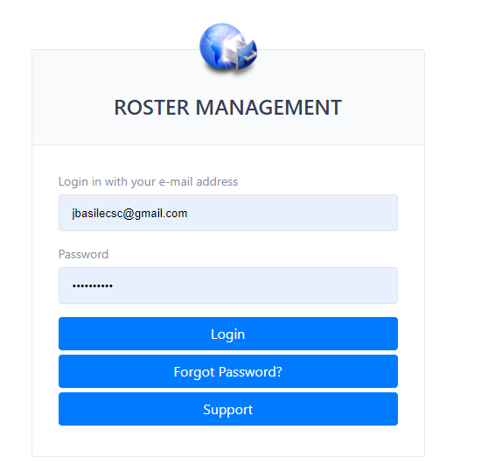
- You will see the below page once you log on, make sure you select the team you want to access.
- Same as the first option you really only need to use the Emailing/Texting and Team Info Report Summary

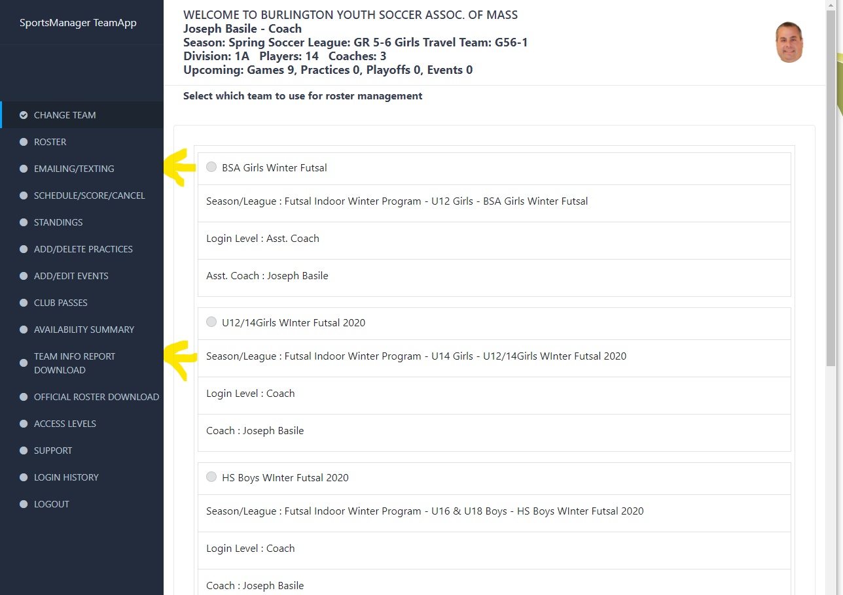
- Same as above just a different look and feel.

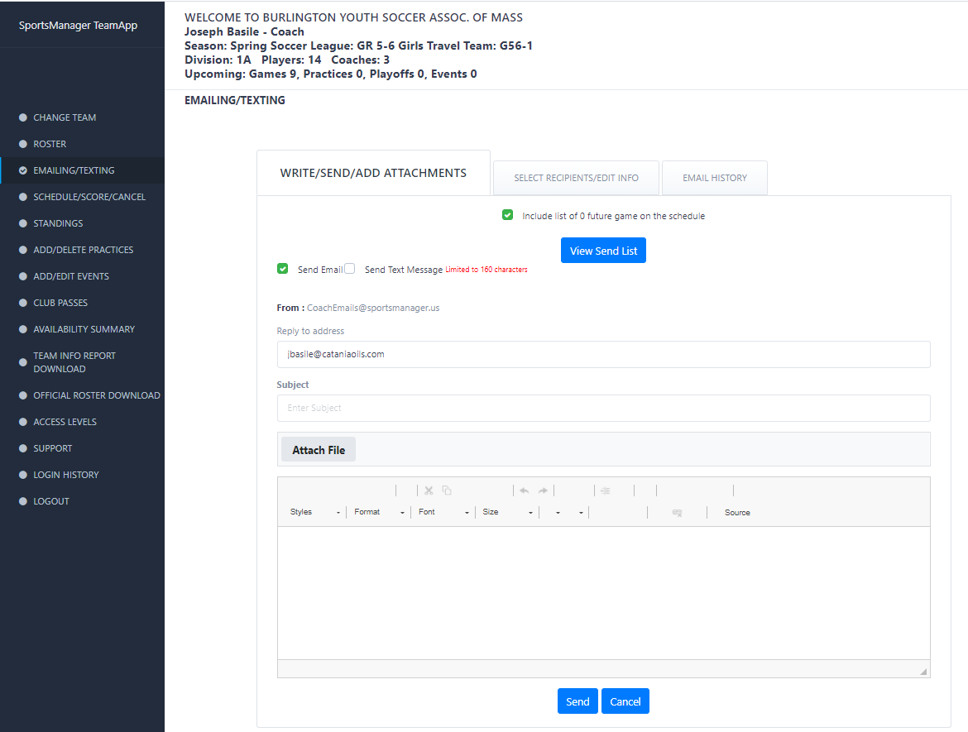

EXAMPLE CLINIC WELCOME LETTER TO TEAM:
Team Italy!
I am looking forward to the fall season starting next week!
Our first game will be on Saturday, September 18th at the Marshall Simonds Middle School (MSMS) on Turf Field #1.
Please remember to wear cleats and shin guards, bring your ball (size 4) and plenty of water.
Please wear your uniform (neon yellow). If you missed the uniform pick up, I will have a shirt for you at the field.
For those of you who are new to clinic, we will have a weekday practice run by our Challenger Coaches followed by the Saturday game (which will be half skills and drills and the other half game). Weekday practice will start Friday, September 24th.
Our Challenger Practice will be on Fridays from 4:30-5:30 pm at Francis Wyman Elementary School.
Please remember to wear cleats and shin guards, bring your ball (size 4) and plenty of water.
If you have any questions, please reach out: steph@bysa-admin.org or 978-230-6084.
Can't wait to meet you all and get out on the field!
Coach Stephanie

