Scheduling Practice

- From the BYSA home page (http://ww.burlingtonsoccer.org), select LOGIN from the top and Coach/Director Login from the tabs. This generally works better from Chrome or Firefox browsers. Safari has a 50/50 success rate.

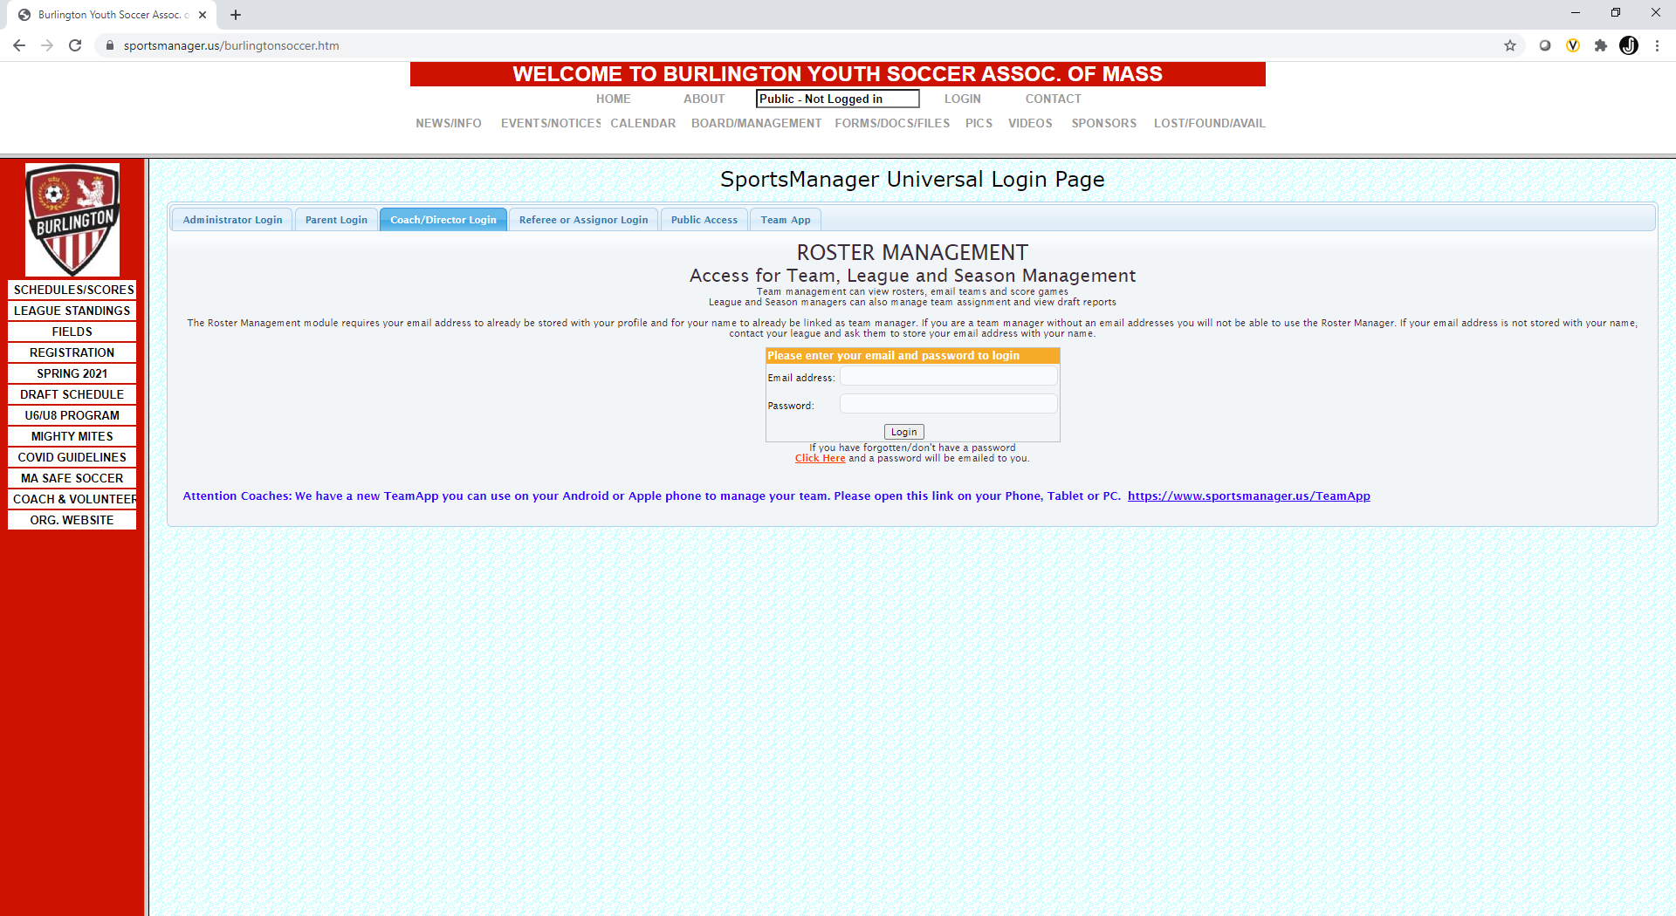

- This will open a new page – called Roster Management. Login in on this page.
Note – if you do not get this page, stop and contact Will Panagiotis (wpanagiotis@verizon.net)
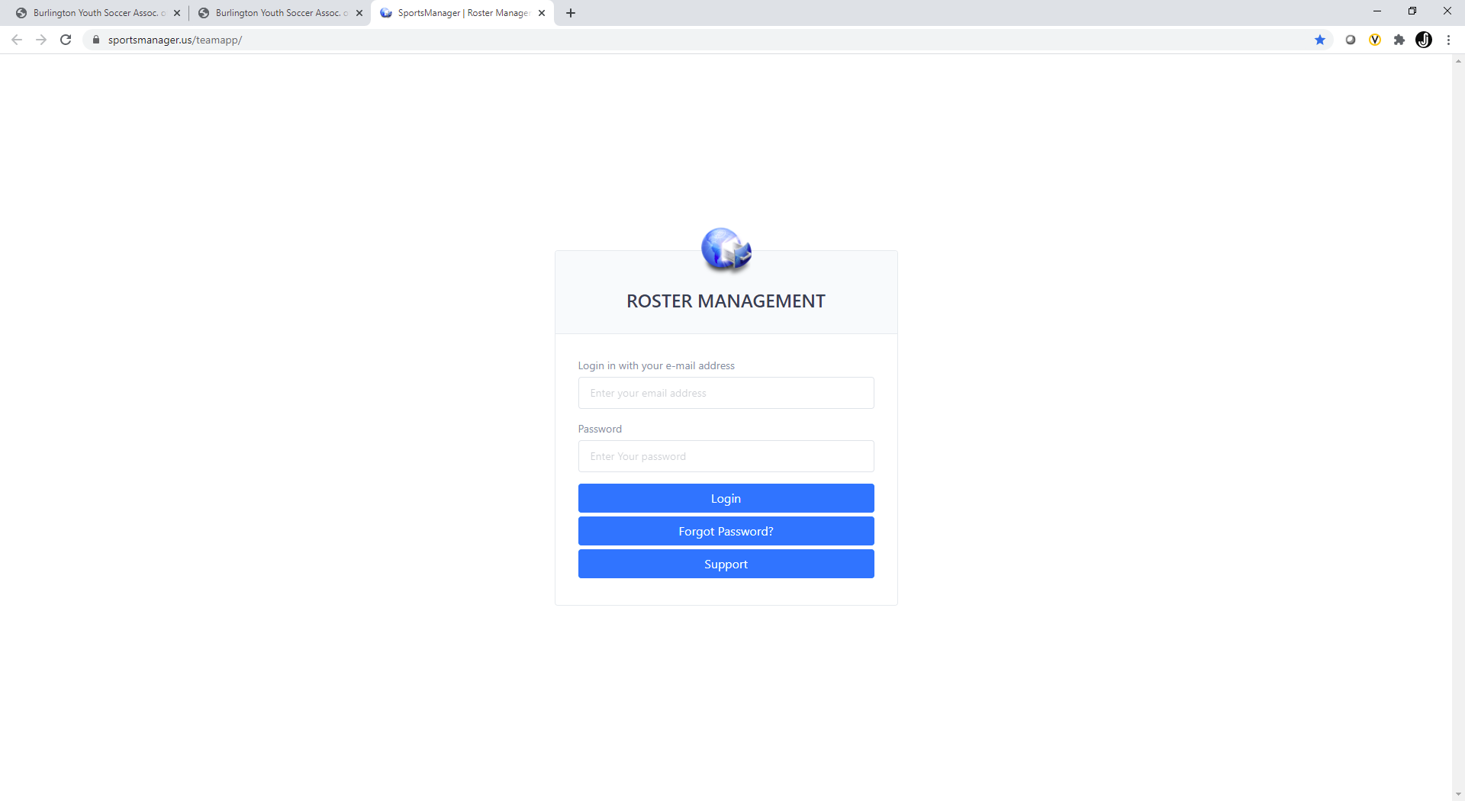

- Make sure you have selected the correct team and click ADD/DELETE PRACTICES from the menu on the left

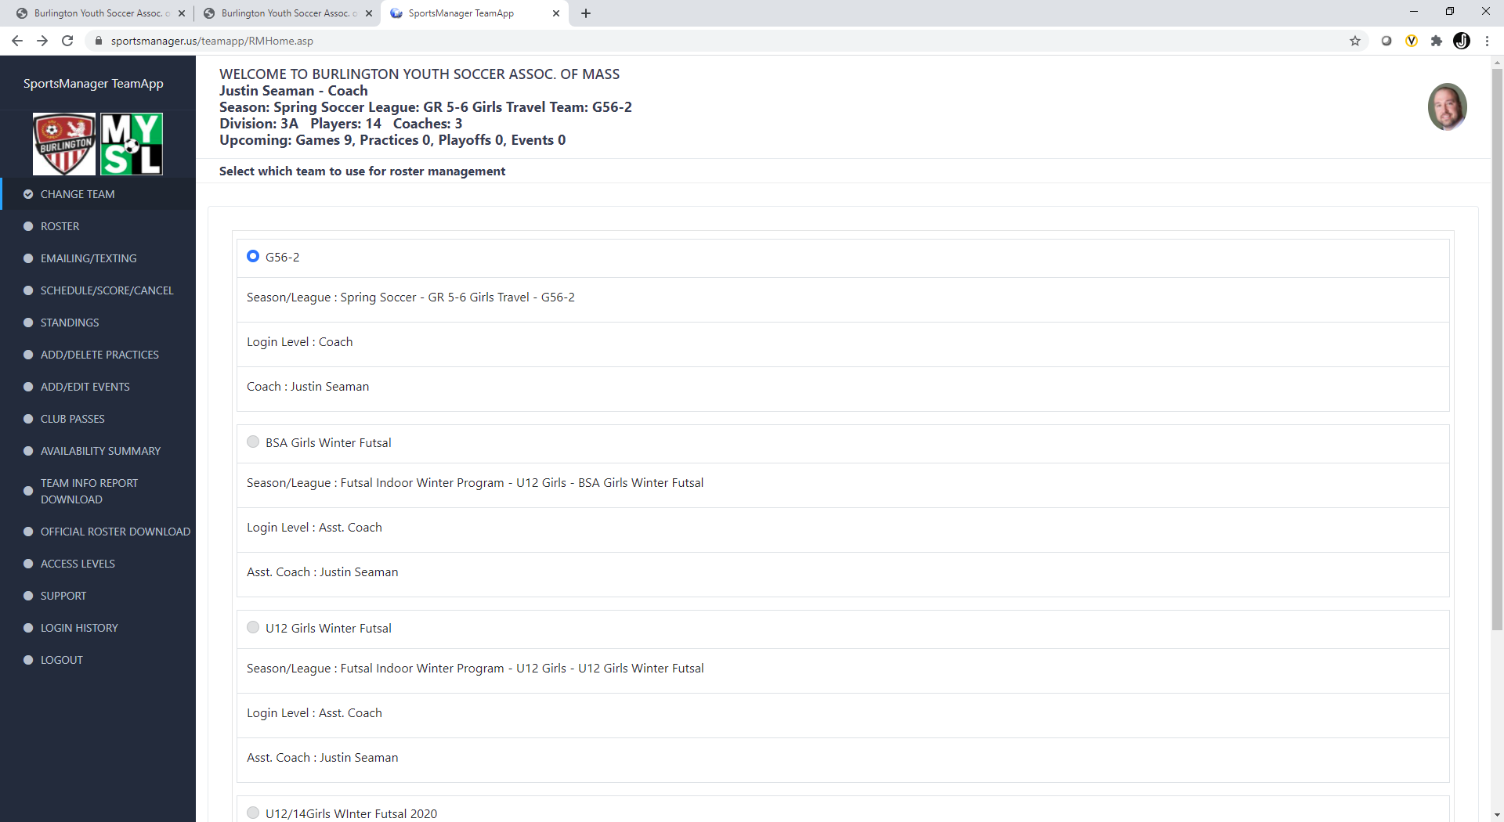

- Once on the ADD PRACTICES page, you will select:
  - Location – the list will auto populate based on your age group and field selection
  - Date – choose a date starting next week (8/30 or later)
  - Time – We cannot start practices before 4pm at most fields
    - For U14 coaches electing to use Varsity/Brush, pay attention the start times (7:15pm at Varsity, 6:30pm at Brush). Earlier practices will be deleted
  - Duration – Please limit this to a maximum of 75 mins to ensure all teams will have a spot
    - Note – these may be adjusted to allow all teams a time to practice. You will be contacted if a change is necessary
  - IMPORTANT - Uncheck and Re-Check the “Add Recurring Weekly Practices”. 10 practices will take you through the end of the season.
    - If you don’t see the box to enter the number of practices, try unchecking/rechecking the box. If that doesn’t work, contact Will Panagiotis (wpanagiotis@verizon.net)
Click “Create Practice” 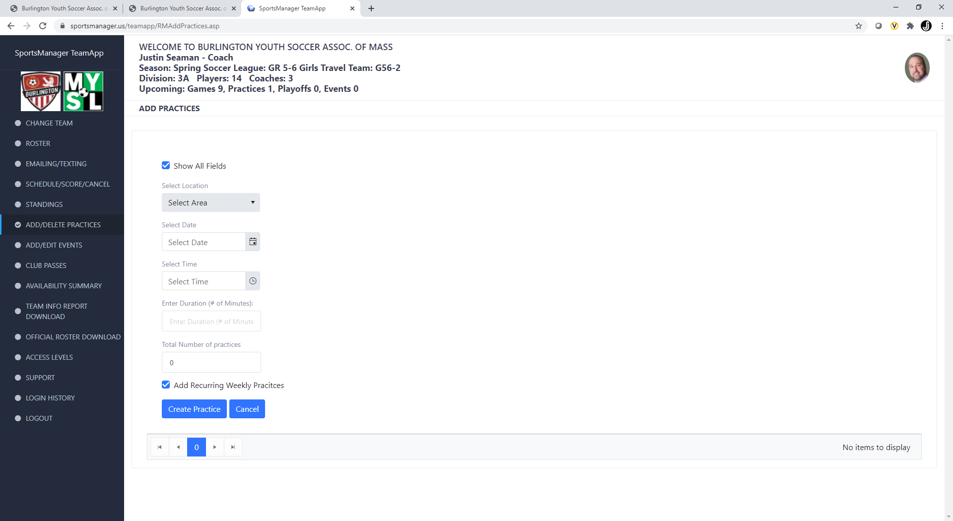
Uncheck and Recheck this box
If all goes well, you should see the following screen:
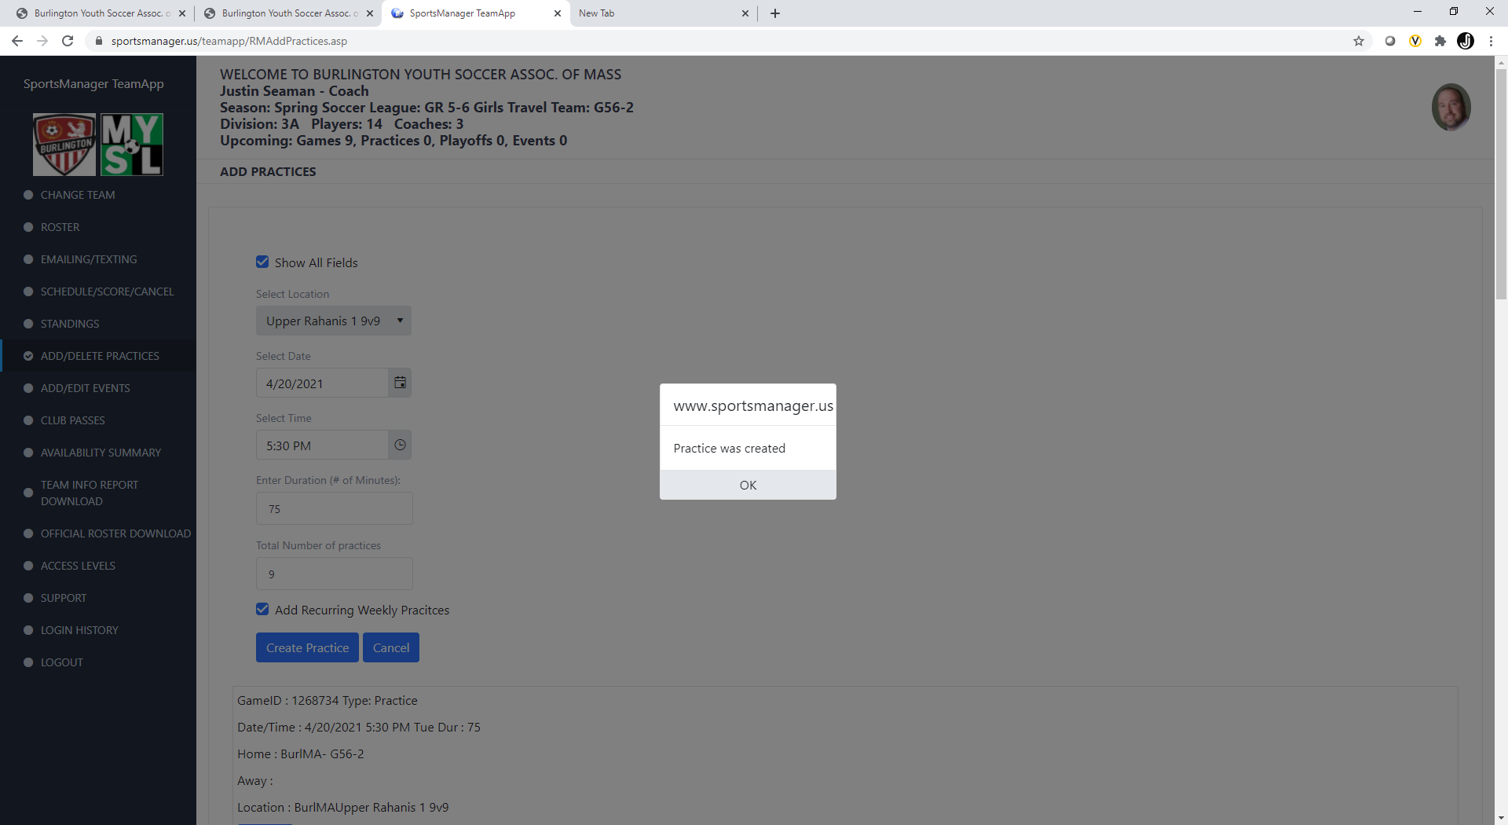

Click OK and you should see your practices through November 5th.

Any questions or issues – please contact Will Panagiotis (wpanagiotis@verizon.net)

Adding practices to TeamSnap
There are two ways to enter practices into TeamSnap – via the app or website
- Website (http://www.teamsnap.com)
  - Login to your account in the upper right corner
    - Make sure the correct team is showing on the home screen
  - Click on Schedule in the menu across the top of the page
  - Click on New
    - Select New Event
  - Enter Your Practice Details – Fields should be there already, make sure you select the same field as you did in sportsmanager
    - “Show” under Optional Event Info to include duration
  - When all the information is there, click “Save” on the bottom of the page
- App
  - Click on the Schedule icon on the bottom of the screen
  - Click on the + icon on the top right corner
  - “Add Event”
  - your practice details - Fields should be there already, make sure you select the same field as you did in sportsmanager
  - When all the information is there, click “Save” on the top right

If you have problems with TeamSnap, please contact your age director.

