BYSA Families,
We hope that everyone is enjoying the Spring Soccer season so far. We want to extend our thanks to all the players, parents, referees and coaches for all your support in getting the season off the ground. As our Spring season is underway, we are already working on plans for the Fall season.
Some exciting news for BYSA: We have launched a new website: https://www.burlingtonyouthsoccer.org/
Thank you for your patience as we work through the transition.
Registration is OPEN May 27th through June 7th for our Fall 2024 travel program and our *NEW* Fall 2024 in-town program (register for only 1 of these 2 options, NOT both).
Registration is also OPEN, May 27th through August 18th for our Fall 2024 clinic program.
Attached is a brief summary of the registration details available for the various age groups and programs. Specific program details are available on our website, under the “programs” tab.
https://www.burlingtonyouthsoccer.org/Default.aspx?tabid=1795899
PLEASE NOTE:
You only need to complete the REQUIRED fields when registering.
When checking out, there are additional options for Registration Insurance and Gap Medical Insurance. We are working with support to remove these options but for now, we encourage you to select no. We apologize for this inconvenience. (Screen shot below).
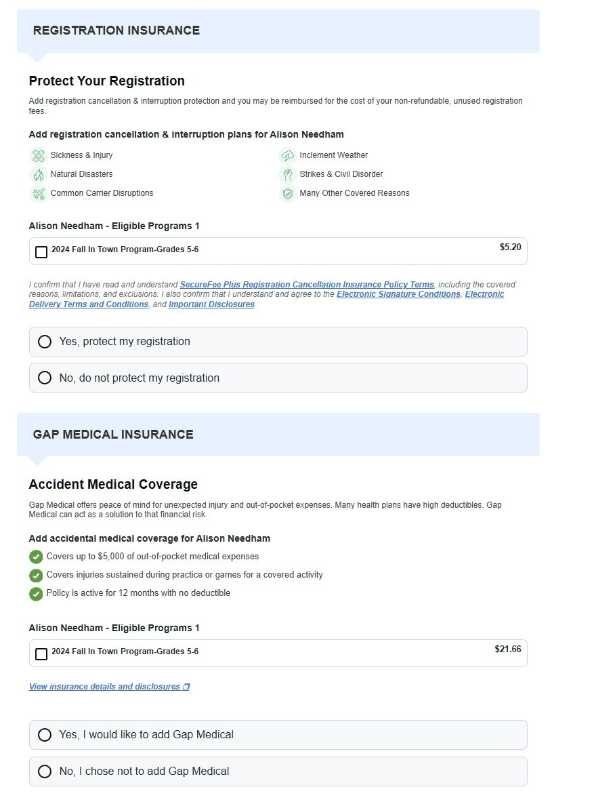

Additionally, we are looking for volunteer coaches.
During the registration process you will have the opportunity to register to be considered as a volunteer Head Coach or Assistant Coach. Please register for the role you prefer; you do not need to register for both. If you have players in two different divisions (ex: U10 and U12) and would like to be considered as a coach for both, then please register for your preferred role in each division. Please only register as a volunteer for yourself and not on behalf of someone else. Submission of volunteer/coach does not guarantee a position on a team. We will reach out with more information and next steps if you are selected to coach.
If anything changes, we will communicate this information to you.
If you have additional questions regarding the season or programs, please contact BYSA at:
info@bysa-admin.org.
We are looking forward to getting the fall seasons kicked off!
Thank you,
BYSA Board of Directors

