How to Print an Official MYSL Roster.
Step 1 - Navigate to: Reports / #22 "Soccer League/Team Roster Form Download"
Step 2: Set the; correct season, <select> "Middlesex", the league and team(s).
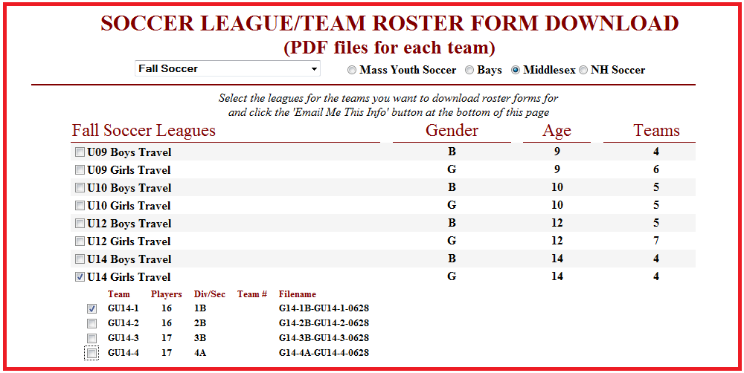
Step 3 - Request to have the pdf roster emailed to yourself or the coach needing the roster, by entering the appropriate email address. You should get an onscreen confirmation that an email was sent.
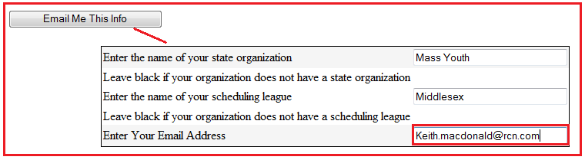
Note: The email roster will either display approved or unapproved. It is up to the age director or registrar to contact the MYSL registrar to see what is missing. All Coaches must have a photo on file and their birth date entered. Do Not Add a Coach without having this info first. If you are adding players or coaches after the rosters have been initially delivered you MUST email the MYSL Registrar and MYSL Boys/Girls Commissioners with the changes and reason for the change. If the changes are during the Spring Season then a player or coach player card will need to be printed and delivered... Hopefully this will change.

