How to process a player Refund Request.
Player refund requests need to be in writing. The BOD would like a filled out "Withdraw Request form" completed, But an email is usually sufficient (especially if the parent is irate).
Create a new spread sheet for each season to track withdrawals information.
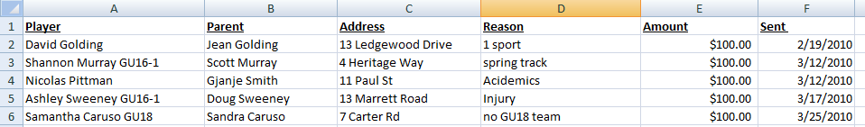
Log into sports manager to verify that the player had paid for the original session.
http://www.sportsmanager.us/BurlingtonSoccer.htm
Navigate to "Youth Players" and find the player. View the "Registration History" to see the exact amount that they paid.
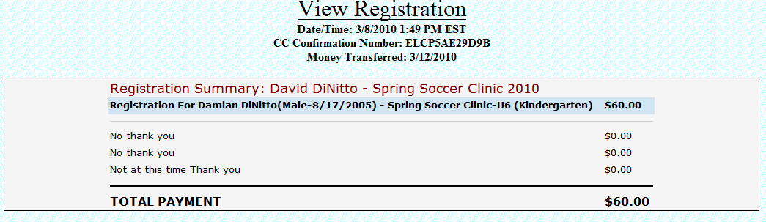
We only return the Full registration amount. We do not return "Late Fees". If the refund request prior to the roster freeze date then no refund charge is applied. A $25 processing fee is applied after the freeze. This helps defray the costs already paid to the League and MYSA.
Add a comment to the players profile that a refund was requested. <Click> Save, then <click> the "Active" button to remove the player from the roster/draft list. This will deactivate them from the season.

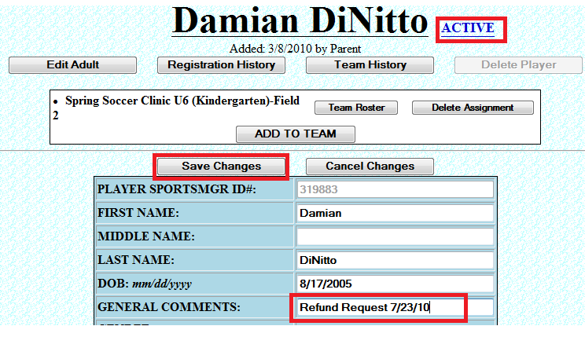
Then Send the treasurer the details of the request, so that he can cut a check.

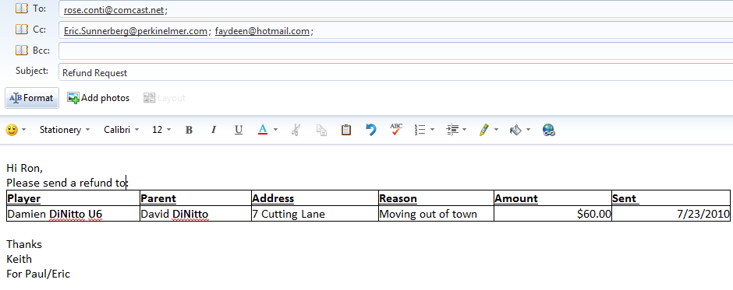

If it is during the season an email needs to be sent to either the Boys Commissioner or Girls Commissioner indicating the team and reason.
Donald Cowden<GirlsCommissioner@middlesexsoccer.org>;
Mary Packard<BoysCommissioner@middlesexsoccer.org>;
CC the MSLS Registrar: marytrogers@comcast.net;

