How to move players from the "Draft List" to their assigned Teams.
First login to Sportsmanager at: http://www.sportsmanager.us/BurlingtonSoccer.htm
Then navigate to:
Set the following; Year, Season, and Age Group for the players that you intend to assign.
<Click> on "View Report" to display the list of players.
<click> on "Assign Players" to bring up the team options for each player.
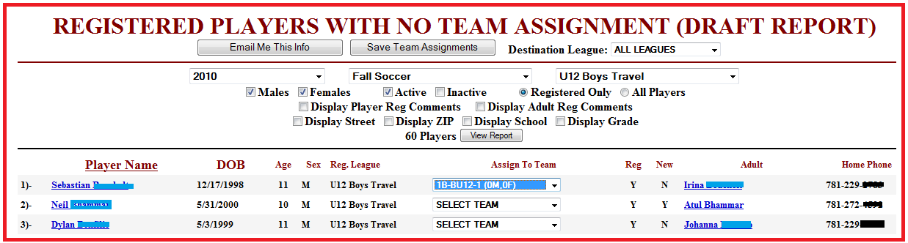
Under the "Assign To Team" there is a drop down box which will list all of the available teams to the players sex and age group.
<click.> and set the correct team for each player. If you are not sure of what team a player should be assigned to you can leave that player as "SELECT TEAM".
When you are set and are ready <click> "Save Team Assignments".
To check your work: Go to "Roster Management" or . Enter the; Season, League, and team Number. And check against your list.
Should you find a player that does not belong you can delete their assignment and they will be placed back in the draft. You can also add a player to a team if you are at the players profile page.

