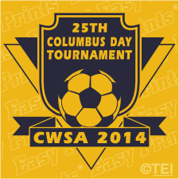
Columbia Windham Soccer Alliance invites you to join us at our…..
25th Annual Columbus Day Soccer Tournament
Saturday and Sunday, October 11-12, 2014
A community tradition for two sleepy Eastern CT towns the tournament has hosted 100+ teams from Connecticut and surrounding states for a full weekend of soccer and fun! Our silver anniversary is sure to be the best yet!
REGISTER AT WWW.CWSOCCER.ORG

- Great Food vendors-locally provided food vendors
- Soccer apparel, merchandise and delicious food for purchase
- Professional Photographer on site
- Fun family activities for entertainment
- Tournament tees/and apparel (including Under Armor)
- Easy, on-site parking
- Trophies for both 1stand 2nd place finishers U11+ age levels
- Participation medals for ALL U-10 and below teams
- Minimum of 3 games- played in Columbia or Windham, CT
- Affordable registration fees, and affiliated with gotsoccer.com
- Discounts to clubs sending for 4 or more teams(save 25.00 per team)
- Early bird discount (save if registered by Aug. 25, 2014, save 10.00 per team)

Thank you in advance for participating in our 25th Annual tournament. This has been our clubs main and enables our club to offer financial aid for any and all families who are economically challenged.

