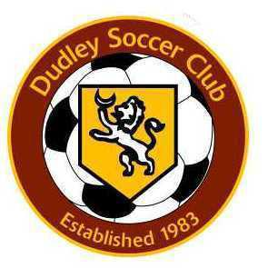

Date: September 18, 2020
RE: Game Day Requirements

The purpose of this memo is to share with you the following requirements for all teams (home and
away) for all games played in Dudley during the fall 2020 soccer season, If not otherwise specified here,
Mass. OEEA guidelines, MYSA / MAYS guidelines, and/or municipal guidelines must be followed at all
times.:

- Each player is allowed one (1) spectator at the game on the field. A 2nd spectator may sit in their car.
- Every spectator must wear a mask at all times at the field, from the time you leave your car until
the time you return to your car.
- Every spectator must maintain a physical distance of at least six (6) feet from others. It is
recommended to bring your own chair.
- Players must wear masks at all times, except when they are six (6) feet from others AND taking a
“mask break”, eating, or drinking. The expectation is that the mask is worn properly during
game play – over the ear masks, no gaiters, covering the nose and mouth
- Coaches are required to wear masks/gaiters that cover the nose and mouth
- Players are to be set up physically distant on the sidelines during games
- All games played will be using the modified rules and requirements set by MYSA / MAYS.

If you have any questions please do not hesitate to contact your opposing coach,
Erik Butzke(Ejb531@gmail.com), or Adam (acravedi@yahoo.com}.

