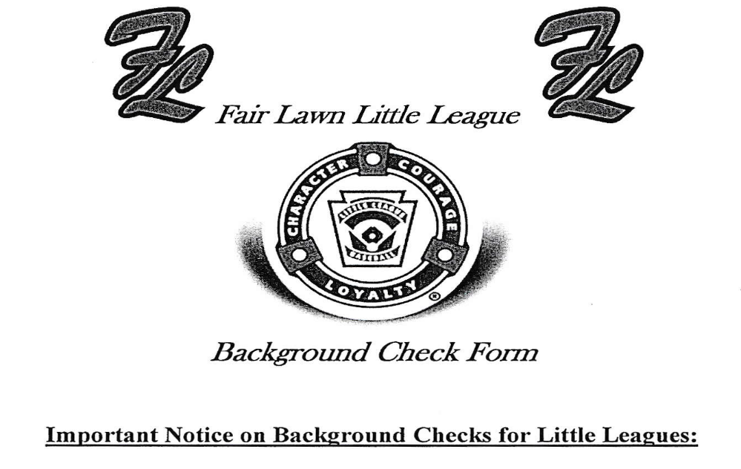
Little League International has contracted with First Advantage to provide local leagues with a special
Internet site that allows members to search a criminal records database of more than 350 million criminal
Records - instantly.
In order to assist Fair Lawn Little League in conducting this required background check, in conjunction
With First Advantage, we ask you to complete the form below.
This information will be utilized ONLY by the Fair Lawn Little League Safety Officer.
Legal First Name__________________________________________

Middle Name_____________________________________________

Legal Last Name__________________________________________

Social Security Number_____________________________________

Date of Birth_________________________________________

Address_________________________________________________

City /zip code_____________________________________________

Drivers License #__________________________________________

E-mail Address____________________________________________

Date received Rutgers Certification ____________________________
Are you a returning coach? Yes/No
Comments/ Additional Pertinent Information:

