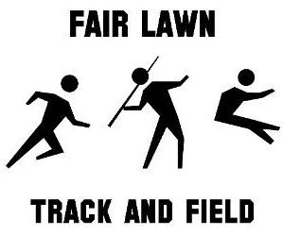
What: Annual Awards & End of Season Dinner
Why: To Celebrate the Athletes & New Friendships
When: Monday, June 10th 6pm-10pm
Where: The Terrace at Biagios 299 Paramus Road, Paramus, NJ 07652
How Much: Adults $30 each ; Athletes & Children 7-14 $20 each; Children Under 6 $15 each
Please join us at the End of Season Dinner for awards, dinner, dancing, and building friendships. There will be a cash bar available in addition to a tricky tray and 50/50 raffle. This is a great evening for the kids and adults alike. Admission includes full buffet, water, soda, D.J. and awards (cash bar for the adults ONLY). Future FLAS Junior Track & Field athletes born in 2012 or above will receive a medal during ceremony please provide their name below.
Please return payment and RSVP in a sealed envelope by Tuesday June 4 to Coach JAC. 52 Heights Avenue. Cell: 201.245.6083 email: flastrack@gmail.com
--------------------------------------------------------------------------------------------------------------------------------------------------
Name of Athlete(s) List Each Name Separately ___________________________________________________
_________________________________________________________________________
Names of Children Born before in 2013 or later List Each Name Separately_______________________________________
_________________________________________________________________________
Number of Athletes to Attend & Children ages 7-14 $20 each x __________
Number of Athlete’s Guests to Attend $30 each x __________
Number of Children (under 6) $15 each x __________
Total Number of Attendees ______________ Amount Due: __________

Checks to be made payable to FLAS Check # _____ Cash ______
This form and payment MUST be returned by June 4th!!!
IT IS VERY IMPORTANT THAT YOU PRINT CLEARLY!!!!

