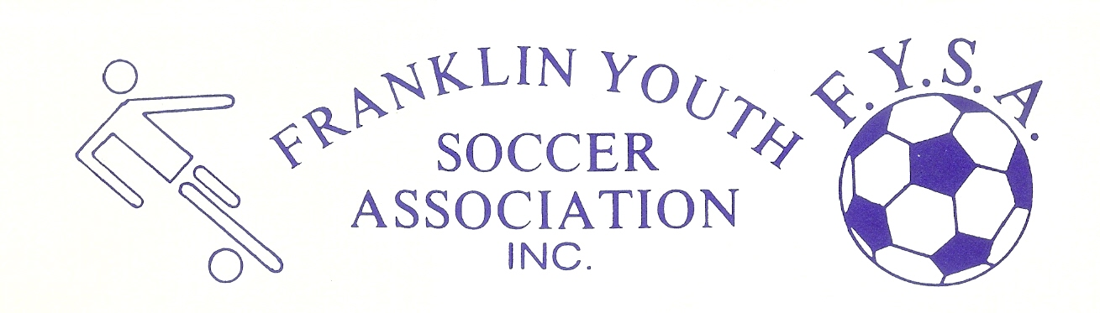Franklin Youth Soccer Academy Program – Game Day Spring 2023

- 5v5 play
- 2 halves of 30 minutes, with a five-minute halftime
- No offsides
- Defenders withdraw to build out line (dashed line on the field) on any keeper possession or goal kick
- Normal substitution rules
- Kindness & respect at all times for our very young refs—no disputing calls
- “Theme of the week” model
- Visiting player policy in effect (players can play in multiple games as needed)
- Standards for proper equipment and uniforms will be enforced by refs
  - Tight fitting clothes, hat, etc. under uniform – no jewelry
- Warm-up procedure
  - Arrive 15 minutes before kick-off
  - Avoid line drills and shooting on the goalie. Use a warm-up that relates to the theme of the week
- Additional Academy rules
  - No Heading
  - On goal kicks or keeper distributions, ball must touch the ground or a player before passing midfield
- Academy rules for adding / swapping players
  - When a game has a 5-goal differential, the trailing team may add a player.
  - After an 8-goal differential, the teams must trade players (don’t let it get that far)
- An Academy “Tournament” will be held at the end of the season.

