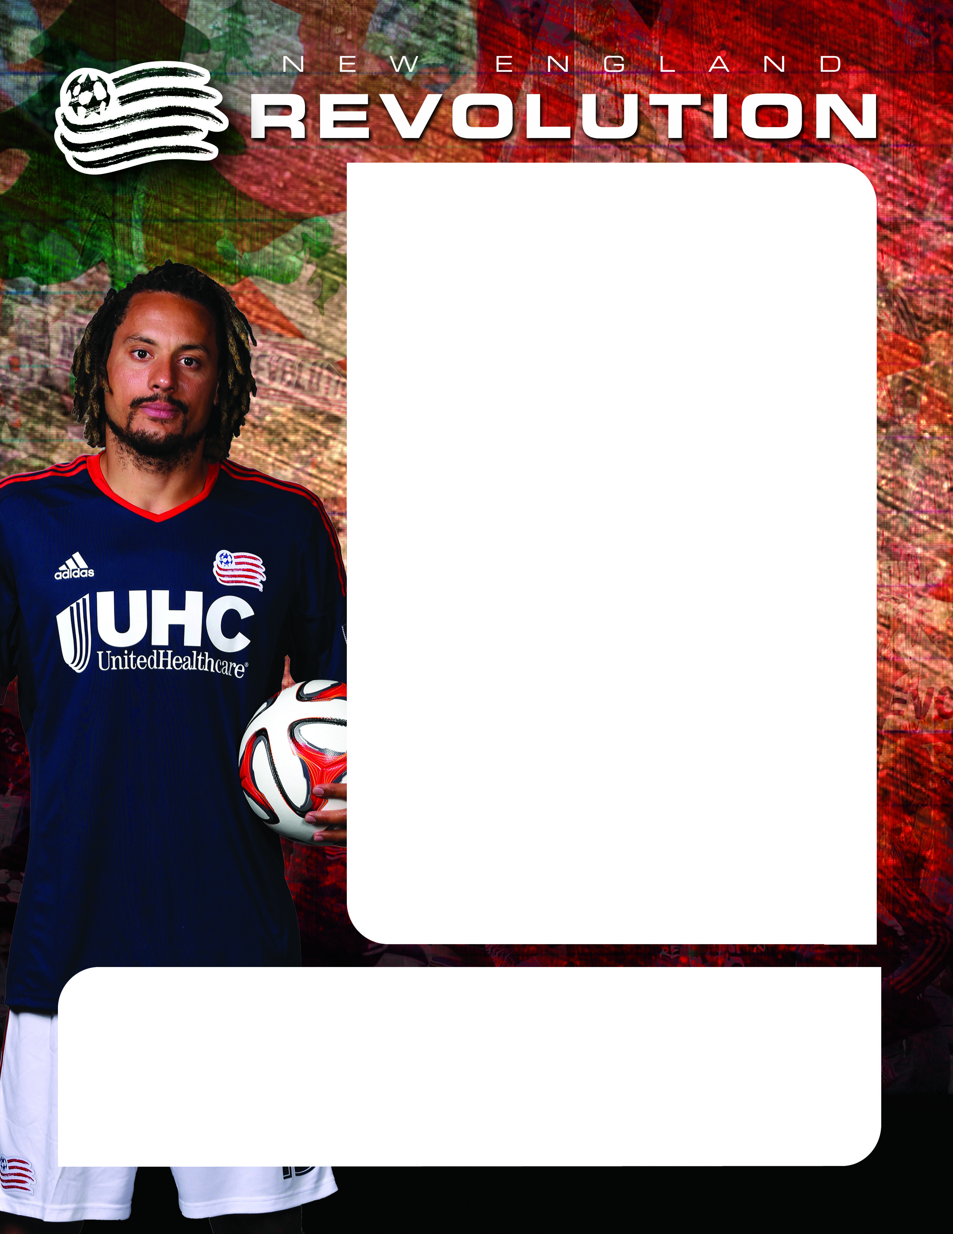

Grafton Soccer Night at the
NEW ENGLAND REVOLUTION

REVOLUTION
VS.
Montreal Impact
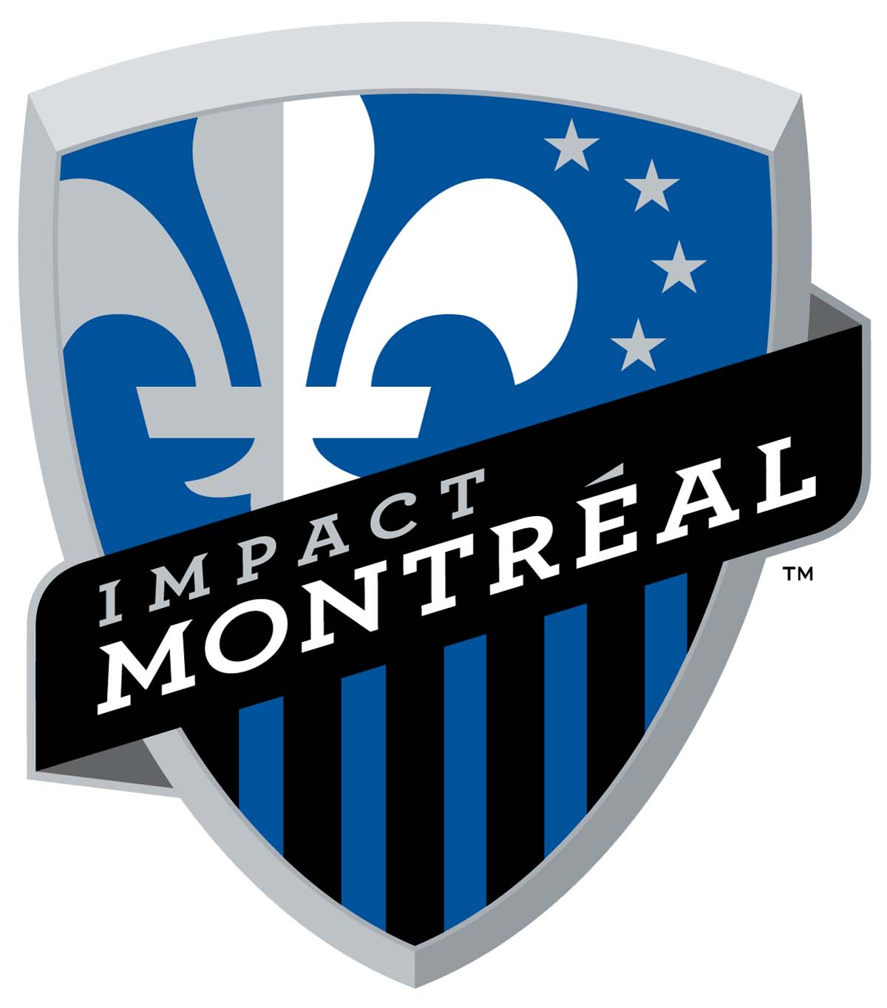


Saturday, October 17th
Kickoff: 7:30 p.m.
Gillette Stadium-Foxborough, MA
Come see Jermaine Jones and the
New England Revolution as they push for the playoffs against Didier Drogba and the Montreal Impact!
Featuring:
- Tickets just $25 each! (regularly $39 each)
- Seats with friends and family in the Grafton Soccer Club section!
FREE Parking for buses and cars!
Deadline to purchase tickets is Friday, October 16th
Revolution Contact
Corey Steadman, (508) 549-0487 or CoreyS@Revolutionsoccer.net

To order tickets, please visit the following link*:
http://tinyurl.com/GraftonSCRevsNight Promo Code: GRAFTON
*(the link works best in Chrome or Firefox browsers)
Please note: Limited seats in the Grafton Soccer Club section
Questions? Contact Ciro Toscano with the Grafton Soccer Club at ctoscano2468@gmail.com

