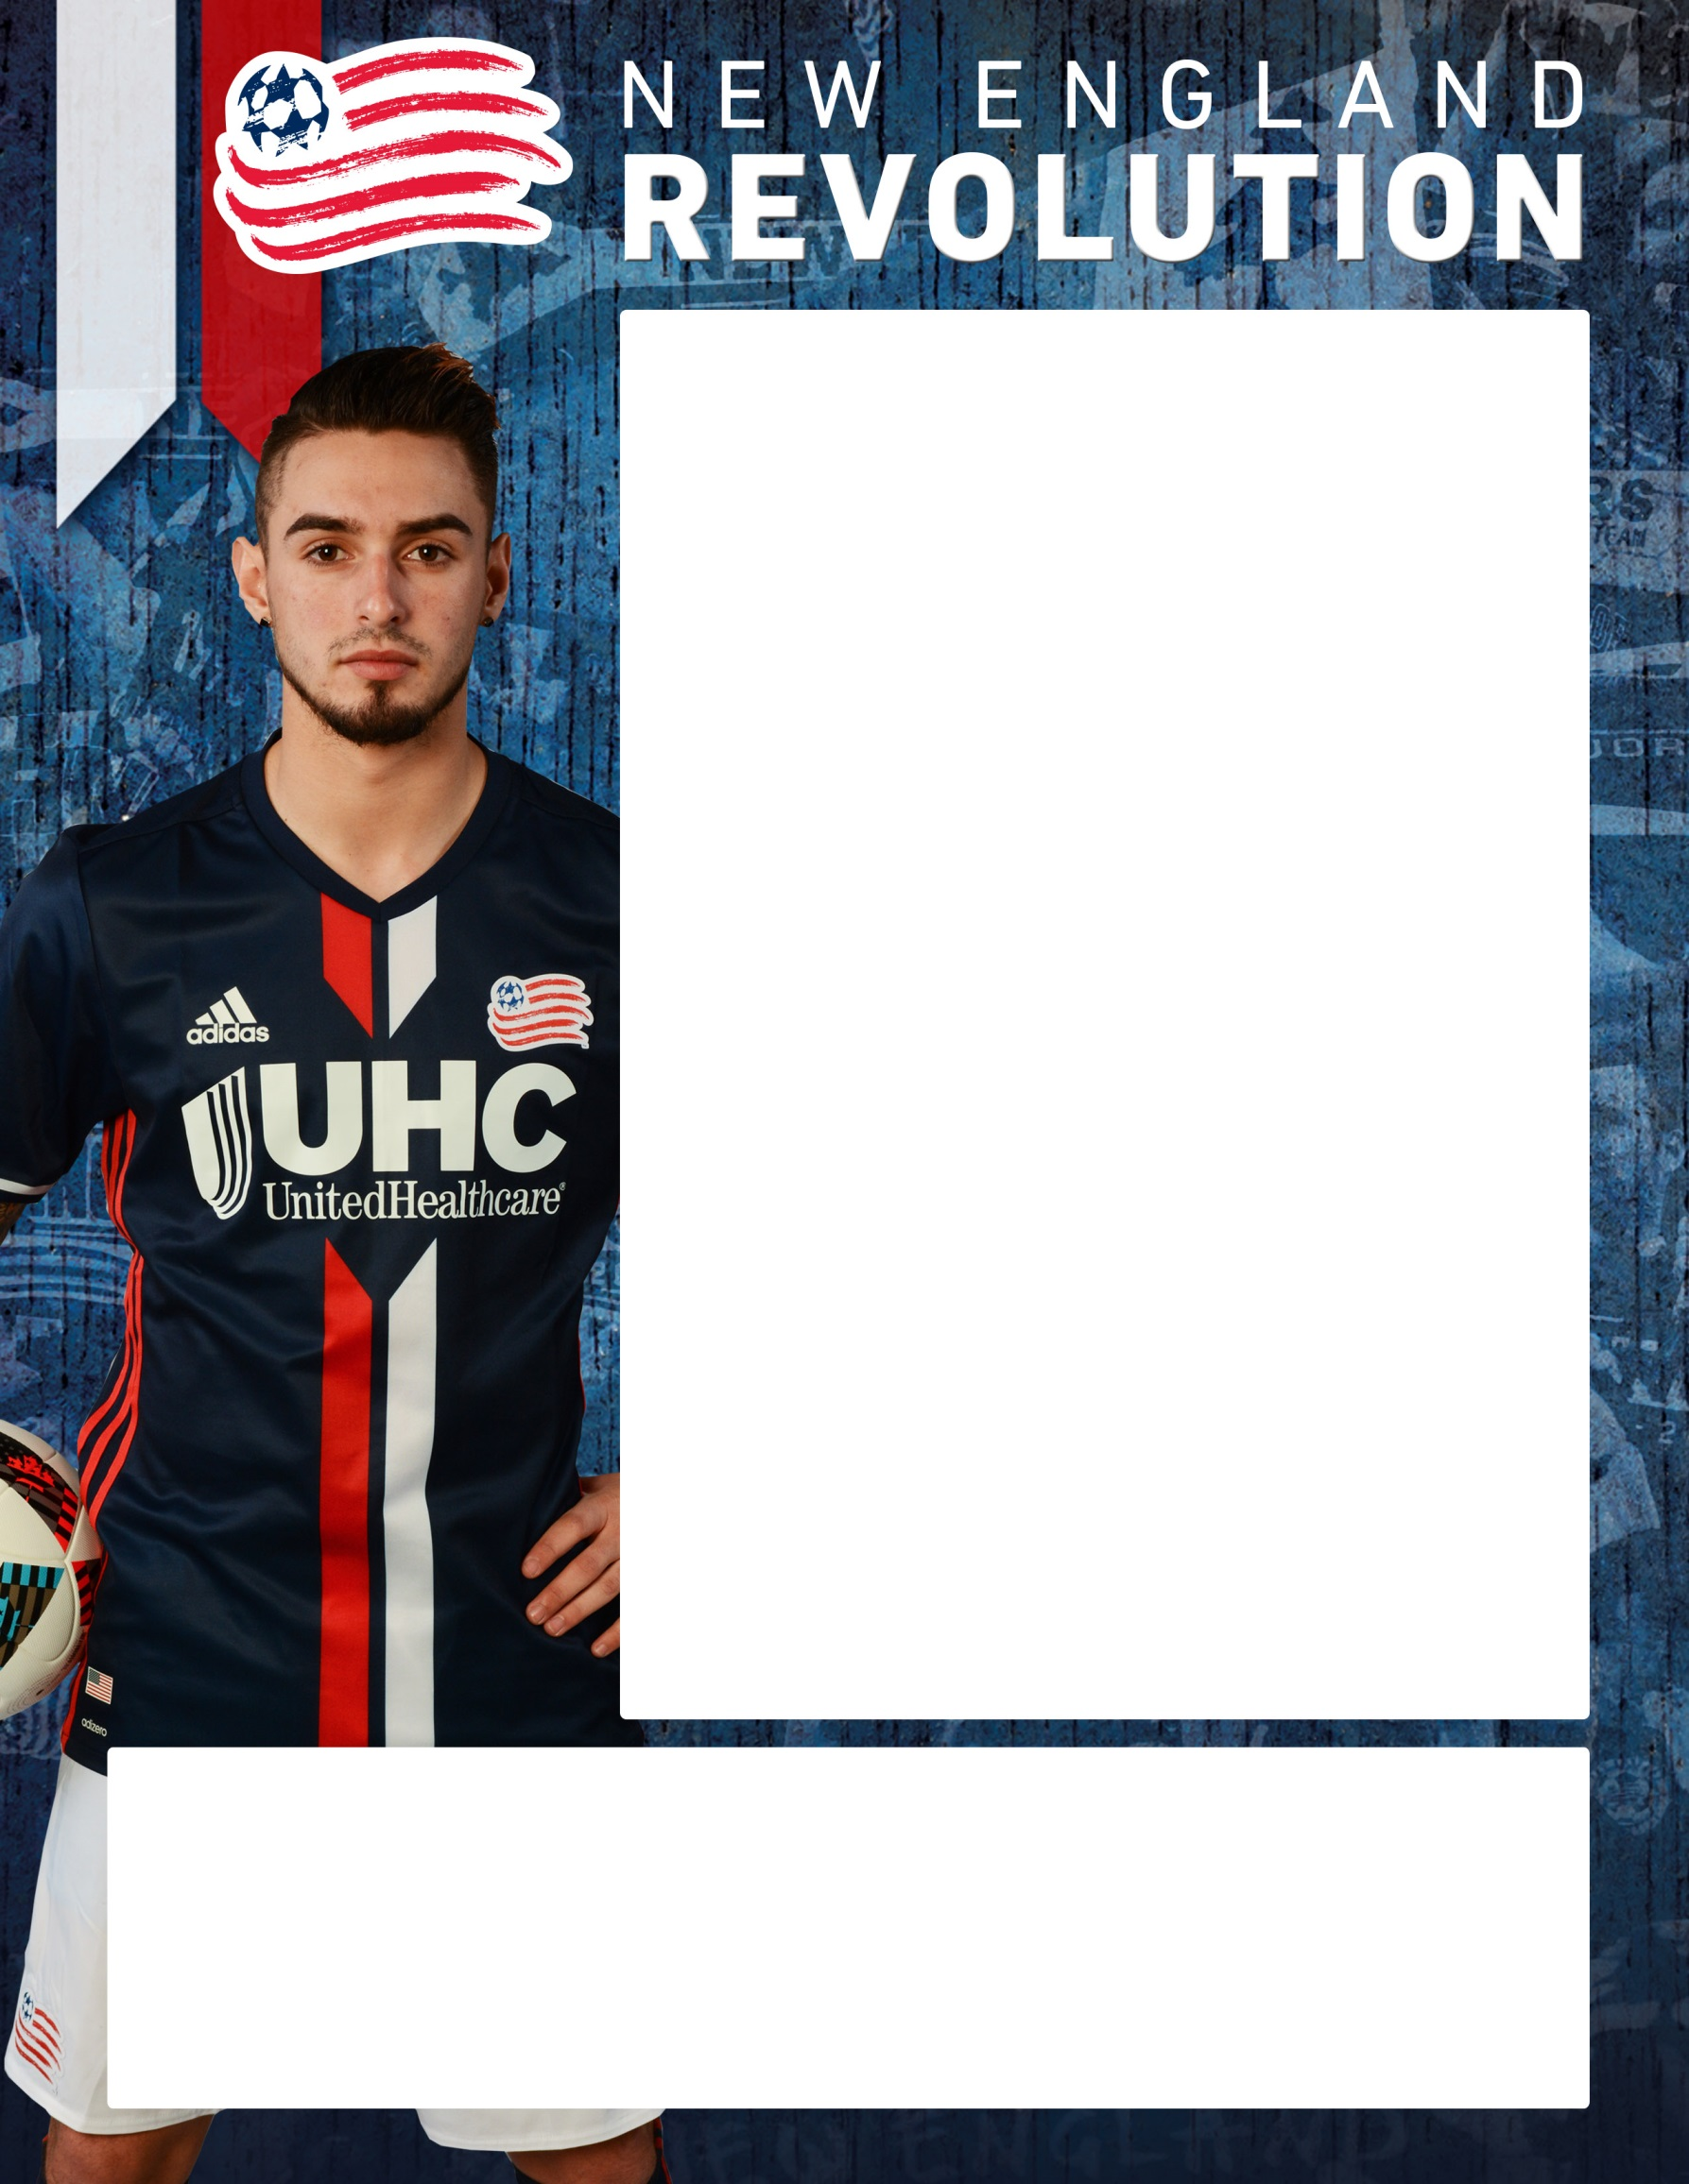
REVOLUTION ACADEMY
GRAFTON SOCCER CLUB: FALL SKILLS CLINICS – U8,10,12,14 and Keepers
The Revolution Skills Clinics are an opportunity for the Grafton Youth Soccer players to attend 8 comprehensive soccer training sessions during the Fall months. Each of the 60 Minute sessions guarantees to challenge the participant through a repetition of detailed technical exercises, while also allowing the players to develop the skills that they have just worked on through a series of conditioned scrimmages.

Age Group Day Field Time
U8 Tuesdays Lions 5-6pm
U10 Tuesdays Lions 6-7pm
U12 Thursdays Riverview 5-6pm
U14 Thursdays Riverview 6-7pm
Keepers Thursdays Riverview 6-7pm

ALL REGISTRATION THROUGH: GSC

For additional information or to Register visit:
http://www.gscsoccer.org

