  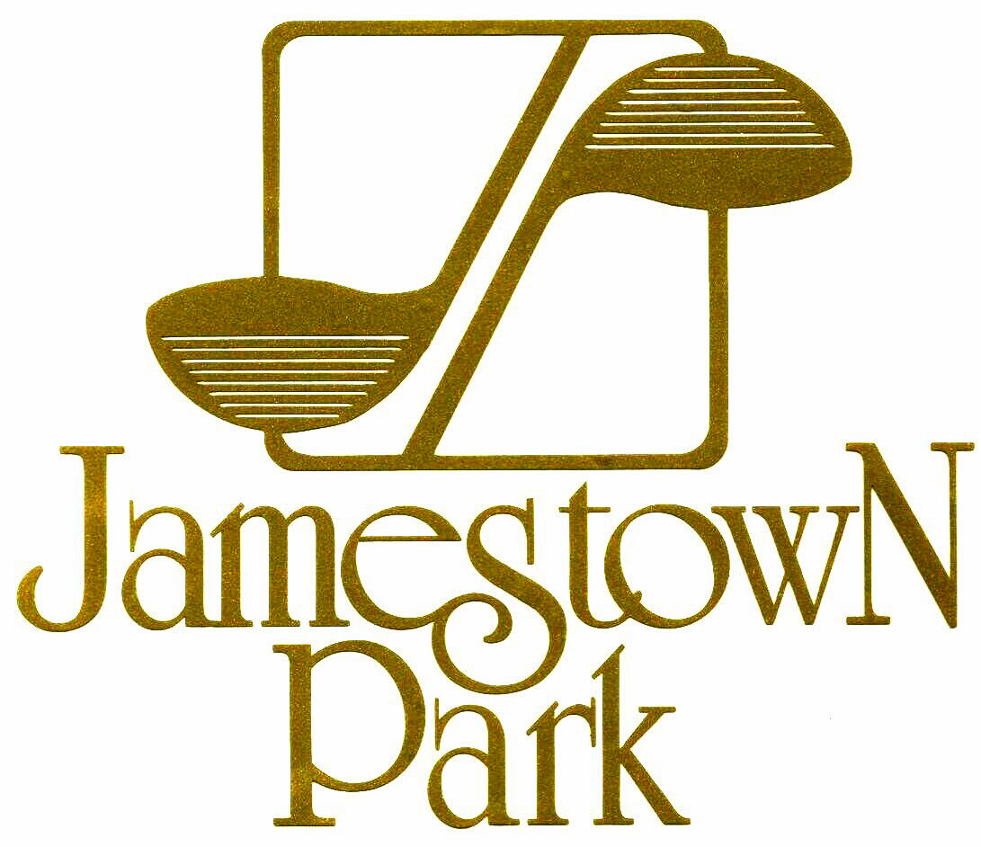
  public presentation
  of the
  parks & recreation trust fund (PARTF) grant
  for
  Renovation and improvement Projects
  at jamestown park
  Jamestown Park & Golf Course Clubhouse
  7041 E. Fork Rd.
  Jamestown, NC 27282
  Please come see proposed plans for Jamestown Park Improvements
  Voice your opinion
  Your opinion matters
  Thursday
  5:00 PM – 6:00 PM
  Voice your opinion
  December 12, 2013
  5:00
  336-454-4912
  Jamestown Park & Golf Course
  Recreation and Golf Course Renovation and Improvement Projects

