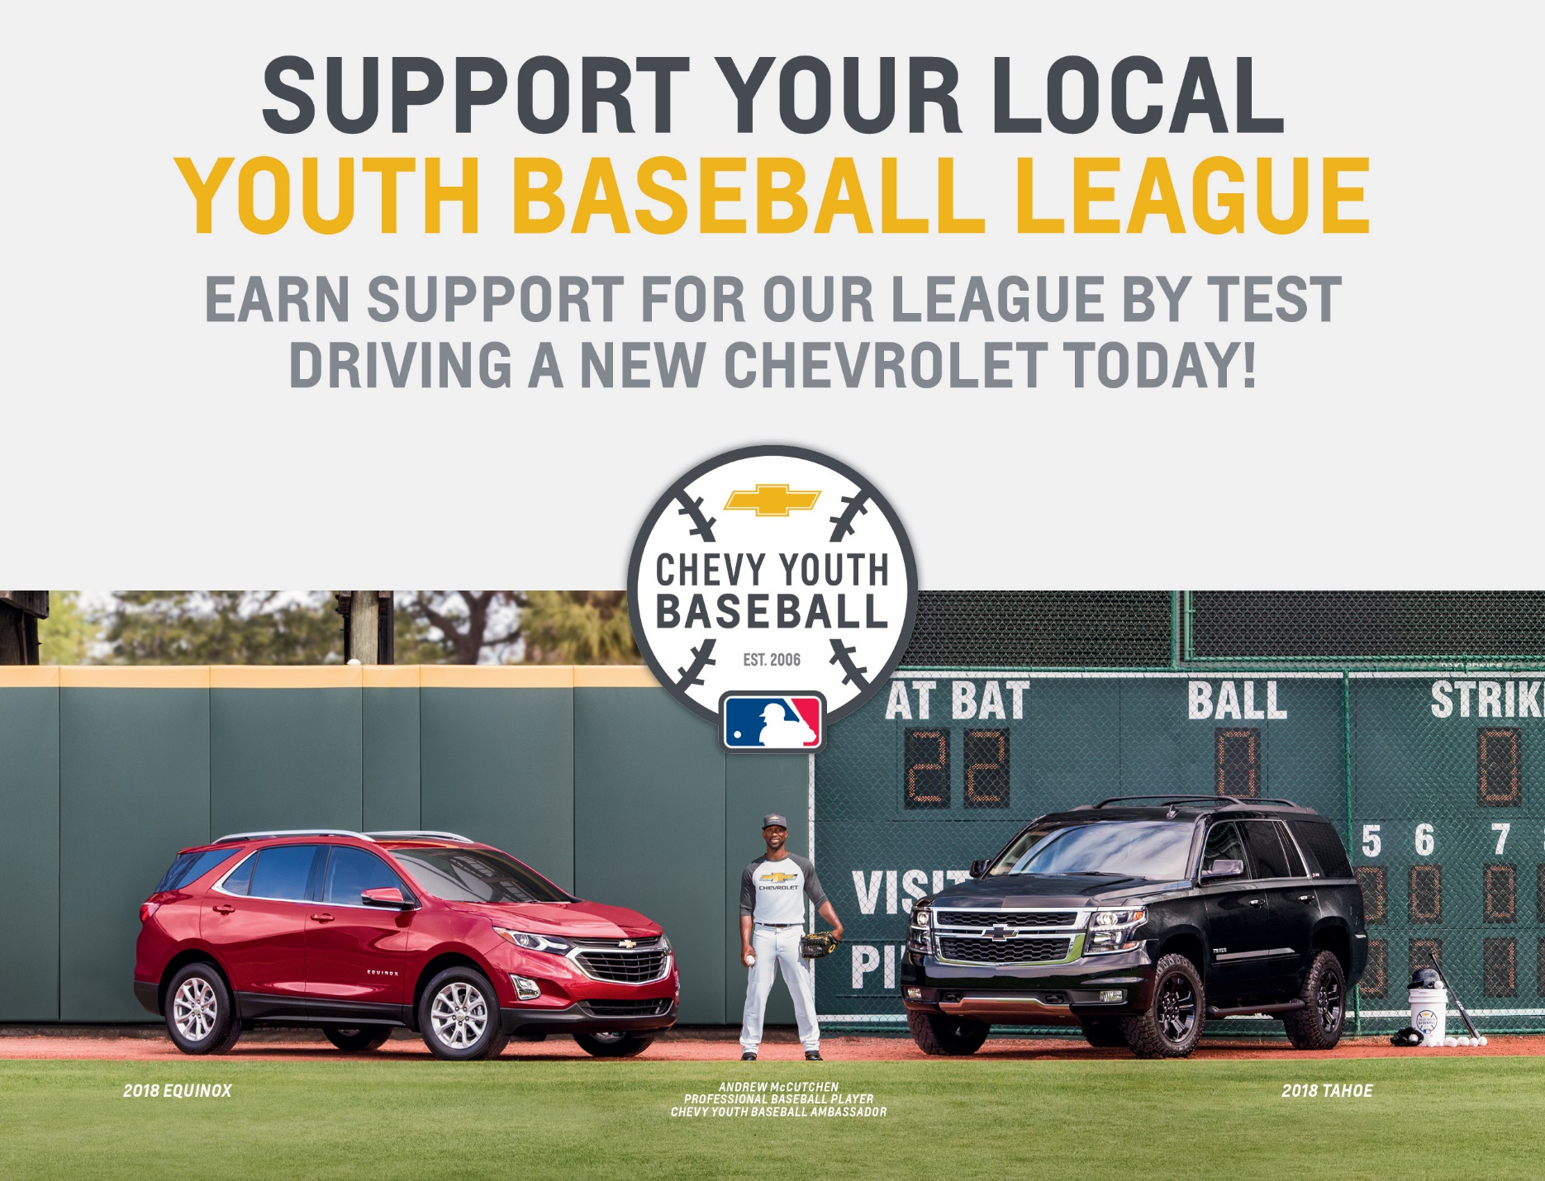
From now until June 30, 2018, Terry Labonte Chevrolet is donating $50 to Jamestown Youth League for each eligible test drive completed of a new (not used) Chevrolet vehicle, up to a maximum of 10 test drives or $500.

The contribution will be made upon completion of the validation process by a dealer representative at gmglobalconnect.com or by the consumer, with our help, at Chevrolet.com/experience. Please see our Chevy Youth Baseball representative,
Robert Siler, for more information.

IMPORTANT: Please complete the validation process on one of our computers
before the consumer leaves!!

