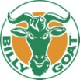The Goats are going to Nationals!!!
The Billy Goat Futbol Club Raytown U19 boys team is holding a soccer clinic Tues., July 15th, 2014. 100% of the Proceeds from this event go to funding of the Goat’s upcoming trip to the Nationals held in Germantown, Maryland. The clinic is geared to any U14 or younger boys or girl soccer players, who want to work on improving their foot skills, dribbling and shooting skills. Please come out and support the Kansas City metro based Billy Goat team as they charge forward in their quest for a national title.
Repeat after me……….”We BAAAlieve…We BAAAlieve…We BAAAlieve that they will win!”
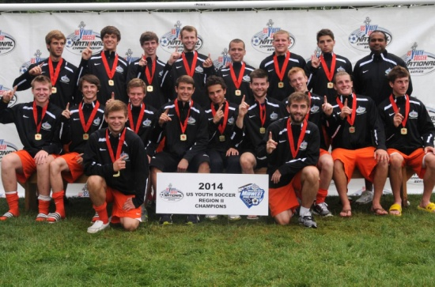
Why GOat to the clinic? Clinic Information Fun Goat facts:
All Goat instructors play collegiate soccer | Raytown Soccer Club fields  14200 E. 87th St., KC, MO  Tues. 07-15, 6:00 – 8:00 p.m.  Makeup rain-out day,  Thurs., 07-17, 6:00 – 8:00pm | All goats like to play on grass fields
Raffle for two tickets to an upcoming Sporting KC game | *Price for the clinic is $25 per person.  Cash or Check (payable to BGFC) | Goats are only gruff when provoked by other soccer players.
Support of the Billy Goat team gives you honorary membership into the Billy Goat Futbal Club | Please come prepared with a ball, water bottle and normal soccer gear including shin guards and cleats. | Contrary to popular believe, Goats eat more than grass. They have been known to consume large quantities of cheeseburgers, chicken wings and Chipotle burritos.

For additional questions, please contact: Joy Conyers @ 816-885-9287, or 816-524-1376

