Lowell Youth Soccer is very excited to announce our discounted Revs offer this Spring and Summer for everyone in our organization to take advantage of!

As part of the coordinating with the Revs, any family that is part of Lowell YS gets discounted seats to go to the game on June 24th and/or July 15th!

Gillette has been rocking while the Revs are hot so get your tickets early and sit with your friends from your team!
Tickets starting at $32 per person
Buy Your Tickets using this link here:
www.RevsGroups.com/Lowell

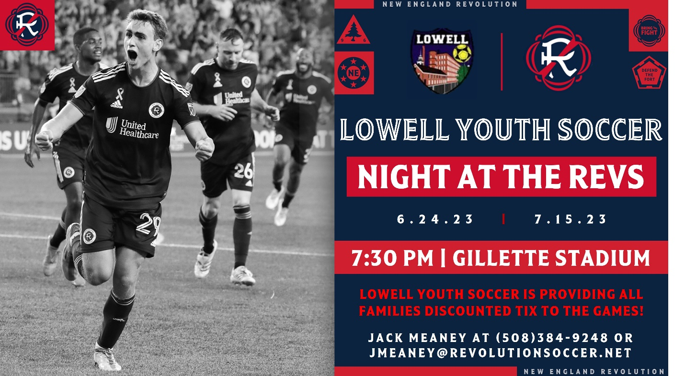

Want to organize your team to sit together, or want to make sure you sit next to friends? Please contact our Revolution representative Jack Meaney at (508) 384-9248 or email him at jmeaney@revolutionsoccer.net with any questions!

Backup Link:
https://revolution.spinzo.com/?group=ysmj-lowell-youth-soccer-4scj

