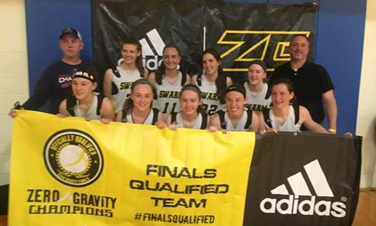

Girls K-5th Grade Basketball Clinics
Central Mass Swarm—10th Grade
5 week basketball clinic to support the 10th Grade Central Mass Swarm team
May 3rd
May 10th
May 17th
May 31st
June 14th
6:00pm—7:00pm
Elmwood Street School—Millbury
E-mail cjwilbur@yahoo.com today to reserve your spot

$50 donation to the team to travel to Washington DC in July
Make checks payable to Chris Wilbur
Any questions please e-mail Chris Wilbur at cjwilbur@yahoo.com

