Mansfield Youth Wrestling Gear
We are ordering… Singlet, Sweatshirts & Fight shorts

Singlet $65.00
 | SINGLET SIZE CHART
Size
YS |  | 40-60 lbs
YM |  | 60-75 lbs
YL |  | 75-90 lbs
XS |  | 90-110 lbs
S |  | 110-130 lbs
M |  | 130-155 lbs
L |  | 155-185 lbs
XL |  | 185-225 lbs
2XL |  | 225-275 lbs
3XL |  | 275-340 lbs
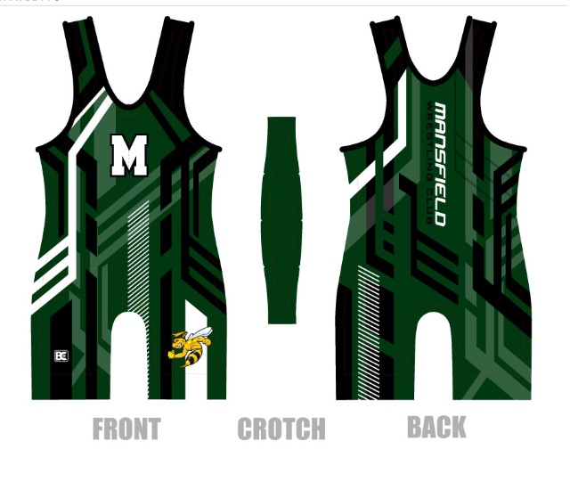

Fight Shorts $35.00
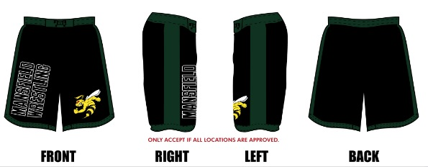
Sweat shirts $ 40.00
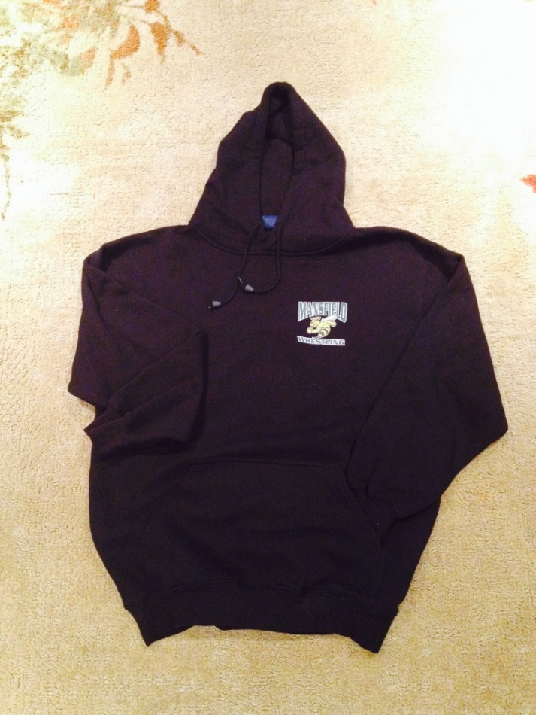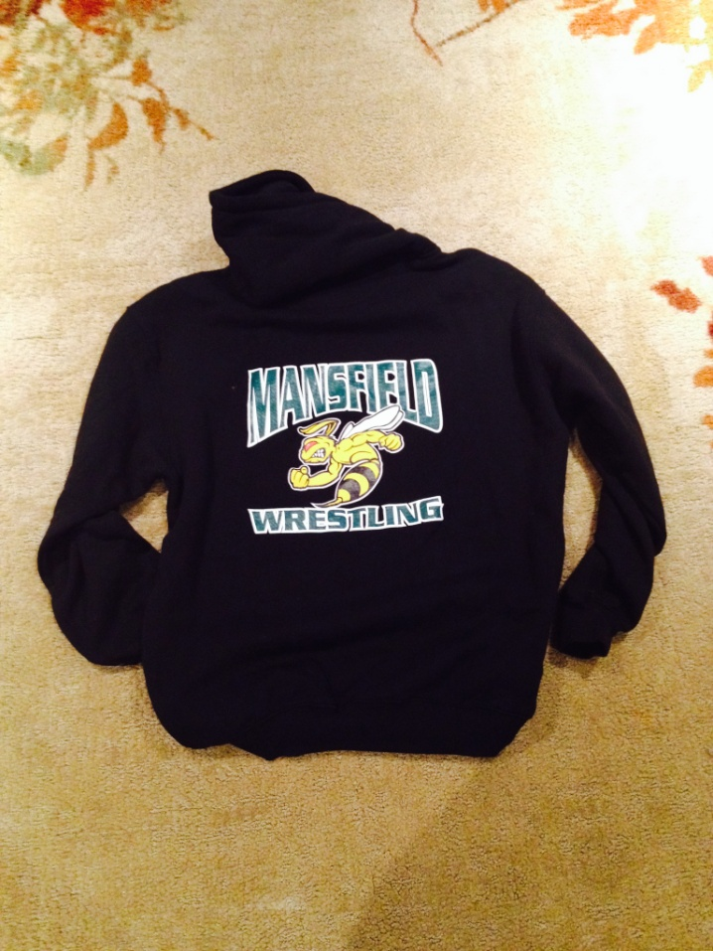

If you are interested in purchasing any of these items, please follow these steps;
- Fill out the attached order form.
- Place check in an envelope (checks made out to Mansfield Youth Wrestling).
- Place the order form in the envelope, with the money & write your child’s name on the outside.
- Pass in orders to Coach Lou NO LATER THAN THURSDAY 1/9/14!
We are NOT accepting e-mailed forms, (it would be too much to collect separate from the money.)
These items are being sold at cost!
Mansfield Youth Wrestling Gear

Name _________________________________
Parent name ____________________________ phone (_____) _____-_______

Please enter the QUANTITY in the chart below.
 | YS | YM | YL | XS | S | M | L | XL | XXL | Price
Singlet $65.00 |  |  |  |  |  |  |  |  |  | $
Fight Shorts $35.00 |  |  |  |  |  |  |  |  |  | $
Sweatshirt $40.00 |  |  |  |  |  |  |  |  |  | $
TOTAL COST |  |  |  |  |  |  |  |  |  | $

Name as it will appear on the Sweatshirt

PASS IN ORDERS TO COACH LOU SEVASTOS NO LATER THAN THURSDAY 1/9/14!

