Instructions to Add High School Team (or any team)
Into BAYS.ORG

Log on to www.BAYS.ORG
Pull down Administration Menu
Click on Unified Logon
User Name JBLOOD1 (first character of first name, last name)
Password is MYS123
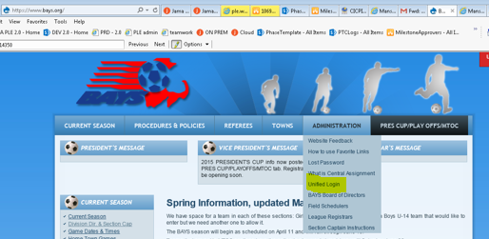

Go to left nav bar and find REGISTRATION
Click on Team Registration
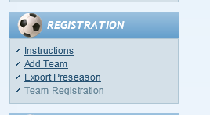

Fill in Details. This is where you request the division for the teams to play in.
Instructions for page https://www.bays.org/node/213
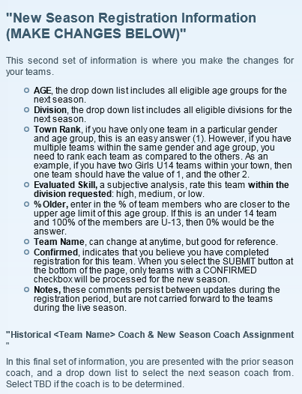
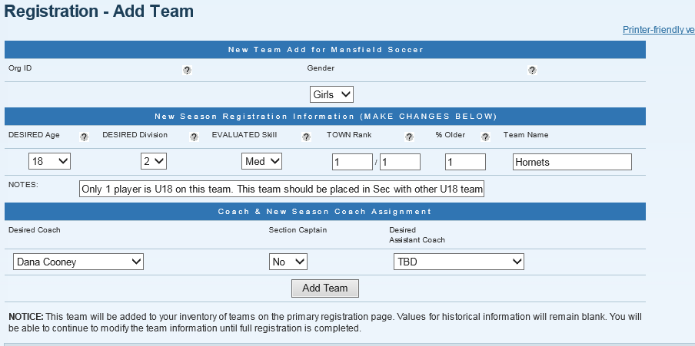

After clicking on Add Team you are presented with this page. Check team is correct.
OR if you need to change the team at any time use this menu option
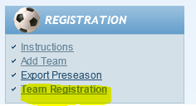

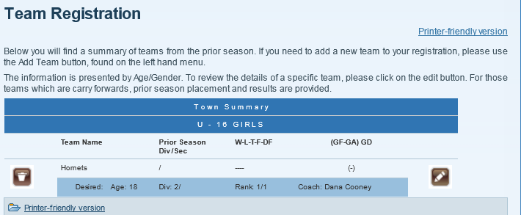

Click on the EDIT button

From this page you MUST CONFIRM the team so BAYS knows to schedule the team.
You don’t need to worry about the prior season information, these teams were not prior season teams.
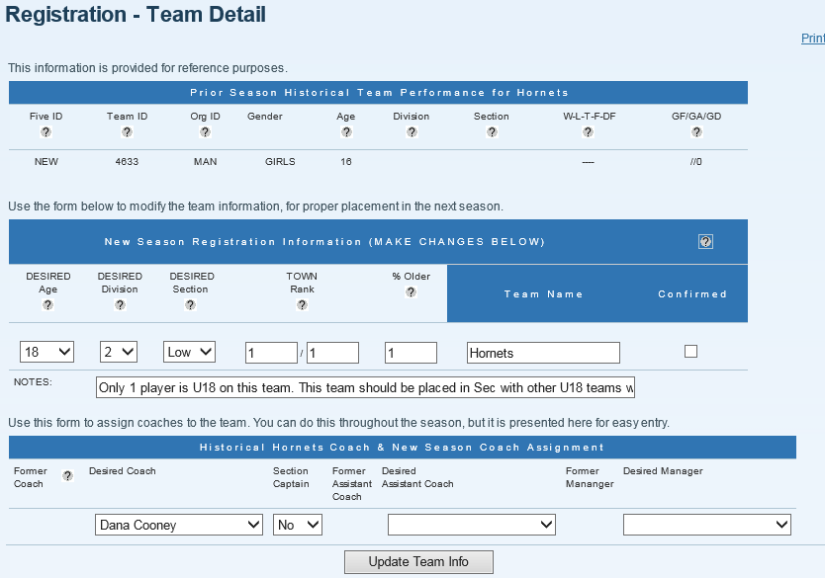
Next step is to wait until BAYS gives the new teams a team number
Then you need to assign fields
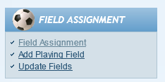
Then you need to sign up for central assigning for referees
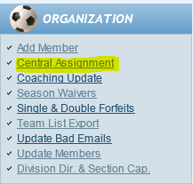

Then view invoice and send the update to David Santos
