
Stamp your personal touch into the history of Mansfield Youth Soccer ! Proceeds from the bricks will go towards supporting the completion of the new synthetic turf field, the largest recreational project in Mansfield in years.


Bricks will be installed at the entrance of the new synthetic turf field at Plymouth Street Complex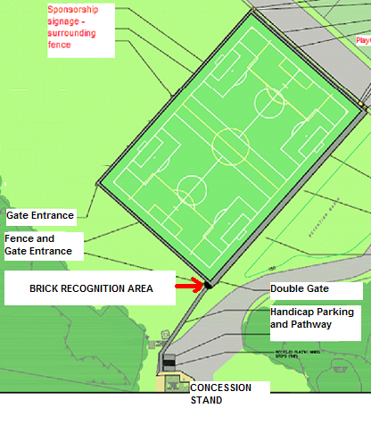
Bricks are available in two sizes.

8x8 – 6 lines of text – 18 characters per line 4x8 – 3 lines of text – 18 characters per line
$200.00 per brick $100.00 per brick
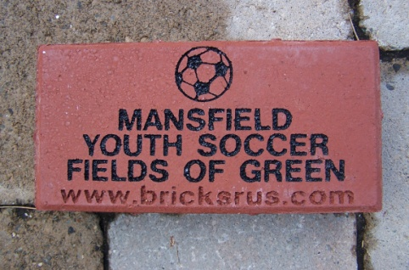
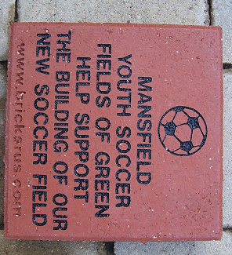

Order quickly… limited space… limited supply

