LIBERTY BELL TEAMS WITH MHS BOYS SOCCER
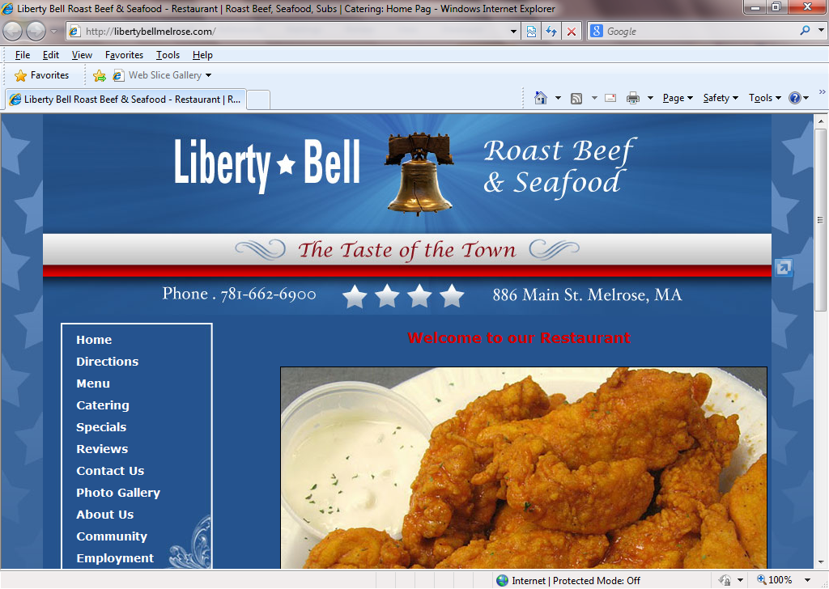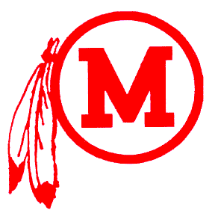

Wed., October 22, 2014 ◊ 5:00 – 8:00 pm

Come join us for dinner.
Help raise money for the MHS Boys Soccer program.
All you have to do is let Liberty Bell do the cooking! Take out or Eat in Liberty Bell will donate a percentage of the evening’s proceeds to the team.

It’s that simple!

We will also be selling stadium seats-$30, string backpacks-$10, and Melrose decals-$3 each or 2/$5.

