How to Register for CORI in Korrio
Step-by-Step Guide For Adults Requiring a Background Check

Mass Youth Soccer has prepared these instructions to support our members with a step-by-step guide for registering for a background check. This year, we will be using Korrio, the official sports automation platform of Mass Youth Soccer.

Why do I need to sign up for CORI in Korrio?

- Easy Status – by logging in to Korrio, you will now have the ability to see the status of your background check verification process and expiration date. Likewise, your club or town also has the same ability.
- Less Hassle for You– with this automated tool, adults will only require a background check every two (2) years, instead of ever year as we have in the past.
- Less Hassle for Club/Town and MYSA Administrators – automated workflow saves everyone time and helps keep our kids safe.

Need Help? If you need help with your Korrio username or password, identifying the URL of your club’s Korrio website, or have any other general support questions, please contact Tamie Endow, Director of Member Services, Mass Youth at tendow@mayouthsoccer.org, or 978-466-8812 x235.

PART 1: Registering for CORI

1. Go to your club’s Korrio website. If you have not received the URL, please contact your registrar.

2. Click on the Programs Tab

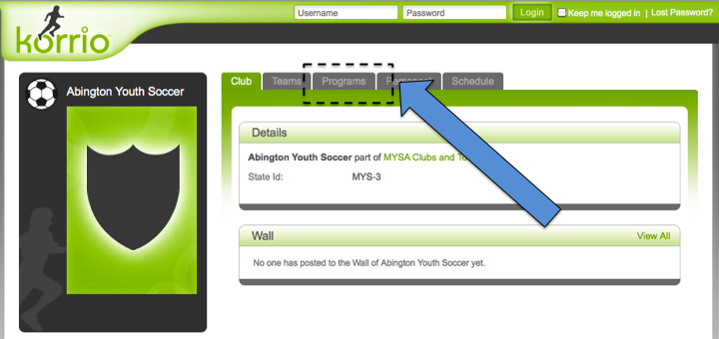

3. Click on Sign Up Now for the program labeled “MYSA Cori Registration”

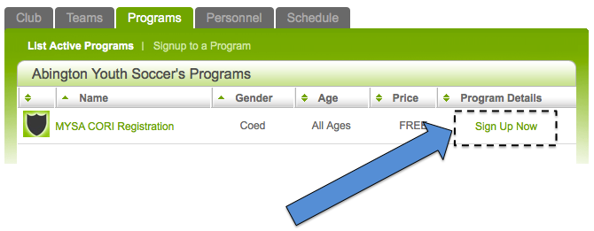

4. If you do not have a username and password, click on “Help me lookup my account” in bottom section of green box.

IMPORTANT NOTE: As part of the CORI process, your club registrar already imported your information into Korrio. This process created an account for you with basic information. When you click to look up your account, Korrio IS retrieving your account for you.

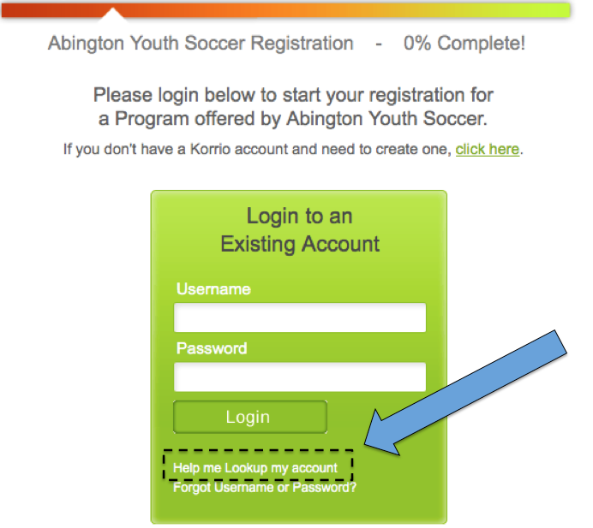

5. Enter your email address and click Lookup Account

IMPORTANT NOTE ON EMAIL ADDRESS: Please use the same email address that you use for other club or town use. If you do not know what this is, please ask your club/town registrar.

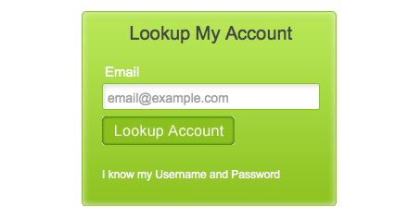

6. Go to your email account and open the email from Korrio to retrieve your username and password

7. Enter your username and password into login screen

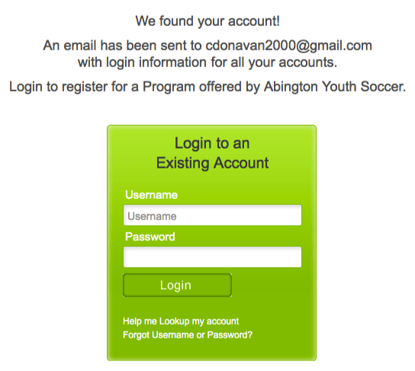
8. Click “Login”

9. Click “Next”

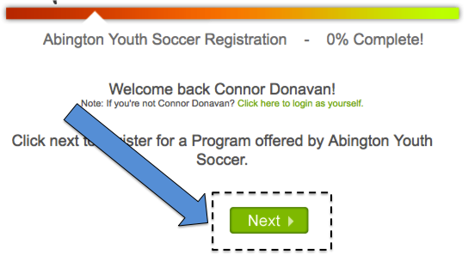

10. Click on your Name and click “Next”

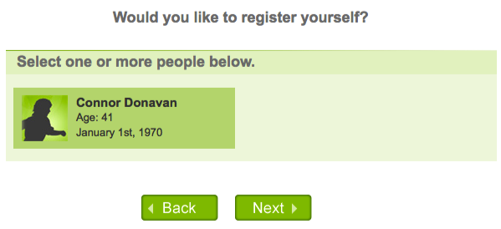

10. Click on MYSA CORI Registration, and click Next

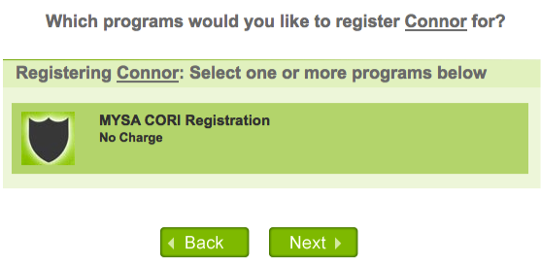

11. Enter ALL information for Volunteer Application and Disclosure Statement

Note: By filling out this form, you are agreeing to the CORI background check process.

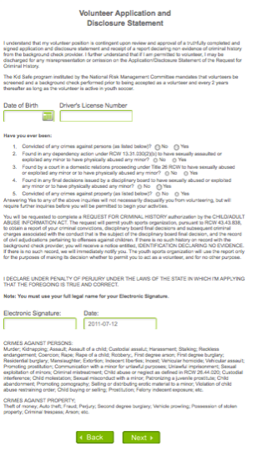

IMPORTANT NOTE ON DATE OF BIRTH FIELD: Korrio’s DOB field works slightly different than other systems.

- First choose the year
- Then the month
- And lastly the day of month

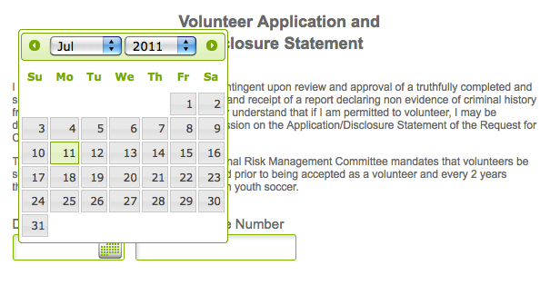

Note on Electronic Signature: Please enter your full legal name.

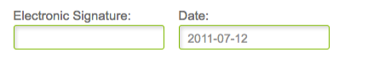

12. Follow the system prompt and click next until your registration is complete.

Continue to PART 2: Checking Your CORI Status on the Next Page

PART 2: Checking Your CORI Status

1. Go to http://korrio.com

2. Enter your username and password



3. Once you are logged in, click on the My Profile Tab



4. Check your Background Check Status

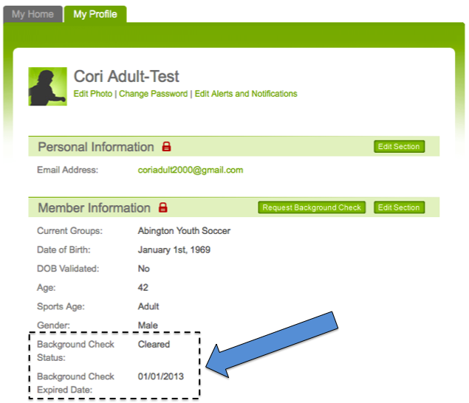

Thank you!

