First Time this year? Fall 2021/Spring2022

MAYouthSoccer.org
Administration
Adult Registration Process
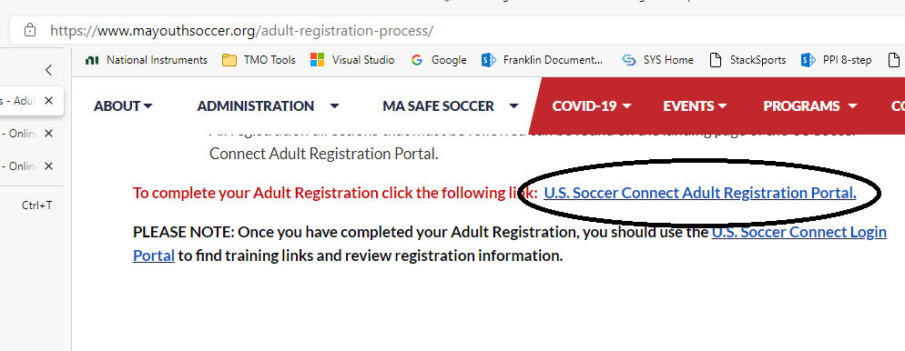
Which will give you the Blue Button

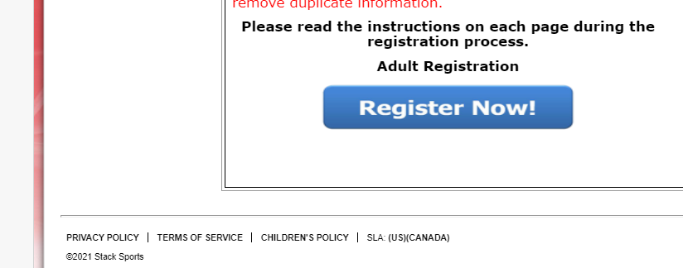

Which gets you to this choice.
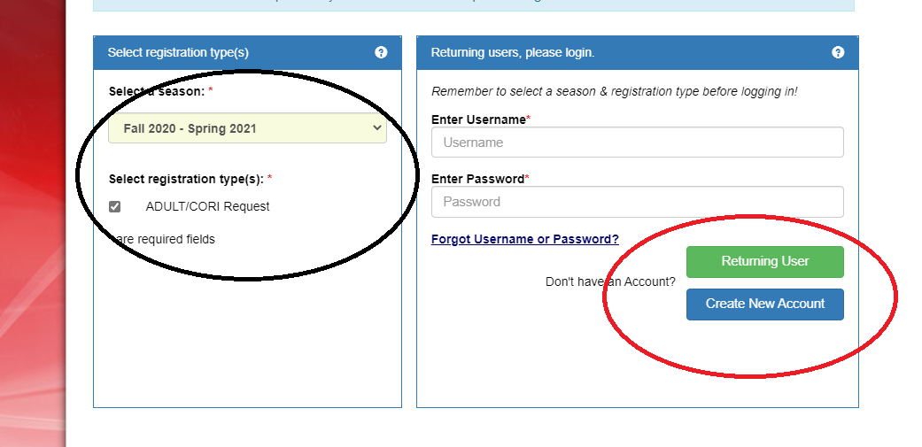

This will register you with MYSL for this year.
From here you will have an opportunity to choose SYS… Sign(initial) the EULA…

If you were registered for SYS before, use the Returning User Button
Once that has been completed….

Back to MAYouthSoccer.org
Administration
Adult Registration Process
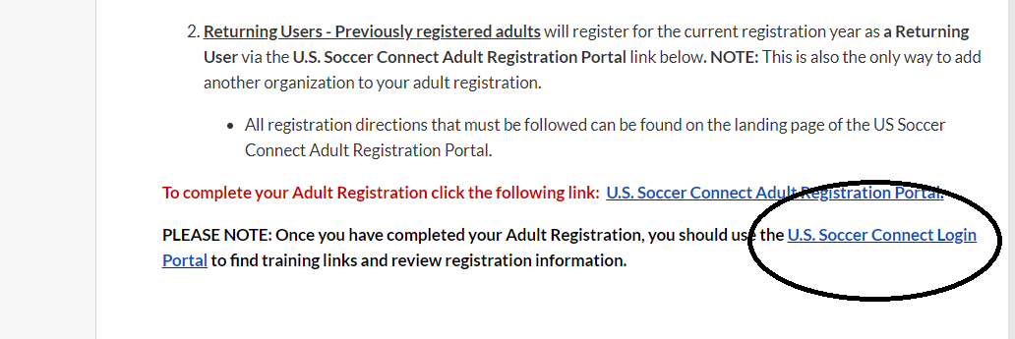
Log in using the same Username/Password
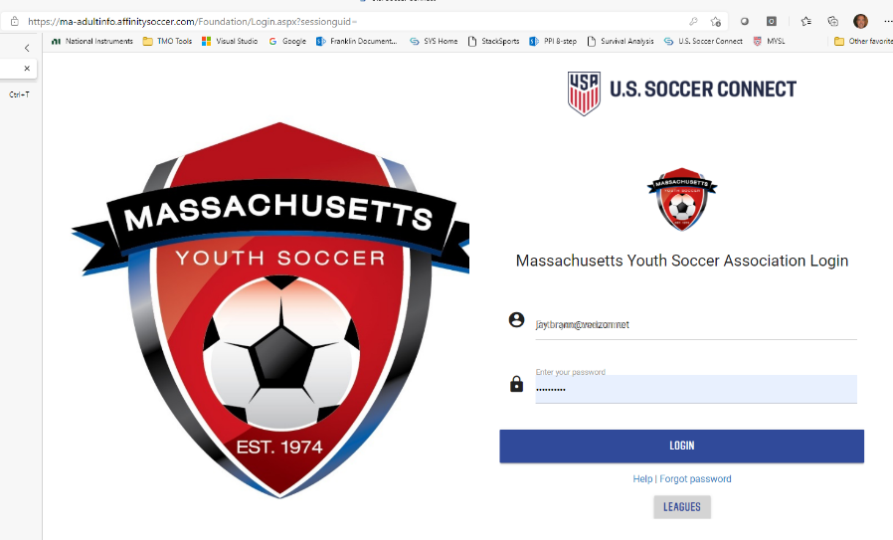
Now you can Manage your Account /Certificates
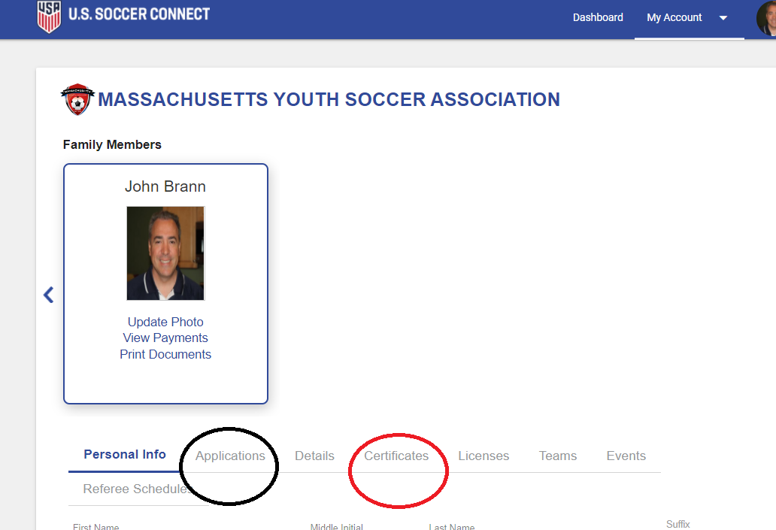

Now Your Certificates
