The Auburn Yoga and Pilates Center and PAWS are teaming up to raise money for Spencer’s Wire Village Elementary School playground in a 5 hour

Pedal for the Playground
Spin-a-thon

Saturday, March 25th, 2017
at The Auburn Yoga and Pilates Center

ALL LEVELS WELCOME!!
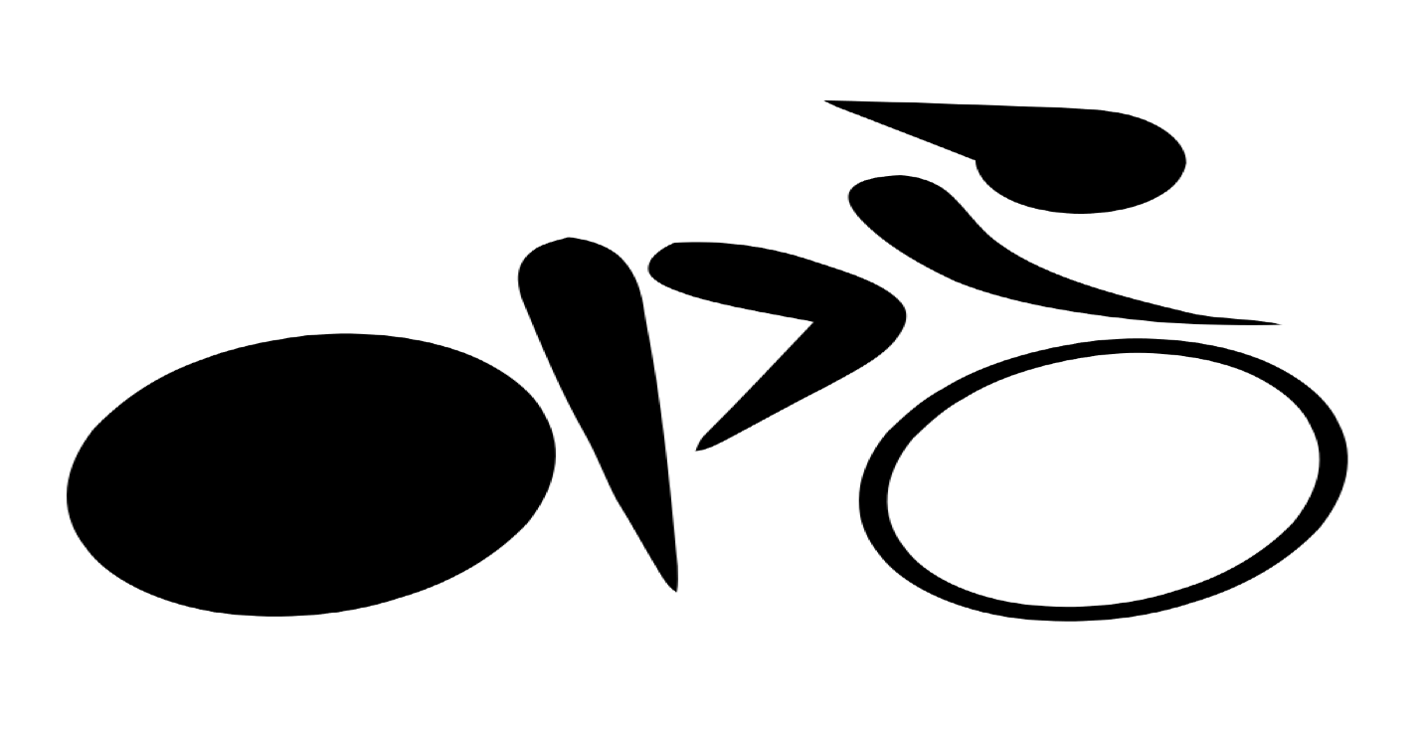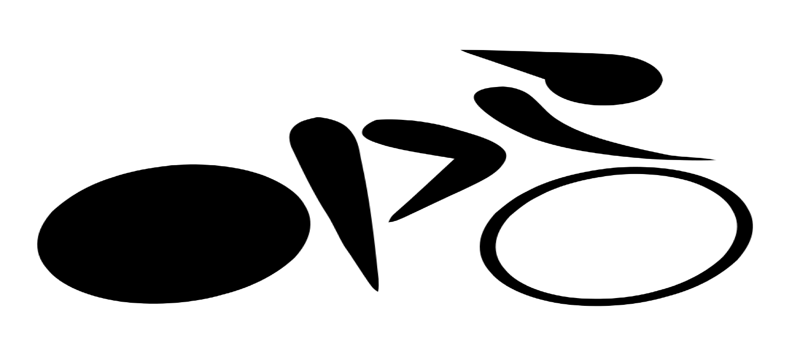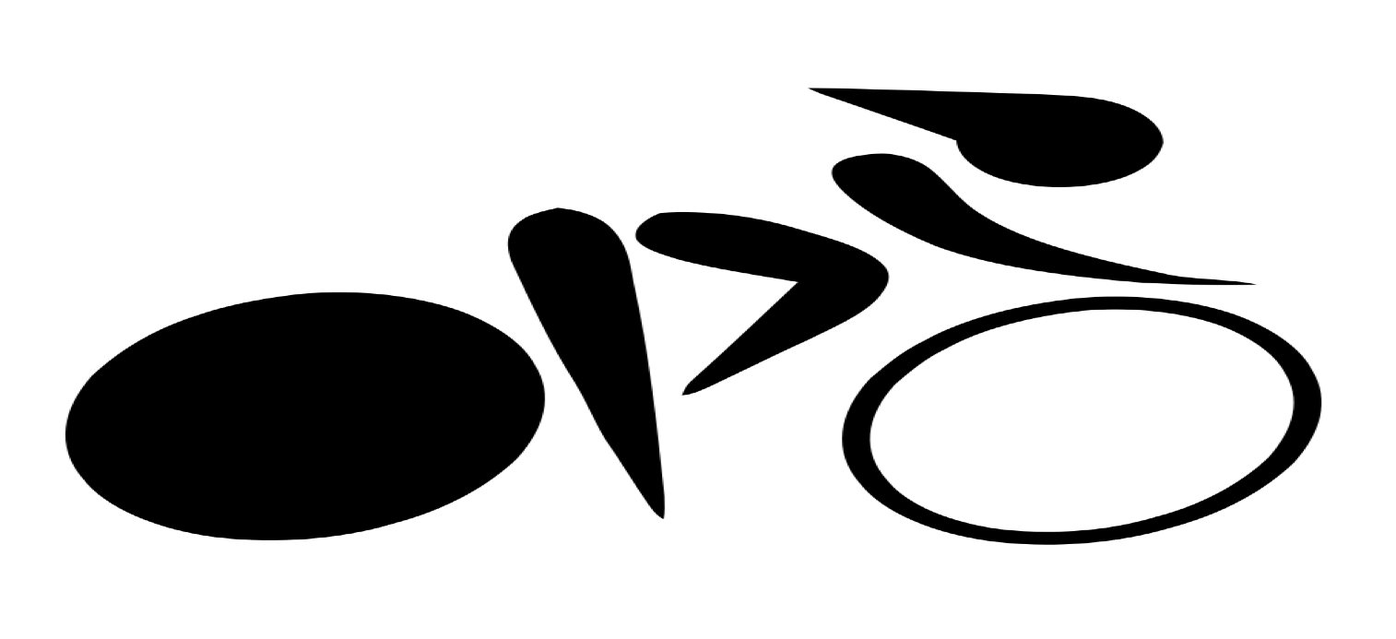
Five 45-minute Spin Sessions to choose from
(choose 1st, 2nd and 3rd preferred time(s)):
2pm-3pm: Family Fun Part 1 (bring the kids along for supervised games while you spin)
3pm-4pm: Family Fun Part 2 (with more games for the kids)
4pm-5pm: Time Travel Tunes + Big Kid Yoga (bring your 8+ year olds for yoga while you spin)
5pm-6pm: Movie Tunes (adults only)
6pm-7pm: Glow Stick Spin (adults only)
Mini yoga stretch after each session

Contact Jenny Schold at jpiconeschold@yahoo.com to register,
or fill out attached registration by March 22nd
*$10 per session * Additional pledges welcome! * Registration fee waived for $50 in pledges!
Checks preferred, payable to PAWS, sent into school or brought to event
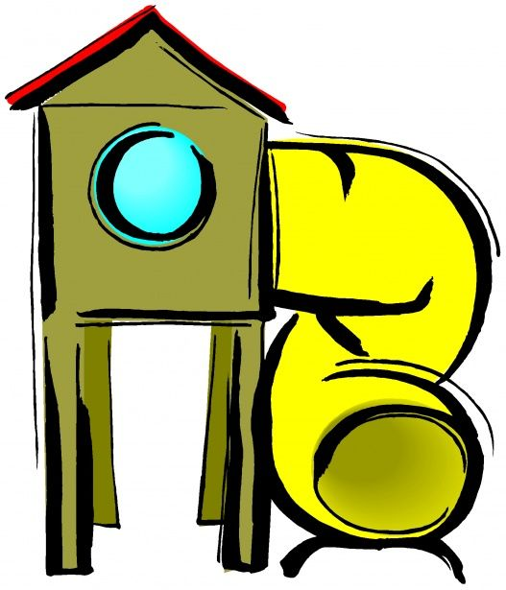
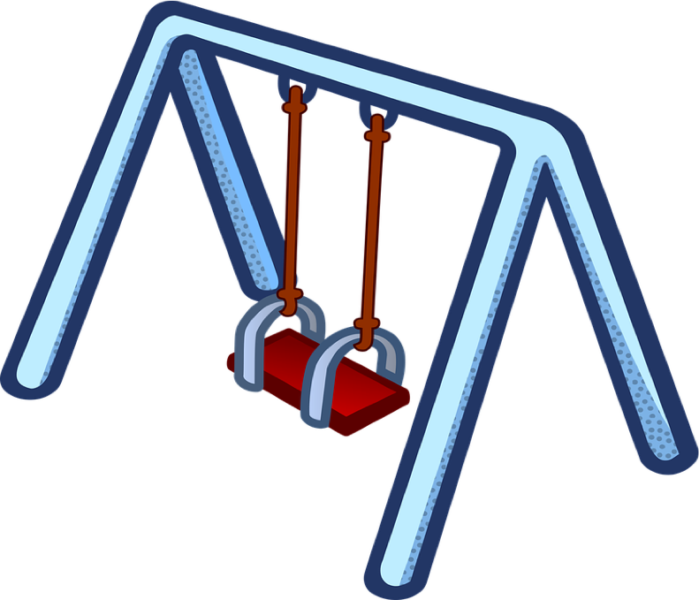
Prize to the spinner with the most pledges!
Register early! Space is limited

The Auburn Yoga and Pilates Center
889 Southbridge St.
Auburn MA, 01501
(508) 832-8177
auburnyogaandpilates.com

