NM Girls Varisty TAP Basketball Night
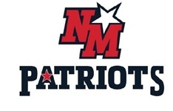
NM Girls Varsity Basketball invites all TAP Players Grades 1-8 to their January 31, 2020 home game vs Tyngsboro as we celebrate TAP Basketball night at NM. All TAP players must be accompanied by a parent. Those who wear their game jerseys will get in free.
Players will be invited on the court during Player Announcements to high five the NM Varsity Girls team onto the floor and stand with the team during the National Anthem. A contest will take place during halftime for the TAP players with the winner getting a prize!!!
Come cheer on the NM Girls Basketball team on Friday, January 31, 2020. All participating players should arrive by 6:30 PM

