United Soccer of Auburn Instructions for Coaches to Email Team Members
- Log onto your United Soccer of Auburn account. www.usauburn.com

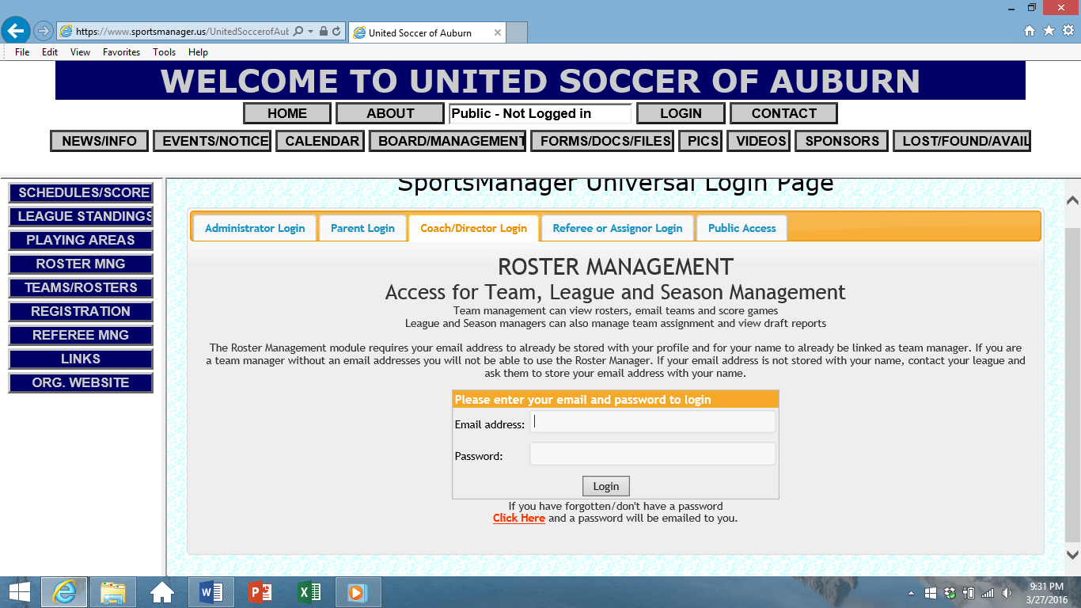

- Choose the appropriate team. Pay attention to the season – at times, the coaches remain the same.
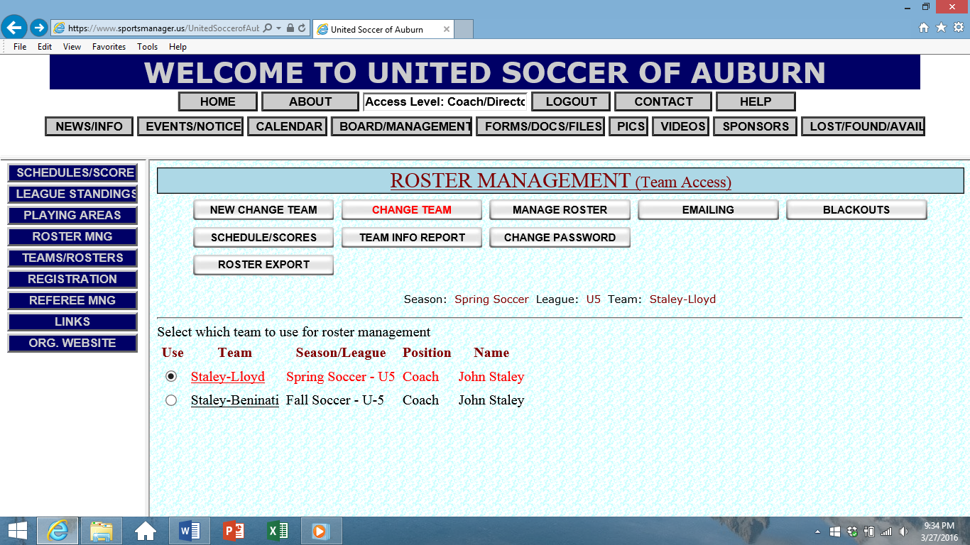

Click on the Coaches name(s) for the team you wish to access.

- Click on the EMAILING tab at the top of the Roster Management page.
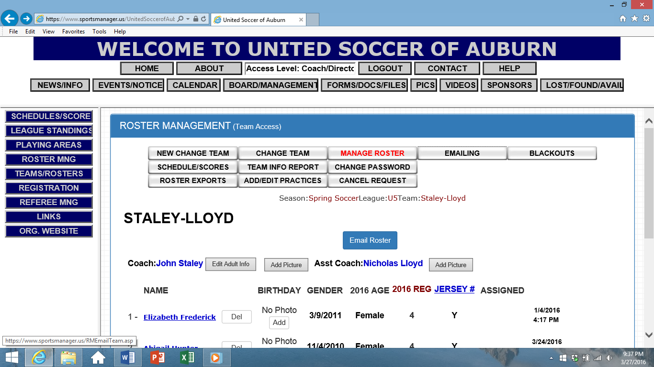

- There are 4 tabs along the top. [Note- this is a zoomed in screen-shot]
  - SELECT RECIPIENTS: the default setting is that all players’ Adult Primary and Adult Secondary emails will be included, as well as all coaches. If preferred, you can check only those you wish to email.
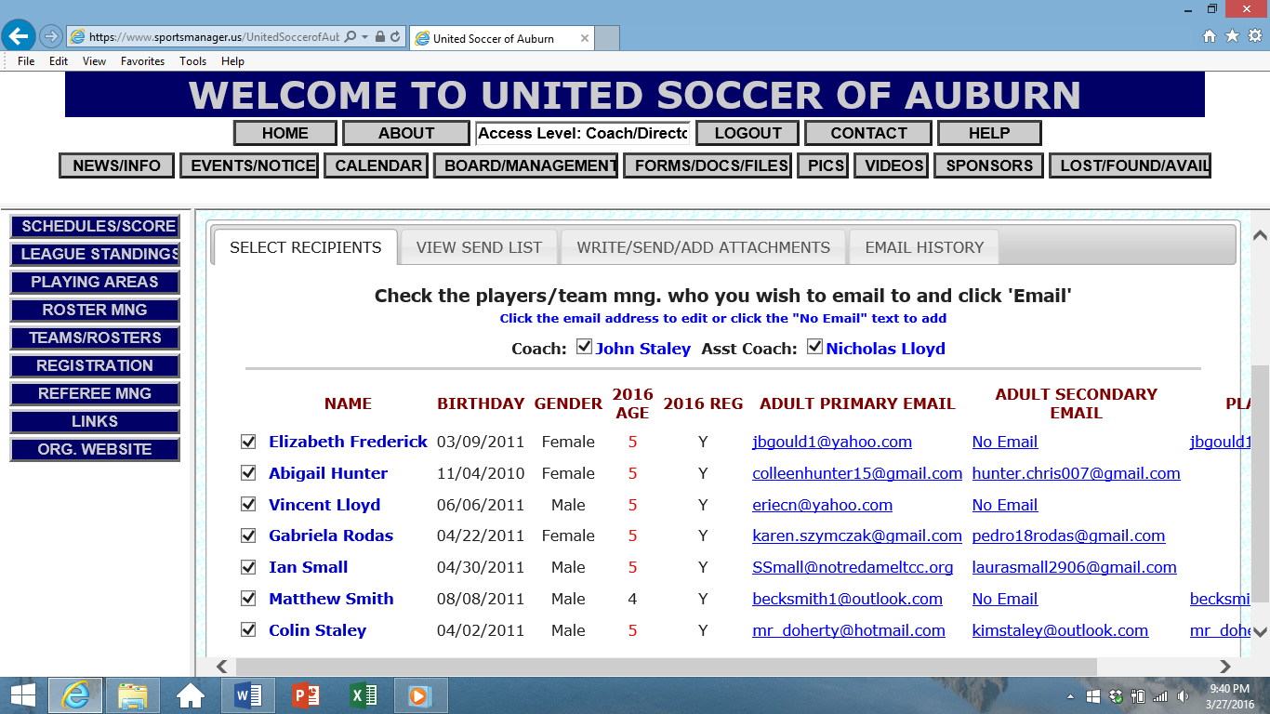
  - VIEW SEND LIST: here you can confirm your choice.

  - WRITE/SEND/ADD ATTACHMENTS: Once you create your message, be sure to hit Send at the bottom of the page.
