Sports Manager (SM) web site: https://www.sportsmanager.us/WakefieldSoccer.htm
Or, go to the WSA home page, http://www.wakefieldsoccer.org/, click on Links, then click on
Wakefield Soccer Association Sports Manager

Logging in as a Coach

- You must have been officially assigned to a team in SM before you can log in
- On the SM home page, click Login at the top of the page
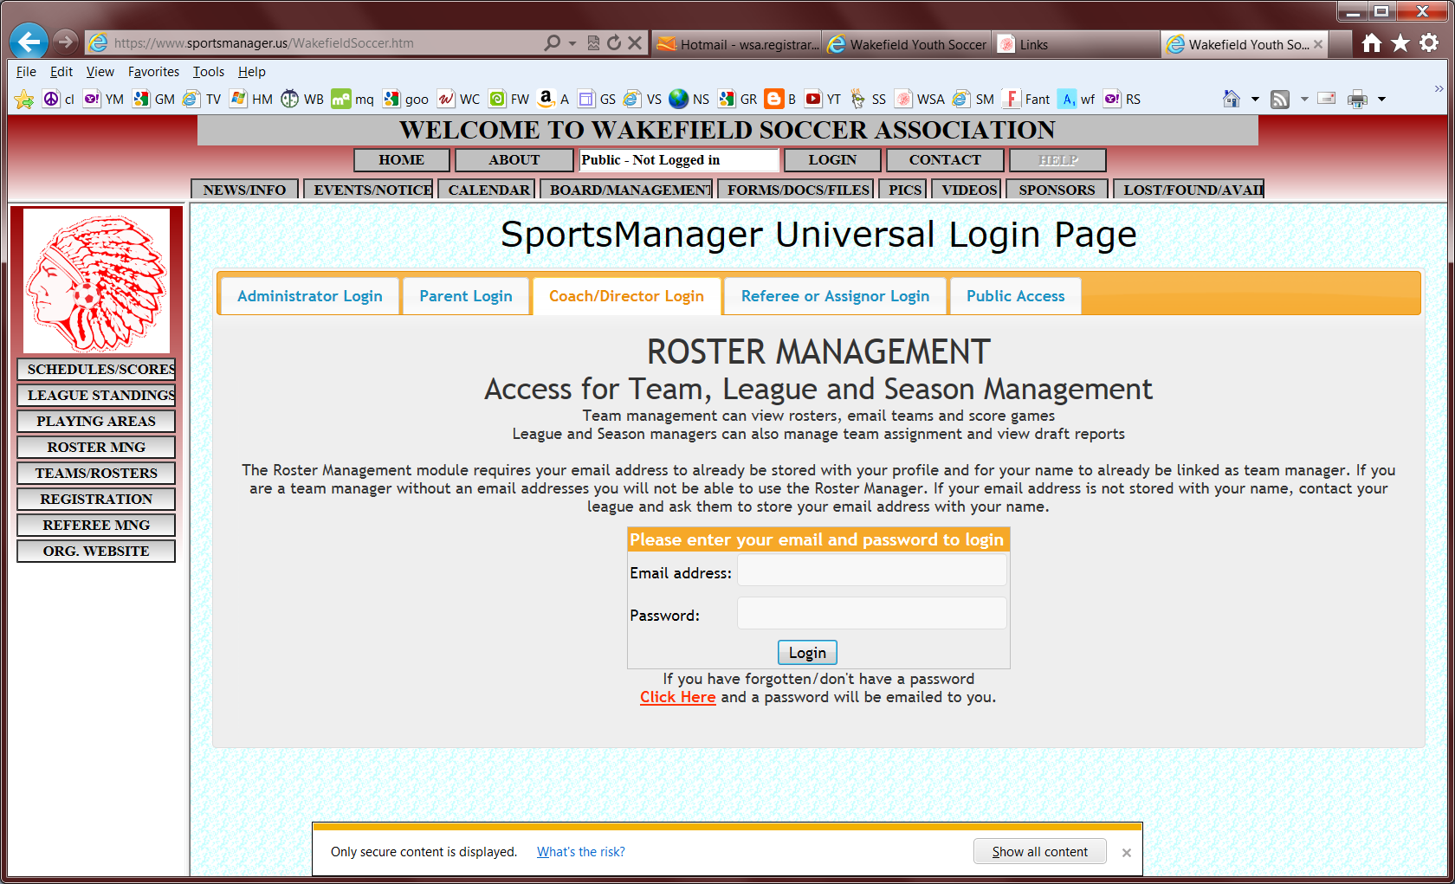
- Click on Coach/Director tab

- Enter your email address. If it does not work, contact registrar@wakefieldsoccer.org to set up your account
- Enter your password. Follow directions on the page for an unknown password.
- Click on Login button
- Upon a successful login:
- If this is your first time coaching and will be coaching only one team, you will be placed directly into the roster management function for your team.
- If you have coached in the past or are coaching multiple teams, you will be presented with a list of teams you are/have been assigned to. Select one team to work with.

Roster Management Functions

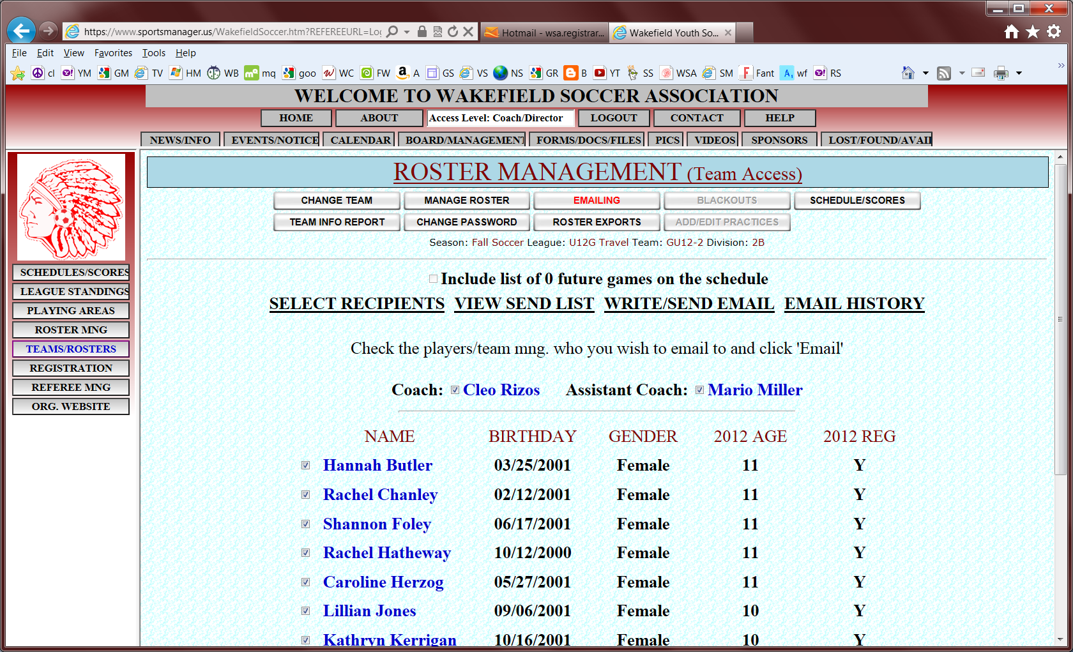
Only a WSA Director or SM Administrator can add/remove players or coaches on a team.
- Click Edit Adult info (under team name) to view or modify your own personal information including your email address.
- Click on a player’s name to see that player’s personal data. Be careful not to accidentally modify any data.
- Click Add picture (next to your own name) to upload a face-only photo of yourself.
- Click Add (under photo) to add player’s face-only picture (for travel teams U12 and above)
- Click REPL Picture to replace the existing photo with a new one. You may need to refresh the page, hit F5, to see the updated version.
- Click Crop to crop the existing photo. You may need to refresh the page, hit F5, to see the updated version.
- Click Jersey# (column heading) to add/modify jersey numbers (for travel teams)
- Click Add Player Comment/Double rostered to add free-format information/comments for any particular player(s)
- Click Email Roster (under team name) to send roster information, in CSV format readable by Excel, to an email address
- Click Click here for MYSL Roster form (Travel teams only) to create a PDF containing an official MYSL roster form that can be printed and used for games if roster has been approved and contains the ‘approved’ watermark
- Edit Team (under team name) should not be used
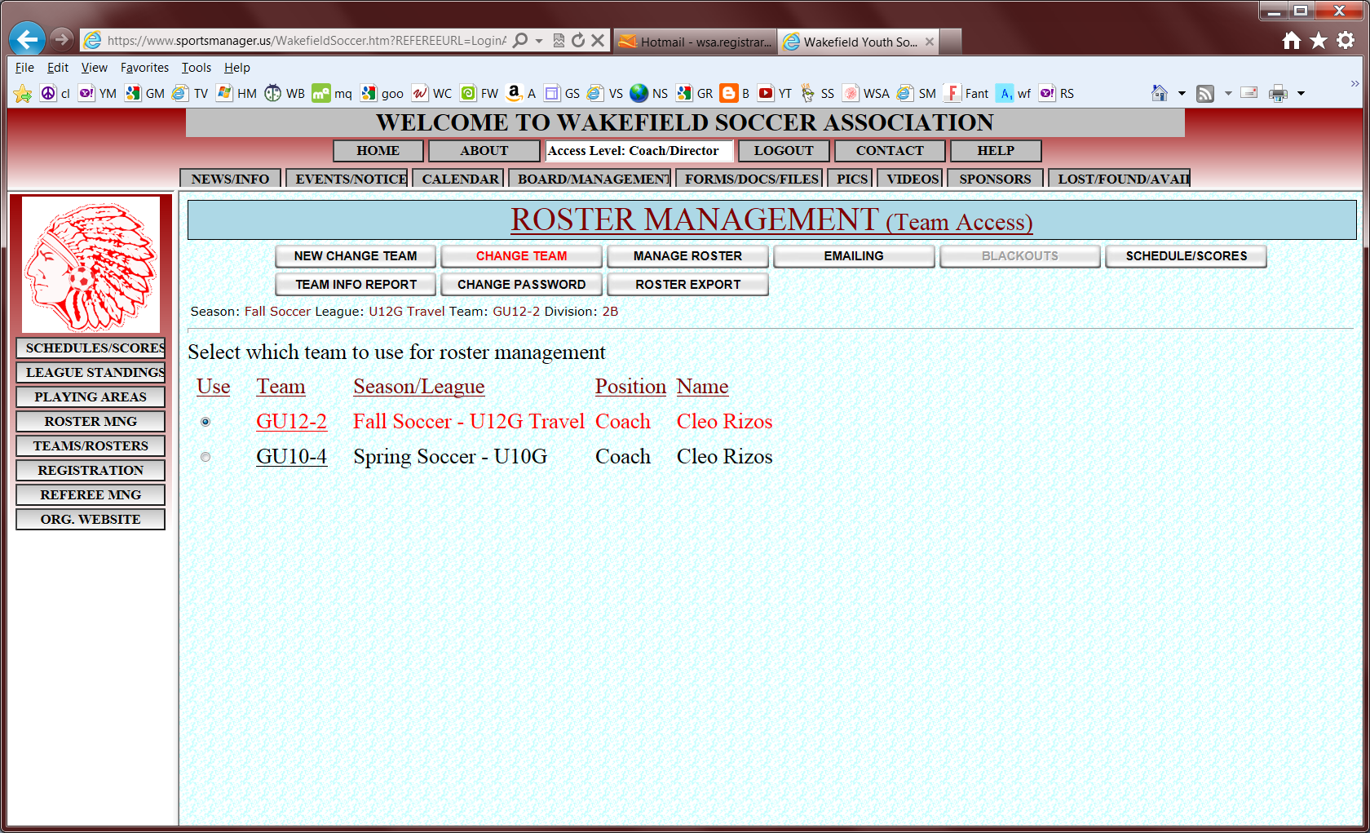
If you have coached in the past or coach more than one team, these two buttons allow you to switch between teams in two different ways.
This button allows you to change your SM login password.

This button will display all of your team members’ information ( including medical and contact information). If you would like, you can copy/paste all or any of this information into Excel. Make sure to select complete sections of data so that it will transfer to Excel cleanly.
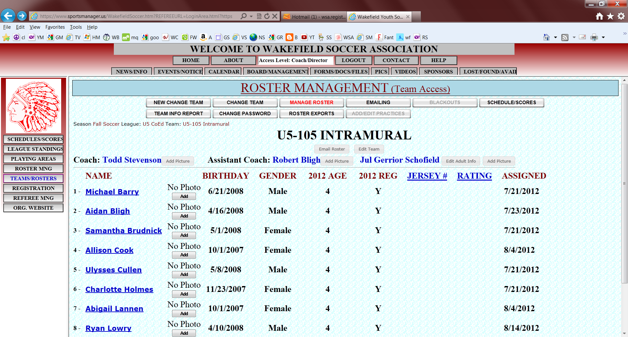
The emailing function allows you to send emails, via SM, to the whole team or selected individuals.
Once your team schedule has been set up, you can opt to send the game schedule in your email by checking the box indicating so.
- Click Select Recipients to select players to whom the email should go to. By default, the whole team is initially selected, including any assistant coaches.
- Click View Send List to see the actual email addresses that will receive the email
- Click Write/Send Email to compose the note and send it
- Click Email History to view any emails you have sent in the past
- Click Email Roster Info (csv) to send a file containing information for each player to a specific email address. The values in the file will be separated by commas, CSV format, which is readable by Excel.
- Click Email Roster Form (pdf) to send an Adobe PDF file containing an Official Game Roster to a specific email address
- Click Print Roster Form (pdf) to print a copy of the Official Game Roster
- Click Email Simple Roster (pdf) to send an Adobe PDF file containing a less detailed game roster to a specific email address
- Click MD Roster Form (pdf) (for Travel Teams only) to open an Adobe PDF file containing a official MYSL roster form that can be printed and used for games if roster has been approved and contains the ‘approved’ watermark

This section displays the selected team’s schedule and scores.
- Click Score to enter the score for a game, its completion status and an optional comment.
These comments should only be positive and constructive. If neither coach enters the score, an email will go out requesting an update. If you don’t receive an email, the score has been entered.
- Click Game Form to send an email containing a game stats form to a specific email address

