The Academy

WSA is proud to announce that we will be introducing a new program to the WSA syllabus The Academy.

The Academy, is aimed at our U7 And U8 players, and is focused on producing better technical players, along with improving coach education.

WSA’s DOC will be working with the New England Revolution Technical coaches, to help create a curriculum that will be fun, yet technically challenging to our players, while educating our volunteer coaches.

The main change to the program, is that each age will have their own training sessions, where the Revolution coaches will come down and demonstrate the session to our volunteer coaches, who in turn will then move to their own square and run their practice. Through this we aim to improve the technical development of our players and the knowledge of our volunteer coaches, so that they can deliver a better technical experience to our young players.

Each team will also have one game each weekend, which will consist of 2 20-minute halves, and a 5-minute break. These games will be played in a 4v4 environment, without goalkeepers. We will also have smaller rosters, so players have more time to play.

In the 4v4 games, players will get more touches and more opportunities to experience various situations, that they wouldn’t on a larger field or playing with bigger numbers. It will also give us an opportunity to talk about small tactical situations such as spreading out and positional play. (Please see picture at the bottom)

Players will also be given, a full uniform as part of their experience, which will be worn at all, practices and games, the uniform will include Shirt, shorts and Socks.

We believe that this experience will help to develop our players at younger age, with stronger technical skills and they will also be more knowledgeable of how to play the game.

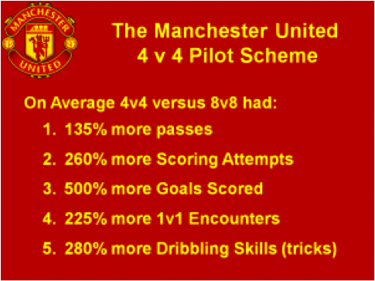

Please follow this link to the registration page.

https://www.sportsmanager.us/PublicLinks/OnlineRegistration.asp?Org=322

