If you have ever registered a child to play WSA soccer, you have an account in our web-based, information system, SportsManager (SM). You can login to this system to view and/or modify your family’s personal data as well as upload a photo for your travel team player(s).

Sports Manager (SM) web site: https://www.sportsmanager.us/WakefieldSoccer.htm
Or go to the WSA home page, http://www.wakefieldsoccer.org/, click on Links, then click on
Wakefield Soccer Association Sports Manager

Logging in
- On the SM home page, click on the Login button at the top, then the Parent Login tab

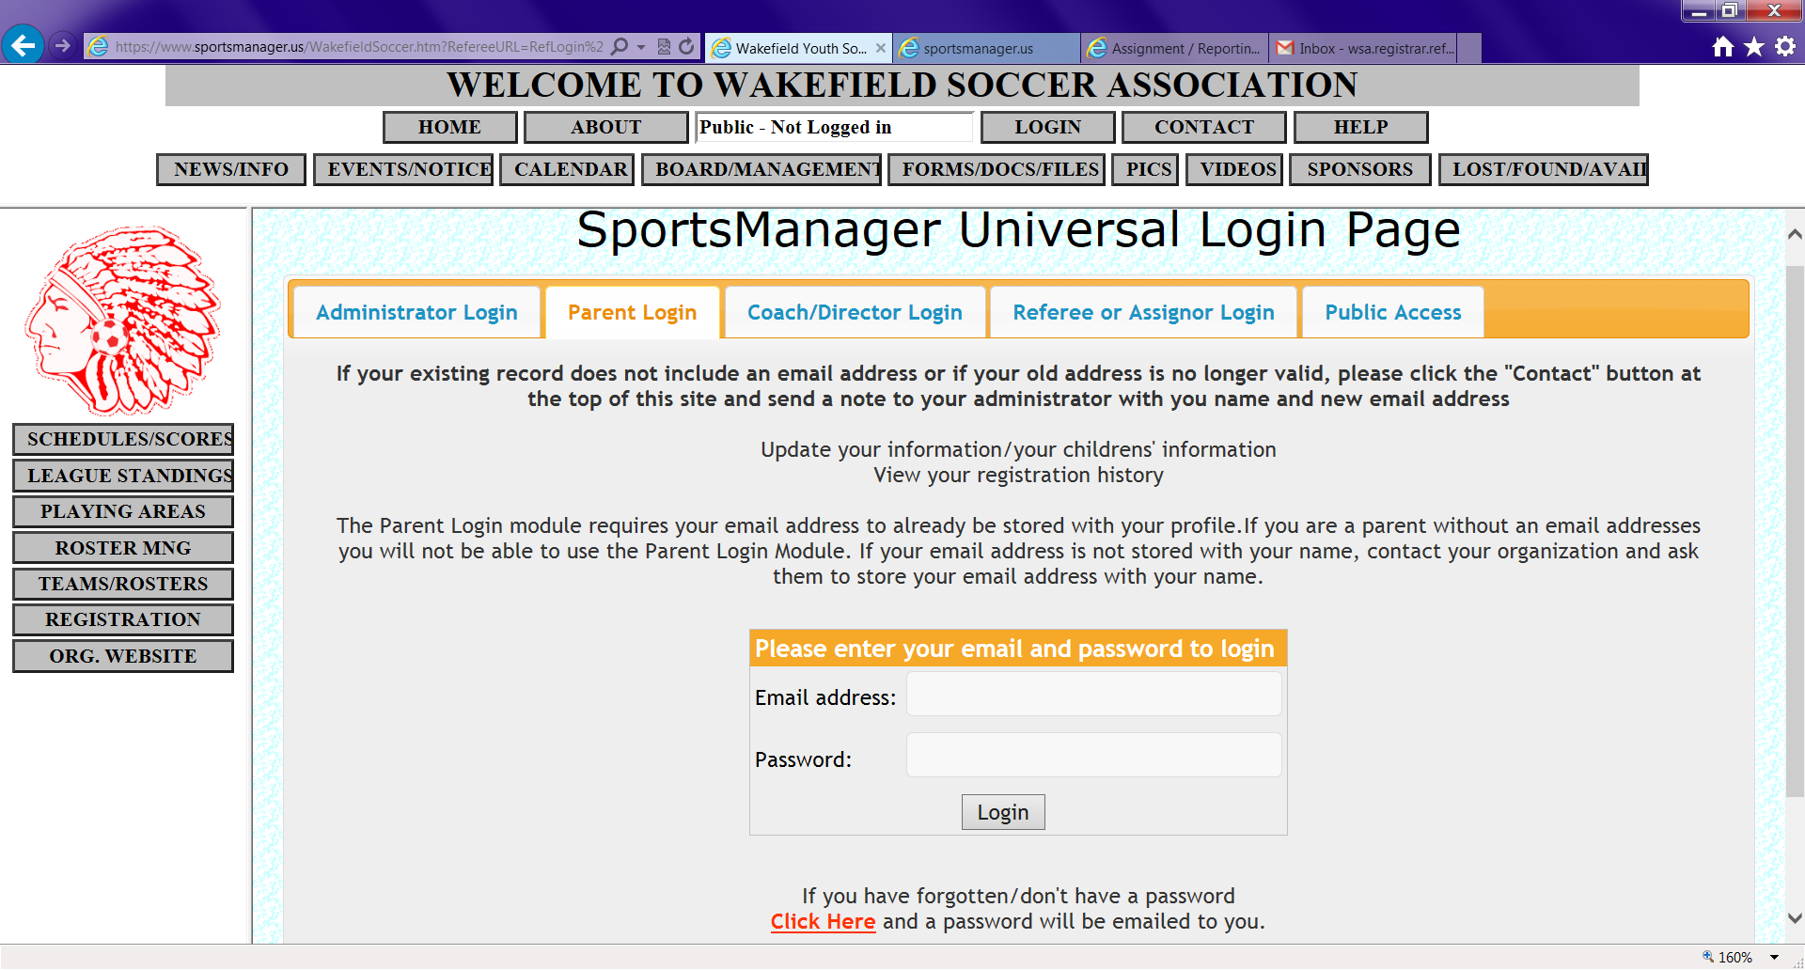

- Enter your email address. If the address does not work or you do not remember it, email registrar@wakefieldsoccer.org to find out.
- Enter your password. Follow directions on bottom of page for an unknown password.
- Click on Login button under the password field.
- Click on Add Photo next to the child’s name that needs a photo.
- A “browse” window will be displayed. Click on the Browse button to locate a current photograph (face-only) of this person. The file should be a jpg, jpeg, bmp or png file (e.g. myphoto.jpg)
- Select the file you would like to upload and click on the Open button.
- Click on the Submit button. The photo should now appear next to the selected person’s name.
- If the uploaded image did not come out well, you can try again using suggestions on the file selection page.

