Coach logon to Sports Manager:
Go To:
https://www.sportsmanager.us/wakefieldsoccer.htm
Then click on the coach tab:
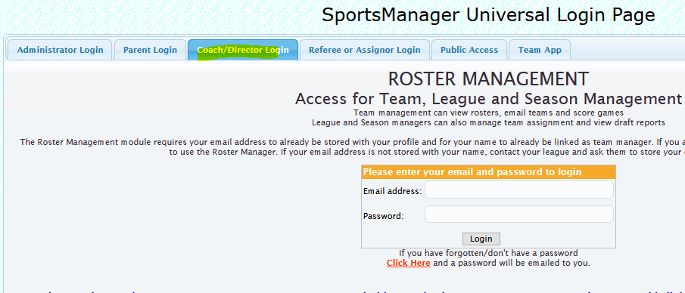

Enter your username and password when the next screen appears. This should be the same as when you registered your child.
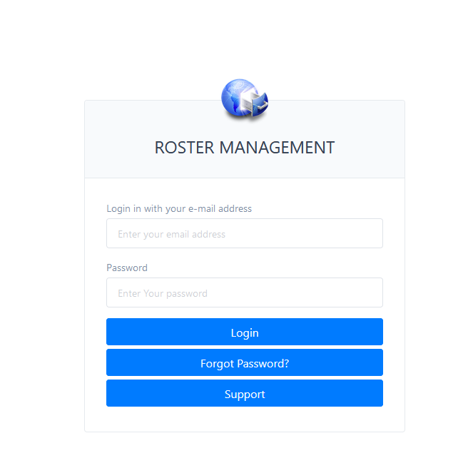

Click on the team you want to access:

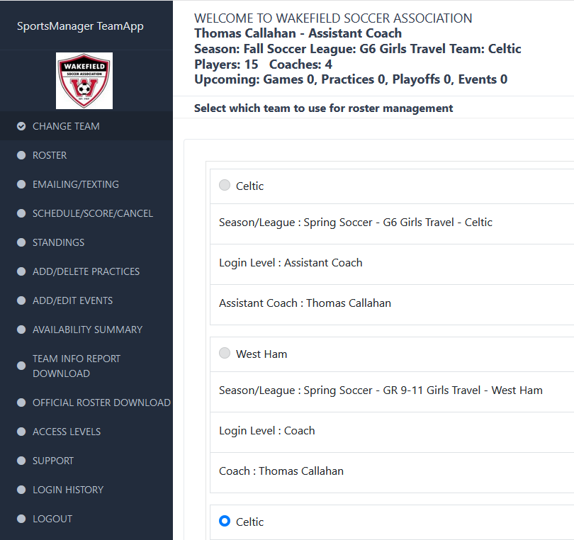

In this screen you should be able to see all of your players and if they need a photo or haven’t registered:
