

Latest Document Revision: 2/15/2015

Travel Director Responsibilities

Table of Contents
1. Season Check list 3
2. WYS Travel Email 4
3. WYS Website Credentials 4
4. Set default Season 5
5. Initial Steps for Setting up New Season 5
5.1 Send Email on Registrations Reminders 5
5.2 Review MAYS Roster due dates and meetings 6
5.3 Create Initial Team list with potential coaches 6
5.4 Verify field information 8
5.5 Developer of Sports Manger contact information 8
6. Create Teams/Rosters and Complete MAYS Registration Process 8
6.1 Create Teams/Rosters (2 Methods) 8
6.1.1 Rollover Approach 8
6.1.2 Manual Approach 8
6.2 Add Coaches and Players to Rosters 9
6.2.1 Add Coaches 9
6.2.2 Draft Approach 10
6.2.3 Roster Manager Approach 10
6.3 Complete MAYS Team Registration Process 11
7. Spring Tasks 12
7.1 MAYS League Spring Team Placement Profile 12
7.2 Player and Coaches Passcards 15
8. Miscellaneous Tasks 16
8.1 MAYS Board and Town Rep contact information and MAYS documents 16
8.2 Waivers (Local and CT) 19
8.2.1 Approve Webster Residents to play for other Towns 20
8.2.2 Check Out of Town Residents to play Webster Youth Soccer 21
8.2.3 Process for Approving CT Players to play for Webster 21
8.3 Uniform Orders 22
8.4 Coach CORI Check 22
8.5 Practice Times 22
8.6 Field Permits 23
8.7 Send Coach Login information 23
8.8 Send Coaches emails on game scheduling conflicts 23
8.9 Send Player Roster information 24
8.10 Approved Game day Rosters 24
8.11 Corner Flag Assignment 25
8.12 Coach Equipment 25
8.13 Send Coach Game Day Schedule 26
8.14 MAYS Game Cancellation Policy and Rescheduling Procedures 26
8.15 Set up Field information in SportsManger 28
8.16 Coach and Player Passcard Distribution 28
8.17 MAYS By-Laws 28
8.18 Miscellaneous Coach Emails 29

Season Check list
- Continually monitor Webster@MAYS.com emails using the wystravel@gmail.com throughout the year at on a weekly basis to check for Yearly AGM meeting (attendance required) as well as yearly coaches meetings.
- Establish Registration Open, Close and End Dates for upcoming season based on deadlines set forth by MAYS (http://www.sportsmanager.us/orgmanager/MAYSL.htm on Home page)
- Set default season in SportsManager and set up new season
- Send Email Registrations Reminders to Parents, Players and Coach on registration dates during the middle of current season and also before the cutoff date of the new upcoming season.
- Verify Field Information in SportsManager
- Review MAYS TeamInfo and Profile dates and establish timeframes on when items are due to MAYS
(http://www.sportsmanager.us/orgmanager/MAYSL.htm on Home page – For Spring Season Only)
- Review Potential Teams and Players based on Registration information
  - Start to find coaches and players if necessary
- Start to Create Teams and Player assignments in SportsManager (1st Pass)
  - Assign Players to Teams
  - Assign Coaches to Teams
- Contact coaches on what divisional they would prefer to play
- Send final Registration Reminder email to Parents, Players and Coaches
- Review Team Rosters and make any needed changes (2nd Pass)
- Complete the Team Registration Process on MAYS Website
- Forward the WYS President and Treasurer the Total Amount to be paid to MAYS and MAYS Treasurer information for Team Registrations
- Complete each Team’s Placement Files for Divisional Placement and send individual placement files to each of MAYS’s Registrars before set deadline (For Spring Season Only)
- Contact coaches if team is moved to a different division for Appeals process and date and time of hearing (For Spring Season Only)
- Email coaches to see if they have any potential game day conflicts
- Send MAYS President any potential Game day conflicts as well as Graduation and First Communion dates
- Review Coach and Player missing passcard photos and contact to upload picture
- Review coaches that need to submit CORI check information and send email
- Create Uniform Order sheet and send to Equipment Manager to order uniforms (try to complete at least 1.5-2 months before first games start)
- Check the Waiver statuses for the following
    - Local Players
    - CT waivers (Parents will need to notify www.CJSA.com)
- Approve or Not Approve Out of Town Waivers
- Continue to modify team assignments as needed based on Registrations updates and player and coach requests
- Send emails to coaches
  - Say Thanks for coaching…
  - Need for the following information:
    - Practice Times desired
    - CORI info in needed
    - Make sure pictures are uploaded to SportsManager
    - Ask for equipment needs
  - Send Initial Rosters (need to call players on their team and also if not registered yet, they must register)
- Create Practice schedule and verify with all coaches
- Create Flag Assignment Schedule
- Finalize the following and send to Coaches:
  - Final Rosters containing player information (with CSV instructions)
  - Approved Rosters (pdf) with instructions and associated fees for not obeying guidelines
  - Practice Days and Times
  - Flag Assignment Schedule
  - Coach login and set up instructions for SportsManager
- Send Coaches the instructions on viewing Team Schedules in SportsManager
- Print and Laminate:
  - Coach Passcards (for Fall and Spring seasons)
  - Players Passcards (for only Spring season, only for U12-U19 & only D1 &D2)
- Send miscellaneous emails to coaches:
  - Make sure they have WYS Town Rep contact information (email/cell phone #)
  - Field/Game Cancellation policies and procedures
  - 7 Goal spread limit and associated fines
  - Code of Conduct & Sportsmanship
  - Mass By Laws
  - Field Permit and Instructions
  - MAYS Site Information
- Can set up coaches meetings to pass out items if you choose or can do individually
- Pass out Passcards to coaches before first game
- Pass out Uniforms to players/coaches before first game
- Pass out equipment to coaches before first game
  - Bag, Game Ball, Cones, Pinnies, Ice Packs, First Aid kits
  - Keys to bathrooms
- Contact the Field Maintenance person to make sure field conditions are fine to play
- During the season, continually monitor the following:
  - Email
    - MAYS will send updates and potential items that need to be addressed
    - Address any internal WYS issues that may arise
    - Upcoming Board Meetings
  - Monitor fields to make sure corner Flags are put away and bathrooms are locked
  - Every weekend, monitor the weather and decide if games need to be cancelled. Make sure to be able to access schedule via computer or phone using SportsManager and if necessary, cancel and games via SportsManager and notify coaches.

WYS Travel Email
The WYS Travel is wystravel@gmail.com with the following credentials:
Username: wystravel@gmail.com
Password: WYSsoccer

This email is used for all correspondence with MAYS (http://www.sportsmanager.us/orgmanager/MAYSL.htm) where this email is automatically copied when any emails are sent to the Webster@MAYS.com email created by MAYS.
IMPORTANT: You should monitor this email on a weekly basis throughout the year as you will receive important notices and message from MAYS as well as from the Webster Youth Soccer website.

WYS Website Credentials
The WYS website can be found at the following link:
http://www.sportsmanager.us/WebsterYouthsoccer.htm

In order to log in as a board member under the Travel Director/Coordinator credentials, click on the LOGIN button at the top of the page and use the following:
Username: wystravel@gmail.com
Password: MAYS-32191201


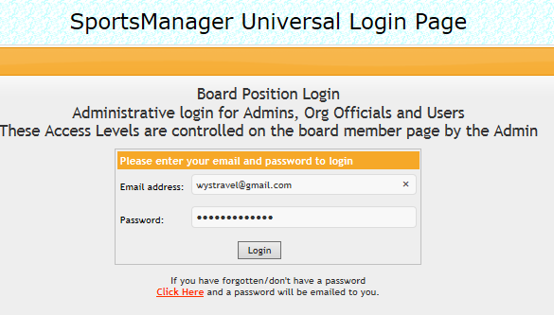

Set default Season
In Sports Manager on the left hand pane, click the “SEASONS/ACTIVITIES” button. In this page, select the either the Fall or Spring Season as the default season by selecting either option (radio button). This will set the default season for the entire Sports Manager site. If you click on the “Spring Soccer” or “Fall Soccer” blue links, this will allow you to change some of the options. Note that some options will be grayed out by MAYS and not allowed to be changed by the town administrators. You can also click on the Open Date, Close Date, Early Discount and Late Fee items to change any of the values which will be used in the Registration process.

Initial Steps for Setting up New Season
The following items should be completed prior the create of teams and Roster in Sports Manager for the upcoming Fall or Spring Season.

Send Email on Registrations Reminders
In Sports Manager on the left hand pane, click the “EMAILING” button and this will allow you to send a mass emails to all parents of players or even a subset of emails. Typically you want to choose “by Player” and choose from 4-20 as this should send to the largest email group.
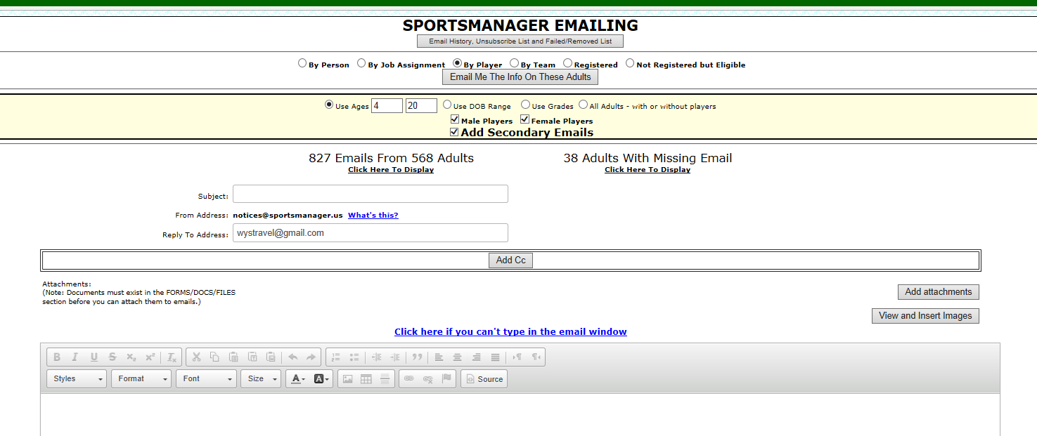
Please note that in order to type, copy/paste and format text within the body of the email, you will need to choose “Show all Content” option when first logging into Sports Manager.
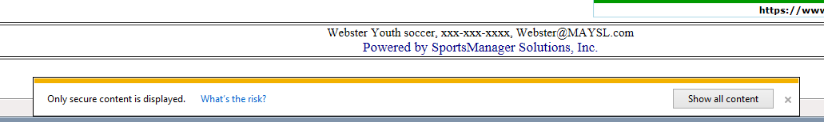
Here is the instructions from the site:
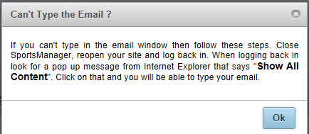
Below are a couple of email Samples of Registration Reminders (just double-click on the icons and the email sample will open via your Email program):
Initial Travel Registration Reminder
Initial Travel Registration Extension Reminder

Review MAYS Roster due dates and meetings
Open the Sports Manager link for MAYS, http://www.sportsmanager.us/orgmanager/MAYSL.htm
Then either in the Upcoming Events section at the top of the main page or scroll to the bottom of the main page to see the MAYS dates and deadlines for games and registrations. Typically, the teams and rosters need to be entered into Sports Manager by the first week in January for the Spring season and by the mid-July for the Fall Season.

Create Initial Team list with potential coaches
Below is a sample of an Excel spreadsheet that can be used to help in figuring out the number teams and coaches needed for each division for the upcoming season (just double-click to open the file):
In Sports Manager you can find the players that are registered by clicking the “REGISTRATION” button on the left hand pane and then click on the “Player/Team Registration List” link:
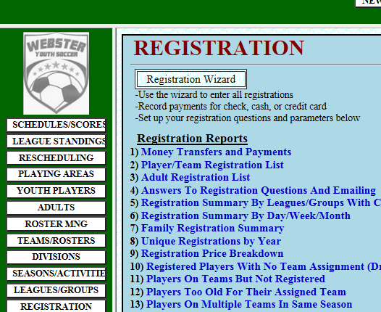
Then you can select the Year, Season and League for all registered Player. After you make you selection, just click on the “View Registration” button to see the list of registered players and you can also email this info by clicking the “Email me this Info” button. This information can help determine the number of teams needed for each division. You may want to check this on a weekly basis as the Registration deadline approaches which will give you time to find coaches if needed.
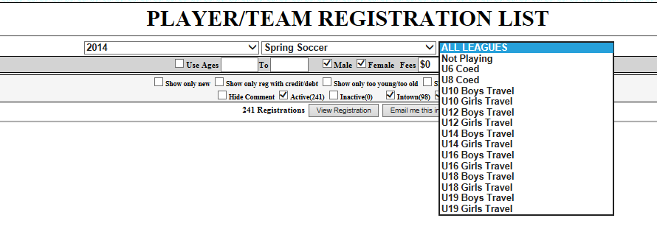

Verify field information
In Sports Manager, make sure that information in regards to the fields is correct. This includes information such as address, directions, field availability and division assignments. The field information has already been set, however it is good practice to verify the information each season. Below is an email link from the developer of Sports Manager that describes the process.

Developer of Sports Manger contact information
Shawn Harty, SportsManager Solutions, Inc.
For Support either email support@sportsmanager.us or call 508-423-2444

Create Teams/Rosters and Complete MAYS Registration Process
After there is enough player and coach information, you can start entering the Teams and Rosters in Sport Manager.

Create Teams/Rosters (2 Methods)
There are 2 methods for creating teams in Sports Manager, the Rollover Approach or the Manual Approach. Both approaches will most likely be used where you can use the Rollover Approach to create the initial teams and then the Manual Approach to add or delete any new teams.

Rollover Approach
- First clear the players and coaches on the teams from last year by clicking on “Teams/Rosters” button on the left hand pane, then make sure the appropriate Season (i.e., “Spring Soccer”) is the selected season, then if there are any coaches or players showing click the “Bulk Assignment Removal Button”, select the appropriate Season (i.e., “Spring Soccer”) and proceed to clear all those rosters.
- Now do the Roll over from the previous season (i.e., “Fall Soccer”) by clicking on Reports, then click “Team Roll Over” reports, select Source = previous season (i.e., “Fall Soccer”) and Destination= upcoming Season (i.e., “Spring Soccer”) and click the option to proceed with the roll over. When finished that will make a complete copy of what was your Fall teams into your Spring season.
- Now go back to “Teams/Rosters”, make sure upcoming Season (i.e., “Spring Soccer”) is selected at the top, then any teams with no players should be deactivated. Add any new teams for the upcoming Season (i.e., “Spring Soccer”) if there are any. (See section 6.1.2 – Manual Approach for more information)
- To finish your rosters for each division, once your Spring season player registration is complete then remove any players from teams that are not returning by clicking on Registration/Players on teams not registered and add any new players for the Spring season by clicking on Registration/Draft report, display it and then click “Assign to teams”.

Manual Approach
- In Sports Manager, click on “Teams/Rosters” button on the left hand pane, then make sure the appropriate Season (i.e., “Spring Soccer”) is the selected season.
- At the Top of the Page, click on the “Add Team” button to add a new team. Select the appropriate season and league via the Drop Down lists. Then enter the team name in the following format:
  - U##X-DZ-Name (where #=Division #, X = B or G (Boy or Girl), Z= 1,2,3 for division, Name = coaches name) Please note that MAYS requires this naming convention
  - For example, U12B-D2-Smith
  - You can leave the remaining information blank and accept the last 2 options.
- If a team has no players or coaches assigned, then you can either deactivate by clicking on the green “Activate” button to the right of the team name.
- Also, if you would like to delete a team, then you need to click on the “Delete Roster” button for that particular team and then the “Delete Team” button should now be available to select and once clicked the team will be deleted.

Add Coaches and Players to Rosters
There is a single method for adding coaches to a Roster while there are 2 methods for adding players to a roster in Sports Manager, the Draft Approach or the Roster Manager Approach. Both approaches will most likely be used where you can use the Draft Approach to create the initial rosters and then the Roster Manager Approach to add or delete any new players or coaches.

Add Coaches
- In Sports Manager, click on “ROSTER MNG” button on the left hand pane, then make sure the appropriate Season (i.e., “Spring Soccer”) is the selected season. Then select the appropriate Division form the Leagues Drop-down list and the appropriate team from the Teams Drop-down list.
- Once the Team is selected, another page will open for that chosen team.
- To add a Coach/Team Manager, click on the “Add Team Mng” button under the Team Name in Bold.
- In the Adult’s Last Name text box, type the coach’s last name and then click the “Search” button. Then Click the “This is the Adult” button next to the adult in which you would like to assign to the team. Next choose the Adult by choosing the Radio Button and then click the radio button on whether you want to assign the adult as a Coach or Asst Coach. The Click on the “Assign Job”
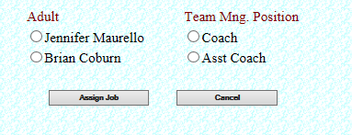

- Now that you have assigned a coach, make sure that coach has a picture assigned by clicking the “Add Photo” button and choose the picture that is sent to you from that particular coach. Coaches are required to have a picture which will be used for their passcard which is required for every season.

Draft Approach
- In Sports Manager, click on “REGISTRATION” button on the left hand pane and then click on the “Registered Players With No Team Assignment (Draft Report) Players” button.
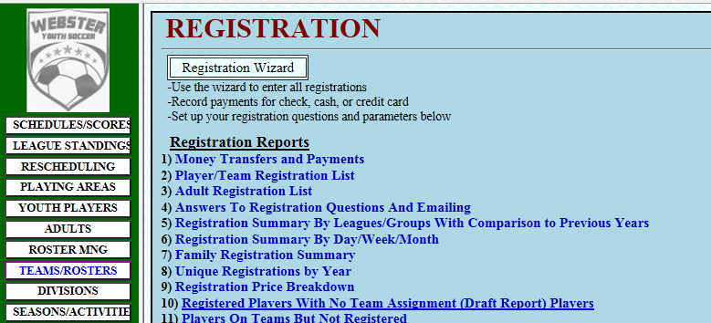
- Select the appropriate Year and Season from the Drop down list.
- Then Select the appropriate Division and then click the “View Report” button to see the list of players that need to be assigned to a team.
- Next click the “Assign To Teams” button near the top of the window. Then you will see a Drop down list next to each player’s name and then choose the correct team for each player in the list.
- Then click “Save Team Assignments” button at the top of the window and the player is now assigned to the team.
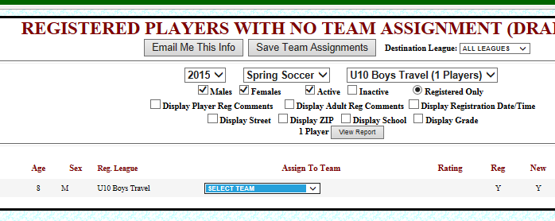

Roster Manager Approach
- In Sports Manager, click on “REGISTRATION” button on the left hand pane and then click on the “Player/Team Registration List” button.
- Select the appropriate Year and Season from the Drop down list.
- Then Select the appropriate Division (All Leagues Drop down list) and then click the “View Registration” button to see the list of players in that particular chosen division.
- A player may or may not have a team assigned. If the player does not have a team assigned or the team assignment needs to change, click on the Player’s Name in blue.
- You will be brought to another window and then click on the “ADD TO TEAM” button. A popup window will open then select the appropriate Season, League and Team.
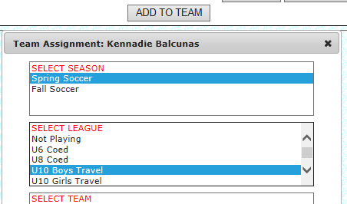
- Then click the “Save Changes” button at either the top or bottom of the window to save the team assignment.

Complete MAYS Team Registration Process
Once your Teams are set and locked, the final step in the Registration process will be register the team with MAYS and this process will generate and Invoice that will be paid to MAYS by our WYS Treasurer.

In order to complete the On-Line MAYSL team registration instructions, you must first be assigned as a board member on your Sports Manager site. It doesn’t matter which position you are assigned to but it must be at least one. If you are not sure go to your Sports Manager site and click on the Board/Management button and near the top you should see yourself assigned to one of the board positions.

Fees:
When you register your teams you will get the correct fee based on the Age group and Division the team is in. You will select the correct division for your teams which will affect the cost of registration. If you register for the wrong division and then MAYSL makes a change during team placement we will issue a credit or debt if there is a price change.

Bond Credits and game change credits or debits:
All of these credits or debits are already entered in the MAYSL system and will appear on your price summary page. You see a registration fee for each team, a total registration fee and deductions for Bonds on file and adjustments for last season’s game changes that may affect your town. If you have any questions on these please let us know.

Steps for On-line team Registration:
- Go to www.sportsmanager.us/orgmanager/maysl.htm , click on the “Registration” button on the left side menu. A new window will pop up in HTTPS mode. Click on the blue text for the upcoming season (for example, “Spring Soccer 2014”), check the box for “Over 18”, enter your name and click “Proceed”
- Enter your email address. This is the email stored in your adult record in your Sports Manager site.
- Once it finds you based on your email click “This is me” next to the name.
- Enter your personal password. If you do not know your password click the “click here” option to have it emailed to you. Get the password from your email and then complete the login.
- Now a list of your Active Teams will appear for registration. You can pick them individually or click the “Check all” option. Once you pick the teams also make sure the correct division is selected. Note that different divisions have different fees in some age groups. Once finished selecting teams and divisions click “Proceed”. Please remember to only select 1A, 2A or 3A. The breakdown of B, C region will be done by the scheduler.
- Enter any optional comments and then click “Proceed”.
- Now you are on the final payment page. You can see the summary of your registration cost which includes the team fees, ref fees, assignor fees and bonds. Then you see any deductions and additions from bonds on file or game changes or other events from last season.
- Now enter a check number or enter “TBD” if you are not sure what the number will be yet and click Proceed. This will create the registration and send you and the league president and treasurer and email confirmation.
- Now mail your check for the total amount shown to this address displayed. You should forward all of this information to the WYS Treasurer so that any invoices will be paid to MAYS.
Please note that the following address is being used to send the checks:
Tricia Desmarais
14 Nicole Dr.
Millbury, MA 01527
(C) 508-246-9042

Spring Tasks
There are certain tasks that only need to be performed during the Spring Season.

MAYS League Spring Team Placement Profile
Typically during the first week in January team placement profiles are due to each of division MAYS registrars and are used to determine if the team should be correctly placed in the division requested. Ultimately, MAYS will use the information in these files to determine if each team should stay in the division requested or be moved up or down based on the information provided. These files are standard Excel files that must be filled out for each D1 or D2 team for U10-U16 and U18/U19 typically do not need to fill out the placement profiles since there are only enough teams for a single division.
The Placement profiles will be uploaded the following MAYS site location under FORMS/DOCS/FILES section:
http://www.sportsmanager.us/orgmanager/MAYSL.htm

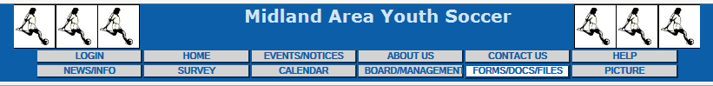
Typically the file will be called “Team Profile Form 201X” where X represent the current year. Download the file by clicking on the link.
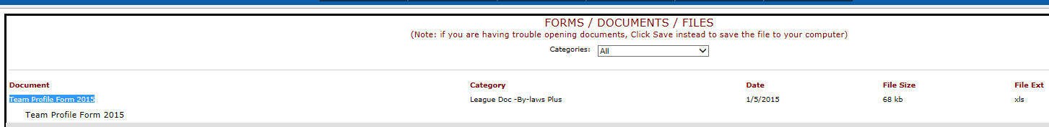
The instructions are contained in the first sheet of the file and you will need previous season roster information as well as previous season records information. The roster information can be obtained from SportsManager and the past season record information can be obtained under the same location in which the placement profile was stored on the MAYS site under FORMS/DOCS/FILES section. Click on each link for each age division to download the previous season record information.
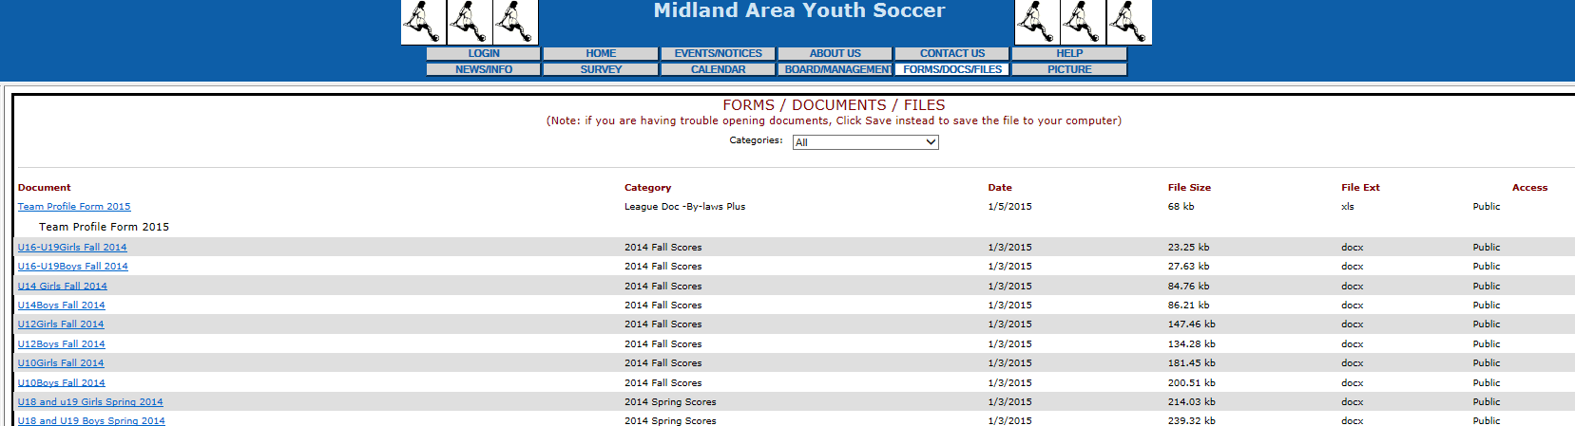
You can either send the placement files to each of the coaches to fill out or you can choose to fill out the files yourself. Sometimes it is quicker just to fill out yourself and have the coach review them if time permits. You need to send these to each MAYS division registrar by the date requested by MAYS or WYS could be fine. The due date is typically found on the MAYS site (http://www.sportsmanager.us/orgmanager/MAYSL.htm) under the Home section near the bottom of the page where all season information is stored.
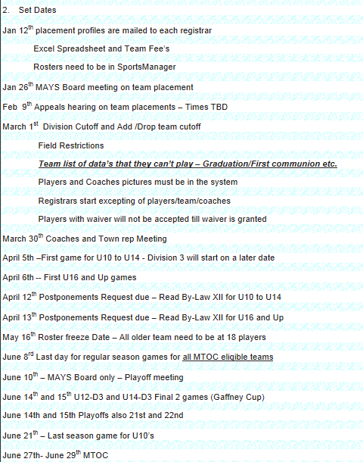
Once each team’s placement Profiles have been completed, the need to be sent separately to each of the following MAYS registrars email address:
U10Girls@MAYSL.com
U10Boys@MAYSL.com
U12Girls@MAYSL.com
U12Boys@MAYSL.com
U14Girls@MAYSL.com
U14Boys@MAYSL.com
U16-19@MAYSL.com

After MAYS reviews the placement files, they will notify each Town Rep via email if a team is going to be moved to a different division than requested and the team can accept the move or can notify that they want to appeal the move and attend a special Appeals Hearing that is conducted by the MAYS board to state their case for appeal. All correspondence is typically handled via email with the MAYS President (President@MAYSL.com)

Player and Coaches Passcards
For the Spring and Fall season all coaches require passcards to be on the sideline to coach. Note that if you have a passcard for that current season, you are allowed to coach any team not sure you assigned team as this allows coaches to help out each other if needed. For the Spring season only, all players in the U12-U19 B/G for D1 and D2 require passcards in order to participate in the game. U10 players do not require a passcard because playoffs do not exists for that age group. If a player does not have a passcard prior to the game, that player is not allowed to participate in the game. So please make sure the coaches that they should keep the passcards with them for all players and not lose them or you will have to print out copies. Also, all passcards must be laminated and individually separated to present to the referee. The coach is not allowed to present a sheet containing the passcards.
In order to print the passcard for Coaches and Players, in Sports Manager click on the REPORTS/MODULES section and click on the following links for either Coaches or Players:
- 29) Player Passcards With Pictures and Missing Picture Emailing
- 30) Coach Passcards With Pictures and Missing Picture Emailing

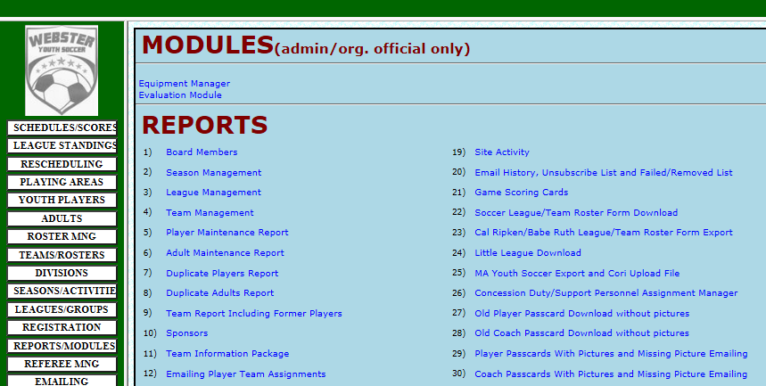
In each section, make sure the appropriate season in Selected at the top and then check all of the teams that you wish to print the passcards for. Then you can either perform the following tasks by clicking on the to three buttons:
- Display/Select Email for missing Photos – Use this to select which passcards you would like to print out.
- Email me the Passcards – Use this to email you all of the passcards in PDF format. One you receive the email you will need to open the PDF, print out all of the passcards in Color and then laminate the sheets using the EZ Laminator provided by WYS. Then after all sheets have been laminated, cut out the sheets into individual passcards, sort by each team and then distribute the players and coaches passcards to each of the coaches before the first game.
- Click here to request email for missing Photos – Use this to send an email to players or coaches that they need to submit a photo to Sports Manager for their passcard. Without a photo, the passcard will invalid.

Miscellaneous Tasks
There are certain tasks that only need to be performed during the Spring Season.

MAYS Board and Town Rep contact information and MAYS documents
All MAYS documents can be found at the MAYS site (http://www.sportsmanager.us/orgmanager/MAYSL.htm) under the FORMS/DOCS/FILES section:
You can find the current update to the by-laws as well as other important documents such as:
- Code of conduct expectations
- Board Information
- Coach and Town Rep Instructions
- Sports Manager Instructions and Procedures
- Team Profiles and previous record information

All MAYS Board contact information can be found at the MAYS site (http://www.sportsmanager.us/orgmanager/MAYSL.htm) by scrolling down midway through the home section
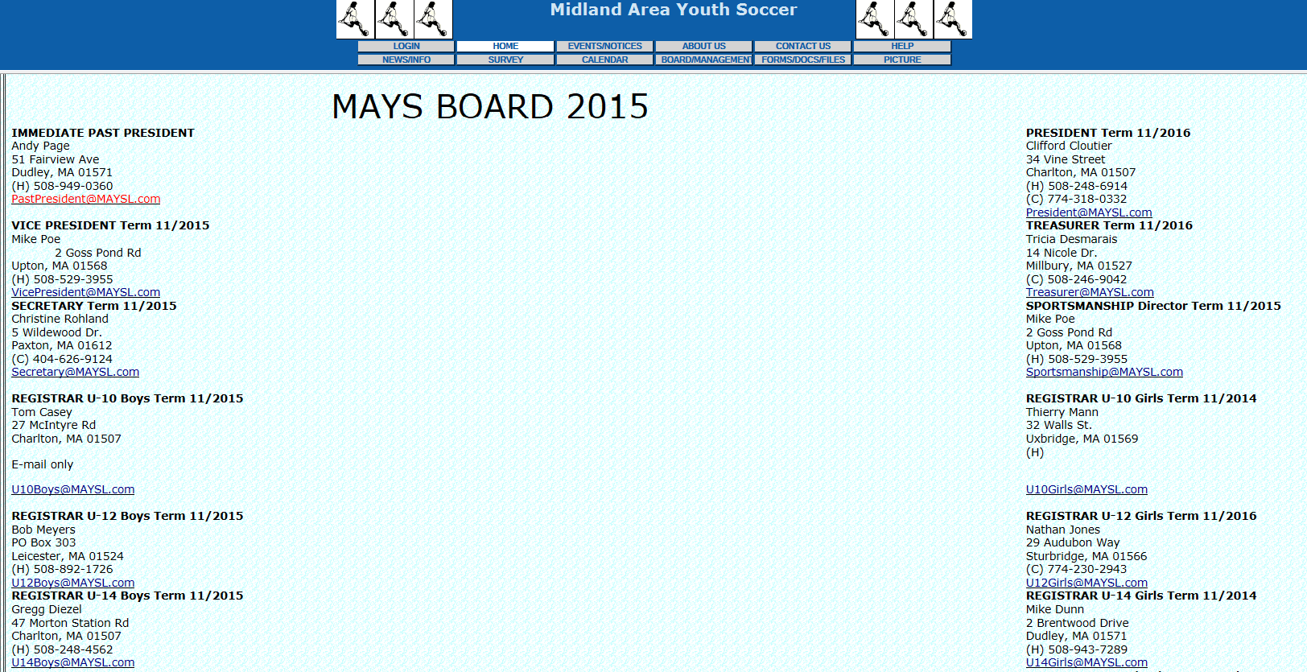

In addition he MAYS Board and contact information can be found under the BOARD/MANAGEMENT section: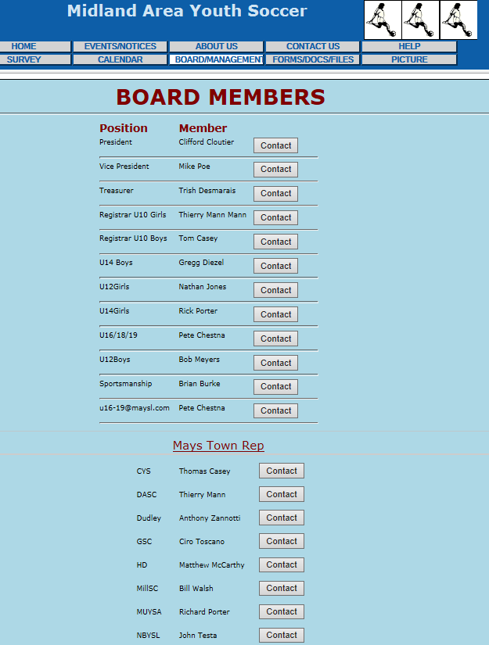

Information for each Town can be found under the ORGANIZATIONS section on the left hand Pane:
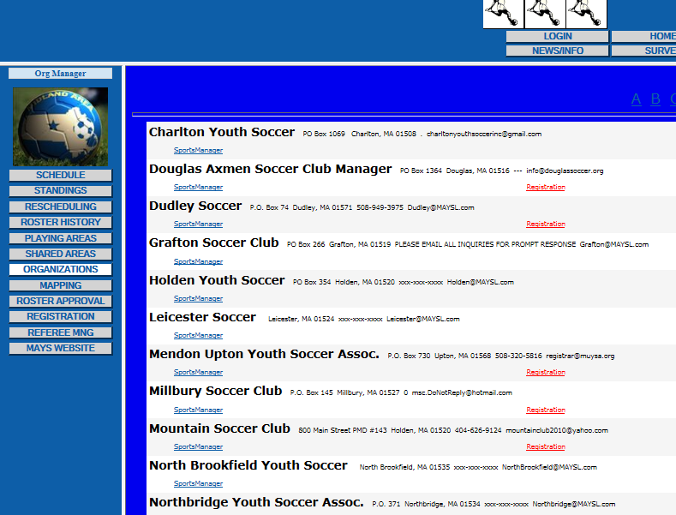

Waivers (Local and CT)
Each season you must check to make sure that your out of town players and out of state players are approved to play and you also need to approve waivers for Webster residents for other towns. Typically WYS approved waivers for Webster residents to play in other towns, but you can check with the WYS president and coaches if unsure if the waiver should be approved. All waiver information is contained in SportsManager under the REPORTS/MODULES:

Approve Webster Residents to play for other Towns
In REPORTS/MODULES, select item #36 MAYS Out-of-Town Waiver Request
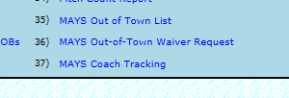
Make sure that the correct season in selected at the top drop down list. You will see a list of Webster players that are requesting to play in other towns and need a waiver. For each player, click on the “Needed” link and then another window opens and choose from a list of options. Typically WYS will either Approve or Not Approve and then if applicable can enter a Comment and then Save your status.
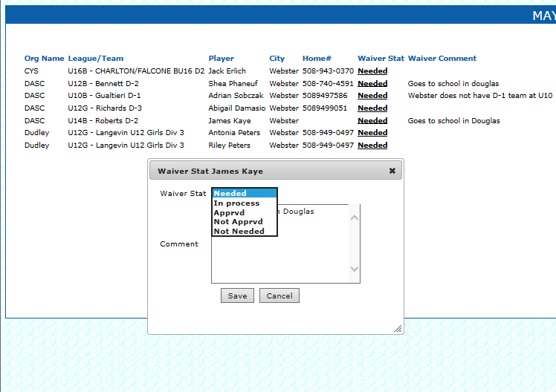

Check Out of Town Residents to play Webster Youth Soccer
In REPORTS/MODULES, select item #36 MAYS Out of Town List and check the list of players that need a waiver from other Town Reps. If players have not been approved within a month to 2 weeks before the season starts, you may need to email the appropriate Town Rep to see if there is an issue with the waiver or they forgot to approve. For players from state of Connecticut, please refer to the following section 8.2.3.

Process for Approving CT Players to play for Webster
There is a special process for approving CT players (out of state) to play in Webster. The reason is MAYS requires WYS to obtain approval from MYSA (Mass Youth Soccer Association). Once MYSA grants the waiver approval from the state of CT, then the CT players is allowed to play in MA. A Connecticut player requesting permission to play out of state must be in good standing and agree to abide by the rules of both State Associations. Please visit www.CJSA.org for more information and contacts.
The following steps need to be followed:
- In order to process the Request for Permission, the following documents must be completed and received by the CT State Administrator.
Please send forms to:
CJSA 11 Executive Drive,
Farmington, CT 06032:
  - Interstate Permission Form
  - USYS Membership Form
  - $30.00 Player Fee
- Upon receipt of the above the CT State Administrator, on behalf of the State President, will sign and then fax the form to the MA State Association.
- Once CJSA sends the forms to MYSA, then you will need to check with Rachel Woo of MYSA to see if the players have been approved to play in MA and if approved you will need to send the email to the MAYS President (President@MAYSL.com). The following is the contact for Rachel Woo:
Rachel Woo
Program Administrator
Mass Youth Soccer
512 Old Union Turnpike
Lancaster, MA 01523
978-466-8812 ext. 236
rwoo@mayouthsoccer.org

- In REPORTS/MODULES, select item #36 MAYS Out-of-Town Waiver Request to check that the CT players have been approved.
- Below are some sample emails used for the CT to MA approval process:

Uniform Orders
Process TDB and added at a future date.

Coach CORI Check
All coaches must pass the CORI process in order to coach for WYS. Also, coaches must resubmit their CORI information every 2 years. Send the following link to the coaches/volunteers:
https://idevforms.americaneagle.com/youthsoccer/form657510374/secure_index.html
Please contact the WYS Registrar if any questions at websteryouthsoccer@gmail.com

Practice Times
At least a couple of weeks before the season, you will need to contact all of the coaches in setting up practice times. Typically, all practice will last an hour unless there is not another team practicing before or after another team. You want to make sure everyone at least have one practice scheduled before allowing any other team to have a second practice. U10 B&G will play at George St. field and U12-U19 B&G will play at Berthold field.
In the past practice have been scheduled via email and a sample has been provided below. There is also functionality within SportsManager to schedule practice times but has not been utilized so please include instructions for future use is using scheduling practice via Sports Manager

Field Permits
Each year a field permit is required by the Town of Webster to use both George St. and Berthold fields. Generally, the WYS President obtains this and you should forward to all coaches so that can print out a copy to have a practice and games in case there are any questions. Here is an example contained in the email sample:

Send Coach Login information
Before each season you should send each coach the SportsManager login information as MAYS now requires coaches to set up their own coach’s login Account in SportsManager to take advantage of new scheduling functionality. With your coach’s login, they will be able to perform the following functions:
- view schedule, score games
- view rosters
- update jersey numbers
- edit personal coach info
- Email teams, see email history for that team
- view “team information pkg”
- Add/Crop pictures of players and asst. coaches
- How to view/print your approved roster form
- Roster email notices for drops and adds.
- New option so coaches can schedule their own practices
- New Game Rescheduling Option

You may also contact the coaches to use these features in order to upload their player pictures for their team.

Below is the document created by MAYS and then a sample emails sent out to coaches:

Send Coaches emails on game scheduling conflicts
Before MAYS begins the scheduling process, coaches should be contacted via email or phone call to see if there are any scheduling conflicts for game days. Those conflicts or requests should be submitted to the MAYS President at President@MAYSL.com.
The Town Rep will also need to send the MAYS President a list of dates that Teams can’t play, for example:
- High School Graduations
- Church First Communions
- Teams that play in Holiday soccer tournaments such as during Columbus Day Weekend

Send Coaches the Player Roster information
Before the season starts, the Town Rep/Travel Coordinator must send the Roster information to each travel coach. Here the steps:
- In SportsManager, click on the ROSTER MNG button on the left hand pane and then select Change Team button on near the top of the window to select a season, league and team.
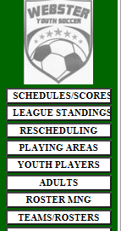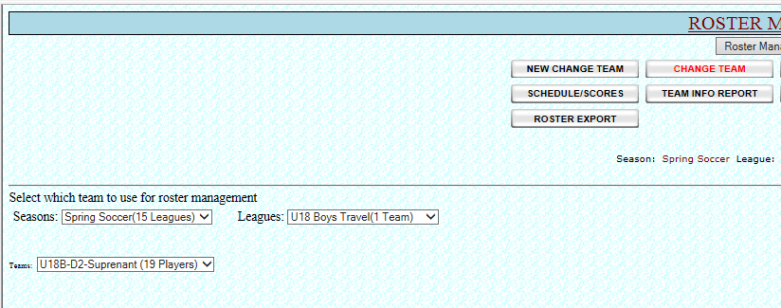
- Once a team is selected, click on the Email Roster button and you can either email to the coach or email to the wystravel@gmail.com and then forward off to the appropriate coach.
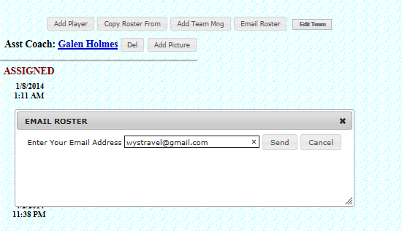

Send Coaches the Approved Game day Rosters
Before the season games start, the Town Rep/Travel Coordinator must send the Approved Game day Roster to each travel coach. Each team must provide 2 copies of the approved Roster to the referees before a game. The coach must sign the rosters and also fill in the number information either by hand or enter via SportsManager using their coach’s login functionality. Town Reps DO NOT need to sign the approved rosters anymore. Coach are NOT ALLOWED to manually write in players on the roster or will be fined by MAYS. Here the steps:
- In SportsManager, click on the ROSTER MNG button on the left hand pane and then select Change Team button on near the top of the window to select a season, league and team.
- Once a team is selected, click on the “Click here for the MAYS Roster Form-Approved” button to download a copy of the approved Roster. Once downloaded, you should then forward off to the appropriate coach via email. You should periodically check to see if there are any issues with the MAYS registrars approving the rosters and if there is you should contact the registrars directly via email to find out any issues. The most comment issues is that the player picture is missing for passcards.

Corner Flag Assignment Process
Before the season starts, it is recommended that a Corner Flag Assignment schedule be created with all coaches to make sure that the flags are set before each home game at each field and taken down at the end of the last game and put back in the bathrooms at George St. Generally, MAYS schedules groups of games at George St. and Berthold, so the coach of the first game of the day should set the flags and then the coach of the last game should take then down and put away. The schedule is created by reviewing the schedule for each field via SportsManager by clicking on the SCHEDULES/SCORES button on the left hand pane and then select the appropriate field to see the schedule for the entire season. Below is an example of an email sent to all travel coaches:

Coach Equipment
Before the season starts, it is recommended that the following equipment be given to coaches:
- First Aid Kit/Ice Packs
- Game Ball
- Ball Bag
- Pinnies (will need in case have a home game with opposing team having same color as WYS)
- Cones
- Key to George St. Bathroom
- Player Uniforms should be passed out to coaches to give to players. Can also have a uniform pickup time for players as well.
Please coordinate with the equipment manager for any questions on equipment and ordering.

Send Coach Game Day Schedule
Before the season starts, you can provide the following instructions for coaches and parents in viewing their schedule for the season:
- Go to the following URL: https://www.sportsmanager.us/WebsterYouthsoccer.htm
- Click on Schedules/Scores button on left hand pane:
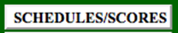

- Select your Division (for example “U18G”) from the “All Leagues” Drop Down and then select your Team Name from the “All Teams” Drop Down at the top:

- Then choose your display option:

- Click on the question mark on the left to display field address and to access a link for directions (link for directions in blue at the bottom):

Below is an email that is sent to coaches before the season:

MAYS Game Cancellation Policy and Rescheduling Procedures
The MAYS travel league game cancellation policy only allows the Town Travel Rep or the President to cancel games, which will be either the Town Rep or Town President. The coaches should not take it upon themselves to cancel a home game due to weather conditions. We have until at least 2 hours before your scheduled home game time to cancel a game. If it is past the 2 hour limit before your scheduled game, then it will be the referee’s decision on whether or not to cancel the game. If we do cancel your home game, the coach must me contacted immediately. Then the home team coach must then contact the opposing coach to informing them of the cancellation at least 2 hours before the scheduled game time. Also, you will need go into SportsManager to cancel the game, please refer to the instructions below.
The home team is then responsible for setting up a make-up date with the opposing coach via Sports Manager and have 2 weeks from the cancelled game to set-up a make-up date and 4 weeks to play the game. Make-up games are a priority and come before practices. So if you are sharing the field, team playing the game will have the field.
In general if the fields are playable, more than likely the game will be played. Please make sure all coaches have Town Rep contact information if any questions.
If you are traveling to an away game and think there is a chance you may not be playing, call the opposing coach. The opposing coach’s info is available on http://www.sportsmanager.us/websteryouthsoccer.htm via the new login process for coaches in SportsManager.
The following sample email can be sent to coaches on the Game Cancellation and Reschedule Process
The following PowerPoint document can be sent to all coaches:

Cancelling games in SportsManager
Below is the PowerPoint document from MAYS on canceling games and closing fields via SportsManager:
You can also view all MAYS reschedules games and current statuses at http://www.sportsmanager.us/orgmanager/MAYSL.htm and click on the RESCHEDULING button on the left hand pane.
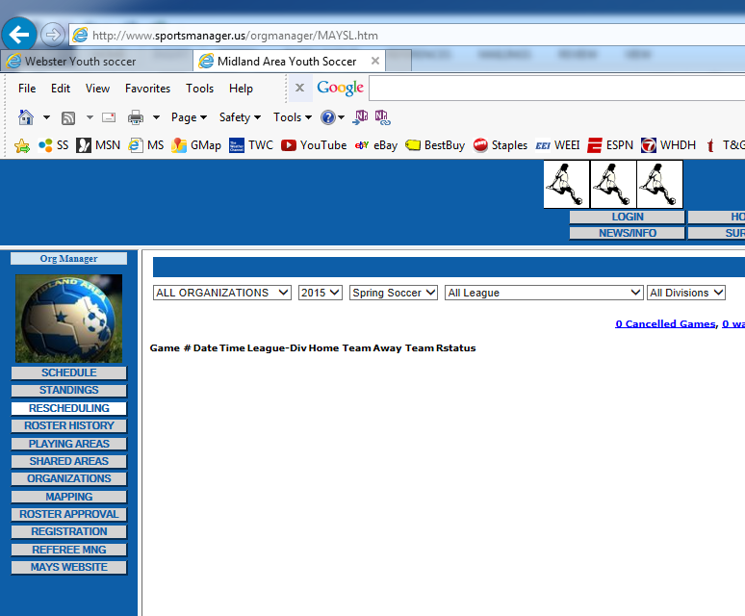

Set up Field information in SportsManger
The following emails contains instructions for setting up fields in SportsManager. This should be complete and should refer to email only if field information and playing times for each field need to be changed.

Coach and Player Passcard Distribution
Please be sure to distribute all Coach and Player passcards to all Travel teams depending on season and division requirements. Please refer to section 7.2 on creating Coach and Player passcards.

MAYS By-Laws
The MAYS By-Laws can be found on the MAYS site (http://www.sportsmanager.us/orgmanager/MAYSL.htm) under FORMS/DOCS/FILES section. Please refer to each season for any changes.

Miscellaneous Coach Emails
The following miscellaneous emails can be sent to all coaches before the season:
- Code of Conduct
- How not to run up the score (teams are not allowed to win by more than 8 goal differential)
- MAYS By-Laws
- MAYS site information
- Coach Set up Instructions
- CORI Process
- View Game Schedules
- Game Cancellations
- Game Day Roster Email with instructions

