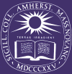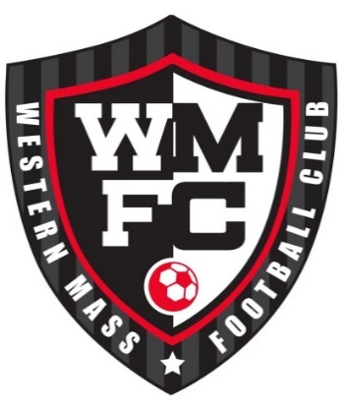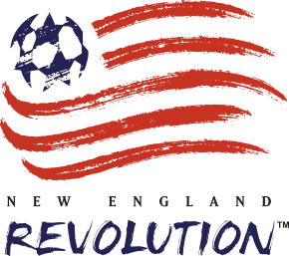

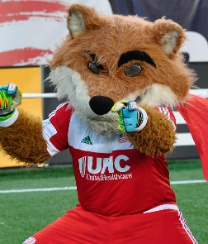
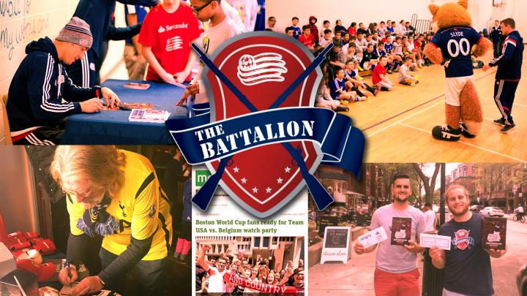
Western Mass FC Soccer Party
Sunday March 13, 2016

The Platform Sports Grill
125 A Pleasant Street
Northampton, MA 01060

11:30 AM – 2:00 PM
Pre-Party begins at 10:55 AM

Western Mass FC will again host the BIGGEST SOCCER PARTY OF THE YEAR at the Platform Sports Grill on Sunday March 13, 2016. This is your chance to meet a starting player from The New England Revolution and Coaches and players from The Amherst College 2015 National Championship Team! The National Championship trophy will be on display!

A starting Revolution player will be in attendance to meet our players and families, take photos, sign autographs and talk with them about life as a professional soccer player. The Revs’ mascot, Slyde the Fox, and The Revolution Battalion will be providing fun games, prizes and giveaways.

The party begins at 11:30. However for the die-hard football fans, the Platform Sports Grill will be opening up 35 minutes early at 10:55 just for our club to watch Liverpool play Chelsea in the Blue Goose Room! The Blue Goose is specially designed with two 110” projection screens and Dolby 7.1 surround sound to create the ultimate viewing experience!

This is a great opportunity to visit with the Western Mass FC community and enjoy an afternoon of family soccer activities all while enjoying the Platform Sports Grill’s extensive food and beverage menu!

This event is free and open to the entire community, but Western Mass FC families can register at https://www.surveymonkey.com/r/WWHS322 to ensure their priority over the general public.

This is a great chance for local youth soccer players and their families to come together for an afternoon of fun!
Wear your Western Mass FC, Local High School or Middle School Soccer jersey and be entered to win a prize!

You can email info@westernmassfc.com or Dan Peters at danp17@yahoo.com with any questions. See you there!

