Wilbraham Soccer Club Holiday Sale

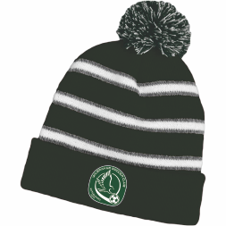
Winter Pom Beanie
$30
Embroidered Logo On Front Cuff. One Size.


Sublimated Fleece Blanket 60 x 50
$45
Orders Due Dec 5th. Please make Checks out to: Wilbraham Soccer Club.
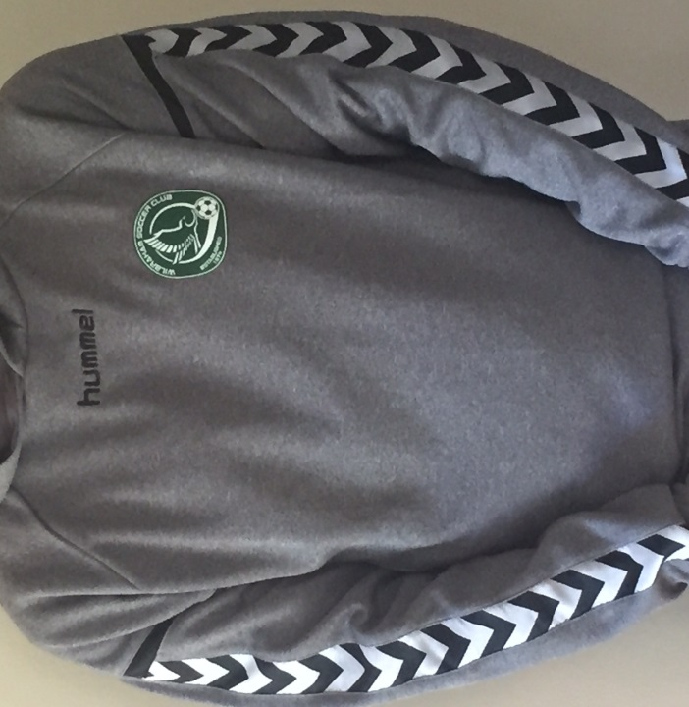
HUMMEL STAY AUTHENTIC POLY Hoody
Patch on left front with option to add number on right front!
$42
Orders Due Dec 5th. Please make Checks out to: Wilbraham Soccer Club. 