WOBURN COALITION AGAINST SUBSTANCE ABUSE
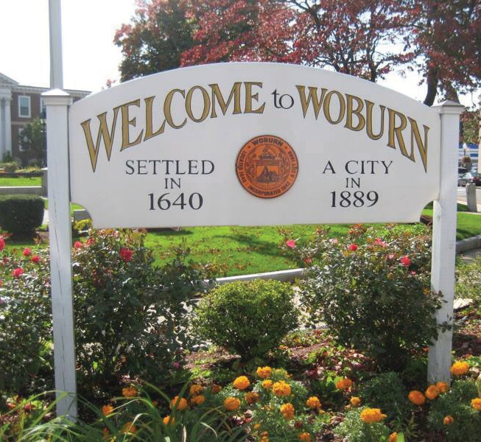
(CASA) hosts an
OPEN DRUG FORUM

GUEST SPEAKERS WILL INCLUDE:
Wednesday, June 17th, 6:30 pm
Woburn Memorial High School Auditorium

Marie and Carmen Lucchese
The Lucchese’s are active in substance abuse prevention and education in the community and are parents of a child who lost his battle with addiction.

Mike Duggan
Mike struggled with his own addiction and became the founder of Wicked Sober Addiction Outreach Program.

Brian Teague
Brian struggled with addiction and now is the manager of Michael’s Sober Living House in Wilmington.

Bobby French
Bobby is a Wilmington High School Hall of Fame ath- lete who battled addiction and is now assistant man- ager at Michael’s House.

LET’S GET THE WORD OUT!
NO ONE IS IMMUNE TO ADDICTION, BUT THERE IS HOPE AND HELP.
Come and listen to their stories, followed by a
Question and Answer session. Show your support
for the cause. Help us educate the community.

RICK JOLLY / SUBSTANCE ABUSE PROGRAM COORDINATOR / CITY OF WOBURN

